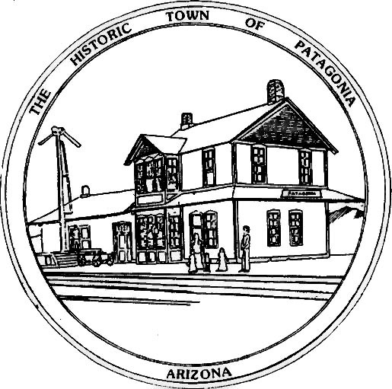

NOTICE OF CANCELLED MEETING

THE TOWN OF PATAGONIA
LIBRARY ADVISORY BOARD

PURSUANT TO A.R.S. 38-431.02, NOTICE IS HEREBY GIVEN TO THE MEMBERS OF THE PATAGONIA LIBRARY ADVISORY BOARD AND THE GENERAL PUBLIC THAT THE BOARD WILL NOT HOLD A

MONTHLY REGULAR MEETING DUE TO NO QUORUM.

DATED THIS 8TH DAY OF MAY 2025

TOWN OF PATAGONIA


______________________________
RON ROBINSON
TOWN CLERK

