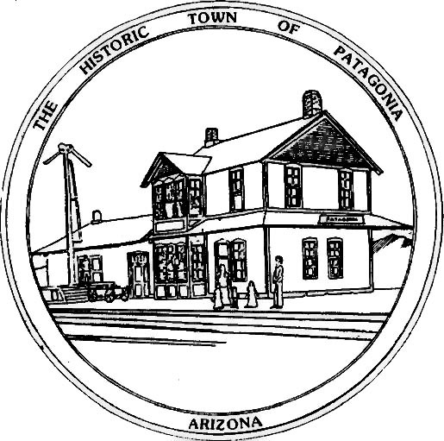

NOTICE OF MEETING

THE TOWN OF PATAGONIA
LIBRARY ADVISORY BOARD

PURSUANT TO A.R.S. 38-431.02, NOTICE IS HEREBY GIVEN TO THE MEMBERS OF THE PATAGONIA LIBRARY ADVISORY BOARD AND THE GENERAL PUBLIC THAT THE BOARD WILL

WILL HOLD AN EXECUTIVE SESSION

TO DISCUSS LIBRARY POLICY ITEMS

10:00 A.M. APRIL 15, 2025, AT

PATAGONIA TOWN HALL
PATAGONIA AZ

DATED THIS 12TH DAY OF APRIL 2025

TOWN OF PATAGONIA


______________________________
RON ROBINSON
TOWN CLERK

