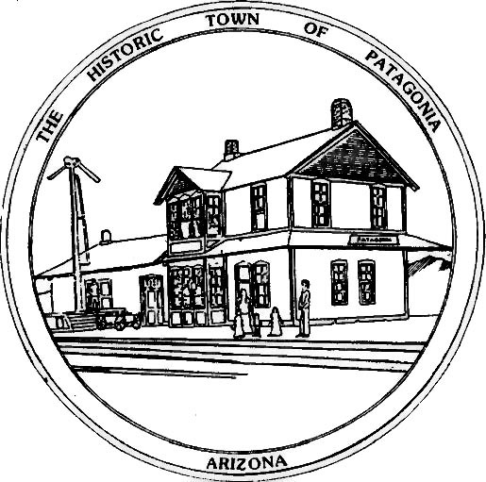

NOTICE OF MEETING

THE TOWN OF PATAGONIA
SONOITA CREEK FLOOD AND FLOW COMMITTEE

PURSUANT TO A.R.S. 38-431.02, NOTICE IS HEREBY GIVEN TO THE MEMBERS OF THE SONOITA CREEK FLOOD AND FLOW STUDY COMMITTEE AND THE GENERAL PUBLIC THAT THE COMMITTEE WILL HOLD A

SPECIAL MEETING
FOR THE PURPOSE OF CONDUCTING COMMITTEE BUSINESS
AT 10:00 A.M. May 15th, 2025

THIS MEETING WILL BE HELD VIA ZOOM MEETING
Meeting ID: 957-511-4862
Passcode: 338501

DATED THIS 13th DAY OF May 2025

TOWN OF PATAGONIA


______________________________
RON ROBINSON, TOWN CLERK

