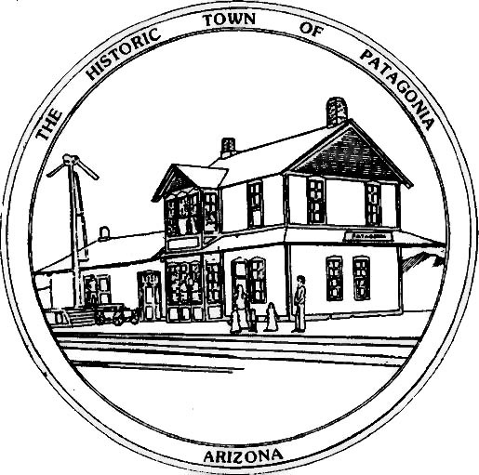

TOWN OF PATAGONIA
PUBLIC NOTICE
THIS IS A COURTESY POSTING OF AN EVENT AT WHICH A QUORUM OF THE
FLOOD & FLOW COMMITTEE & THE PLANNING AND DEVELOPMENT COMMITTEE MAY BE PRESENT.
THIS IS NOT AN OFFICIAL COMMITTEE MEETING AND NO OFFICIAL BUSINESS
WILL BE CONDUCTED OR ANY OFFICIAL ACTION TAKEN.
WEDNESDAY, JULY 10, 2024 @ 6:00 P.M. IN TOWN COUNCIL CHAMBERS, CAROLYN SHAFER WITH PARA WILL BE PRESENTING AN ACTIVITES UPDATE.

POSTED: 07/05/2024 BY

Ron Robinson, Town Clerk

