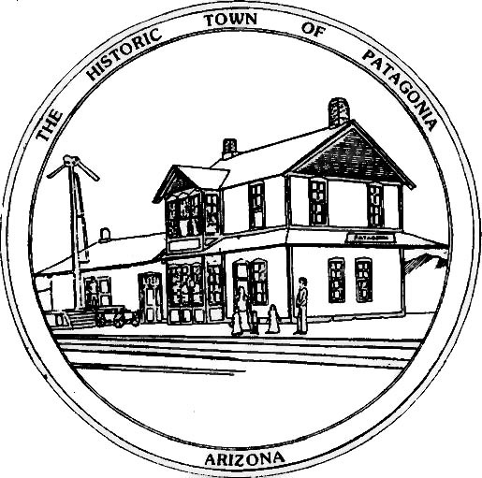

TOWN OF PATAGONIA
PUBLIC NOTICE
THIS IS A COURTESY POSTING OF AN EVENT AT WHICH A QUORUM OF THE
FLOOD & FLOW COMMITTEE, THE TOWN COUNCIL OF PATAGONIA & THE PLANNING AND DEVELOPMENT COMMITTEE MAY BE PRESENT.
THIS IS NOT AN OFFICIAL COMMITTEE MEETING AND NO OFFICIAL BUSINESS
WILL BE CONDUCTED OR ANY OFFICIAL ACTION TAKEN.
TUESDAY, APRIL 30, 2024 @ 5:30 P.M. AT PATAGONIA UNION SCHOOLS
THERE WILL BE A TOWN HALL FORUM LED BY ATTORNEY GENERAL KRIS MAYES.

POSTED: 04/23/2024 BY

Ron Robinson, Town Clerk

