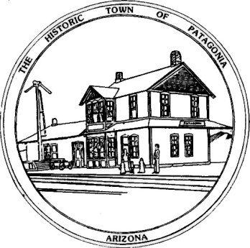

Town of Patagonia Codes and Ordinances Chapter 9
Health, Sanitation and Environment
Patagonia Town Trash Customers,
Please remember to bag all trash, no loose trash will be collected. Place a lid on your trash container to keep weather and animals out. This is for the health and safety of our Sanitation Workers. Thank you.
-Town of Patagonia
Section 9-2-3 Residential Customer Preparation of Solid Waste
- All residential customers shall set out their solid waste at the location and prior to the time designated in the notice of solid waste collection routes. All solid waste is to be bagged and in the container for the purpose of health and safety to the sanitation workers. Trash containers will be used for the sanitary accumulation, storage, and collection of solid waste. Such containers shall be of rust-resistant metal or plastic, shall have handles on the outside and shall covers on them to prevent any rain or animal infiltration. The trash container can be no more than 50 pounds.

