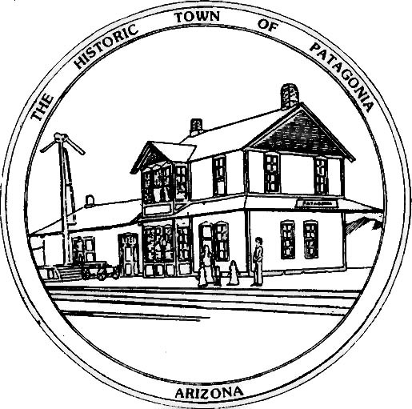

TOWN OF PATAGONIA
PUBLIC NOTICE

THIS IS A COURTESY POSTING OF AN EVENT AT WHICH A QUORUM OF THE
FLOOD & FLOW COMMITTEE AND THE TOWN COUNCIL OF PATAGONIA MAY BE
PRESENT.
THIS IS NOT AN OFFICIAL COMMITTEE/COUNCIL MEETING AND NO OFFICIAL
BUSINESS WILL BE CONDUCTED OR ANY OFFICIAL ACTION TAKEN.
TUESDAY, MARCH 26, 2024, FROM 6:00 P.M. TILL 8:00 P.M. AT TOWN HALL.
THE PRESENTERS WILL BE DISCUSSING THE PATAGONIA FLOOD CONTROL
PROJECT.

POSTED: 03/04/2024 BY

Ron Robinson, Town Clerk

