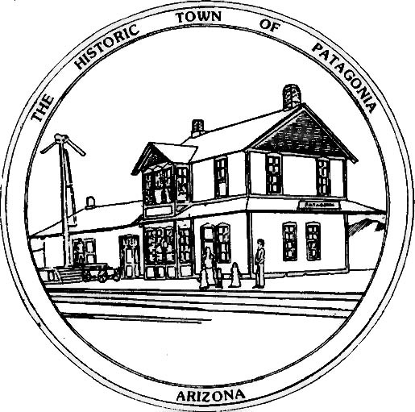

TOWN OF PATAGONIA
PUBLIC NOTICE
THIS IS A COURTESY POSTING OF AN EVENT AT WHICH A QUORUM OF THE
FLOOD & FLOW COMMITTEE AND THE TOWN COUNCIL OF PATAGONIA MAY BE
PRESENT.
THIS IS NOT AN OFFICIAL COMMITTEE MEETING AND NO OFFICIAL BUSINESS
WILL BE CONDUCTED OR ANY OFFICIAL ACTION TAKEN.
WEDNESDAY, FEBRUARY 7, 2024 @ 1:00 P.M. AT CADY HALL
THE PRESENTERS WILL BE DISCUSSING PROTECTING NATURAL RESOURCES IN OUR REGION. THIS IS AN INFORMATIONAL MEETING ONLY. WRITTEN QUESTIONS AND COMMENTS WILL BE ACCEPTED.

POSTED: 02/05/2024 BY

Ron Robinson, Town Clerk

