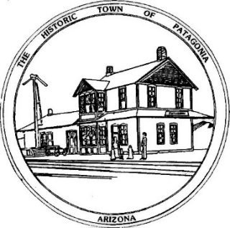
TOWN OF PATAGONIA
PLANNING AND DEVELOPMENT MEETING AND PUBLIC HEARING AGENDA
June 6, 2023, 6:00 P.M.
Zoom Meeting I.D. 957-511-4862 Password 338501
- CALL TO ORDER
- ROLL CALL
- PLEDGE OF ALLEGIENCE
- APPROVAL OF MINUTES FROM MAY 2, 2023, MEETING
- CALL TO THE PUBLIC A. R. S. §38-431-01(H): AT THIS TIME, THE PUBLIC WILL ONLY BE RECOGNIZED TO SPEAK ON AGENDA ITEMS LISTED FOR PUBLIC INPUT PURSUANT TO TOWN CODE SECTION 2-5-6. ANY MEMBER OF THE PUBLIC IS ALLOWED TO ADDRESS THE COMMITTEE, SUBJECT TO A REASONABLE TIME SET BY THE COMMITTEE PURSUANT TO THE ARIZONA OPEN MEETING LAW. AT THE CONCLUSION OF THE CALL TO THE PUBLIC, INDIVIDUAL MEMBERS OF THE COMMITTEE MAY RESPOND TO CRITICISM MADE BY THOSE WHO HAVE ADDRESSED THE COMMITTEE, MAY ASK STAFF TO REVIEW THE MATTER, OR MAY ASK THE MATTER BE PLACED ON A FUTURE AGENDA. HOWEVER, MEMBERS OF THE COMMITTEE SHALL NOT DISCUSS OR TAKE LEGAL ACTION ON MATTERS RAISED DURING AN OPEN CALL TO THE PUBLIC UNLESS THE MATTERS ARE PROPERLY NOTICED FOR DISCUSSION AND LEGAL ACTION.
OLD BUSINESS
NONE
PUBLIC HEARING ON USE PERMIT
- THE COMMITTEE WILL HOLD A PUBLIC HEARING ON THE USE PERMIT SUBMITTED BY DOUGLAS ECKMAN FOR RECOMMENDATION TO THE TOWN COUNCIL. USE PERMIT IS FOR THE CONTRUCTION OF A 6’ WALL CONSTRUCTED ON THE BACK OF HIS PROPERTY AT 423 MCKEOWN AVENUE
REOPEN REGULAR COMMITTEE MEETING
- DISCUSSION AND POSSIBLE ACTION ON PROPOSED USE PERMIT SUBMITTED BY DOUGLAS ECKMAN
- STAFF OR MEMBER REPORTS: AT THIS TIME THE TOWN STAFF OR A COMMITTEE MEMBER MAY REPORT ON ITEMS OF INTEREST TO THE COMMITTEE. SUCH ITEMS MAY NOT BE ACTED UPON BY THE COMMITTEE AT THIS TIME, BUT MAY BE SCHEDULED AS A FUTURE AGENDA ITEM.
- FUTURE AGENDA ITEMS: AT THIS TIME THE COMMITTEE MAY BRING FORTH TOPICS FOR FUTURE AGENDAS AND SET THE DATE FOR THE NEXT MEETING.
- ADJOURN

