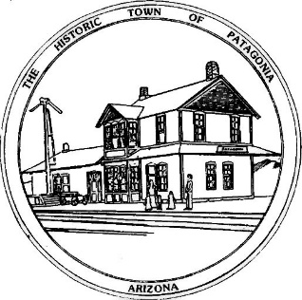

NOTICE OF MEETING AND PUBLIC HEARING OF THE

PATAGONIA TOWN COUNCIL

Pursuant to Articles 7-1-6-G, 14-2-C-3 and 14-2-C-4 of the Code of the Town of Patagonia, Notice is hereby given to the General Public that the Town Council of the Town of Patagonia will CONDUCT A PUBLIC HEARING TO CONSIDER THE FOLLOWING APPLICATION FOR A USE PERMIT:

Douglas Eckman requests approval of a 6’ block wall constructed on the back of his property located at 423 McKeown Avenue. The block wall is to be constructed along the portion of his property abutting Smelter Avenue. Once the block wall is constructed, it will have a stucco finish and painted.

SPECIAL MEETING AT 6:00 P.M. JUNE 28, 2023

THE MEETING WILL BE HELD AT

TOWN HALL

310 MCKEOWN AVENUE

PATAGONIA, AZ

AND VIA ZOOM MEETING, I.D. 957-511-4862 PASSCODE # 338501

Dated this 7th Day of June 2023

Ron Robinson, Town Clerk

