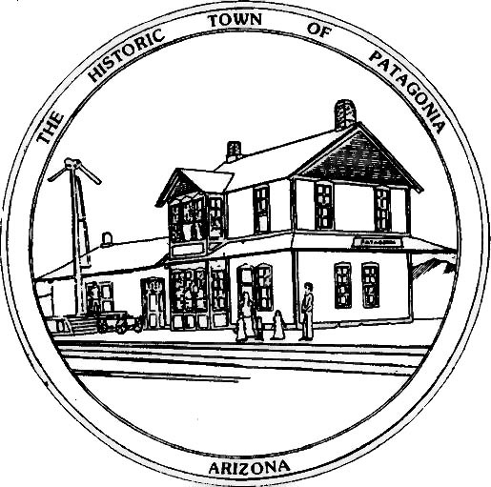

NOTICE OF

special MEETING

and

Possible executive session

THE TOWN OF PATAGONIA TOWN COUNCIL

PURSUANT TO A.R.S.38-431.02 and 38-431.03(A)(3), (4), NOTICE IS HEREBY GIVEN TO THE MEMBERS OF THE PATAGONIA TOWN COUNCIL AND THE GENERAL PUBLIC THAT THE PATAGONIA TOWN COUNCIL WILL HOLD A

special council MEETING AT 6:00 P.M.

MAY 17, 2023

THIS MEETING WILL BE HELD AT

TOWN HALL

310 McKEOWN AVENUE

PATAGONIA, Arzona

As Indicated in the agenda,

pursuant to A.R.S.38-431.03(A)(3), (4) THE Town Council may vote to go into executive session,

which will not be open to the public, to discuss certain matters.

DATED THIS 15TH OF MAY 2023

TOWN OF PATAGONIA

______________________________

RON ROBINSON

TOWN CLERK

