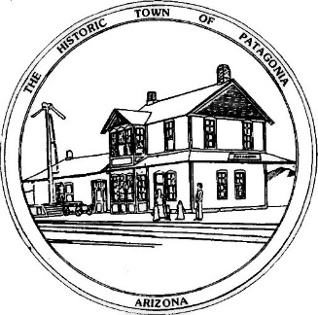

TOWN OF PATAGONIA NEW HIRE BENEFITS AND TIME SCHEDULE AS TO WHEN THEY START

UNIFORMS: AFTER 4 WEEKS ON THE JOB THIS BENEFIT IS PROVIDED BY THE TOWN. PLEASE GIVE YOUR PANT AND SHIRT SIZES TO ANDREA. WORK BOOTS ARE TO BE BOUGHT BY THE EMPLOYEE WITH A PURCHASE ORDER ISSUED BY THE TOWN IN JANUARY OF EACH YEAR OF EMPLOYMENT. YOU WILL NEED TO GIVE ANDREA THE SIZE JACKET YOU WEAR AND OUR UNIFORM SUPPLIER WILL FURNISH IT TO YOU. JACKETS WILL BE GIVEN EVERY TWO YEARS.
HEALTH, VISION, DENTAL & LIFE INSURANCE: AFTER 60 DAYS ON THE JOB, 100 % OF THE HEALTH BENEFIT FOR THE EMPLOYEE IS PROVIDED BY THE TOWN. IF YOU CHOSE TO ADD YOUR FAMILY TO THE HEALTH PLAN, THEIR COST WILL BE DEDUCTED FROM YOUR CHECK.
ARIZONA STATE RETIREMENT SYSTEM: AFTER 20 CONSECUTIVE WEEKS ON THE JOB THE PERCENTAGE ALLOTTED FOR THE YEAR WILL BE WITHHELD FROM YOUR CHECK. THIS BENEFIT IS MANDATORY.
PAYCHECKS ARE ISSUED BI-WEEKLY

