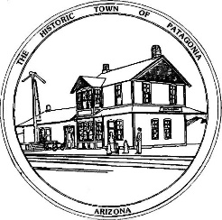

NOTICE OF A SPECIAL MEETING OF

THE TOWN OF PATAGONIA

TOWN COUNCIL

PURSUANT TO A.R.S. 38-431.02, NOTICE IS HEREBY GIVEN TO THE MEMBERS OF THE PATAGONIA TOWN COUNCIL AND THE GENERAL PUBLIC THAT THE PATAGONIA TOWN COUNCIL WILL HOLD A

SPECIAL COUNCIL STUDY SESSION

TO DISCUSS CHANGES TO

CHAPTER 14 OF THE TOWN CODE

AT 6:00 P.M. MARCH 01, 2023

THIS SPECIAL MEETING WILL BE HELD AT

TOWN HALL

310 MCKEOWN AVENUE

PATAGONIA, AZ

WITH PARTIAL PUBLIC PARTICIPATION IN THE MEETING AND

VIA ZOOM MEETING I.D. 957-511-4862 PASSWORD 338501

DATED THIS 27TH DAY OF FEBRUARY 2023.

TOWN OF PATAGONIA

RON ROBINSON

TOWN CLERK

