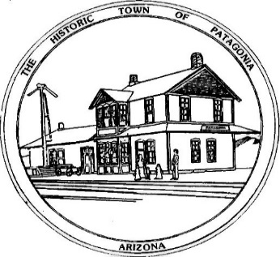

NOTICE OF SPECIAL MEETING

FOR THE TOWN OF PATAGONIA

PLANNING & DEVELOPMENT COMMITTEE

PURSUANT TO A.R.S. 38-431.02, NOTICE IS HEREBY GIVEN TO THE MEMBERS OF THE PATAGONIA PLANNING AND DEVELOPMENT COMMITTEE AND THE GENERAL PUBLIC THAT THE PATAGONIA PLANNING AND DEVELOPMENT COMMITTEE WILL HOLD A

SPECIAL MEETING

AT 6:00 P.M. JANUARY 3, 2023

THIS MEETING WILL BE HELD WITH PUBLIC

PARTICIPATION AND VIA ZOOM

MEETING I.D.: 957-511-4862

PASSWORD: 338501

TOWN HALL

310 MC KEOWN AVENUE

PATAGONIA, AZ

DATED THIS 30TH DAY OF DECEMBER 2022.

TOWN OF PATAGONIA

RON ROBINSON

TOWN CLERK

