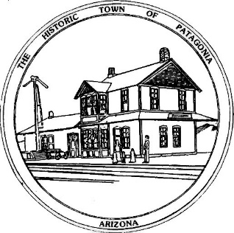

NOTICE OF SPECIAL MEETING AND PUBLIC HEARING

PLANNING AND DEVELOPMENT COMMITTEE

Pursuant to Articles 14-2-C-3 and 14-2-C-4 of the Code of the Town of Patagonia, Notice is hereby given to the General Public that the Planning and Development Committee of the Town of Patagonia will CONDUCT A PUBLIC HEARING TO CONSIDER THE FOLLOWING APPLICATION FOR A USE PERMIT:

FOR A PROPOSED HOSTEL LOCATED AT 317 SMELTER AVENUE IN THE FORMER STRADLING BUILDING NOW OWNED BY DOLESWOOD LLC, SANTA CRUZ COUNTY ASSESSOR PARCEL NO. 106-35-034. THE HOSTEL WOULD BE DESIGNED TO ACCOMMODATE HIKERS, BIKERS AND HUNTERS.

SPECIAL MEETING AT 6:00 P.M. NOVEMBER 1, 2022

THE MEETING WILL BE HELD AT

TOWN HALL

310 MCKEOWN AVENUE

PATAGONIA, AZ

AND VIA ZOOM MEETING, I.D. 957-511-4862 PASSCODE # 338501

Dated this 10th Day of OCTOBER 2022

Ron Robinson

TOWN CLERK

POSTED 10/10/2022

