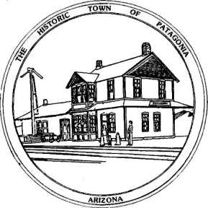

Town of Patagonia
Public Hearing Regarding Use of CDBG Funds

The Town of Patagonia intends to apply for up to $1.9 million in FY21/22 CDBG funds from the Colonias Set-Aside account. CDBG funds must be used to benefit low-income persons and areas, alleviate slum and blight or address urgent need. A public hearing will be held at 6:00 pm on Wednesday, August 31st, 2022, at Town Hall, 310 McKeown Avenue to gather citizen input on the use of the CDBG funds. The activities that qualify as Colonia projects will be limited to those that:
- Address the lack of decent, safe, and sanitary housing (Housing Rehabilitation);
- Address the lack of potable water supply
- Address the lack of adequate sewage systems;
- Address the lack of adequate flood-control improvements;
- Planning for Waste Water Treatment improvements; or
- Planning for Potable Water Delivery improvements.

For more information about the hearing, grievances, or the CDBG program; or to receive assistance in formulating prospective project ideas for presentation at the hearing contact the following:

Name, Title: Ron Robinson, Town Manager
Organization: Town of Patagonia
Address: 310 McKeown Avenue
City, State, Zip: Patagonia, AZ 85624
Telephone: 520-394-2229
Fax: 520-394-2861

Persons with disabilities who require special accommodations may contact Isabel van Nest at the above location at least 48 hours before the hearing.

