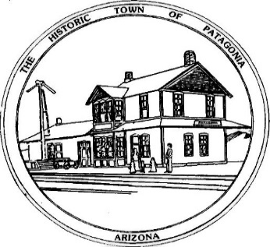

NOTICE OF SPECIAL MEETING

FOR THE TOWN OF PATAGONIA

PLANNING & DEVELOPMENT COMMITTEE

PURSUANT TO A.R.S. 38-431.02, NOTICE IS HEREBY GIVEN TO THE MEMBERS OF THE PATAGONIA PLANNING AND DEVELOPMENT COMMITTEE AND THE GENERAL PUBLIC THAT THE PATAGONIA PLANNING AND DEVELOPMENT COMMITTEE WILL HOLD A

SPECIAL MEETING

AT 6:00 P.M. AUGUST 9, 2022

THIS MEETING & PUBLIC HEARING WILL BE HELD WITH PARTIAL PUBLIC PARTICIPATION AND VIA ZOOM MEETING

MEETING I.D.: 957-511-4862

PASSWORD: 338501

TOWN HALL

310 MC KEOWN AVENUE

PATAGONIA, AZ

DATED THIS 8TH DAY OF AUGUST 2022.

TOWN OF PATAGONIA

RON ROBINSON

TOWN CLERK

