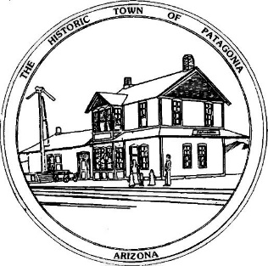

NOTICE OF MEETING

THE TOWN OF PATAGONIA

TREE AND PARK COMMITTEE MEETING

PURSUANT TO A.R.S. 38-431.02, NOTICE IS HEREBY GIVEN TO THE MEMBERS OF THE PATAGONIA TREE AND PARK COMMITTEE AND THE GENERAL PUBLIC THAT THE PATAGONIA TREE AND PARK COMMITTEE WILL HOLD A

REGULAR MEETING

AT 4:00 P.M. MAY 20, 2022

310 McKeown Avenue

Patagonia, Arizona

THIS MEETING WILL BE HELD IN PERSON WITH PARTIAL PUBLIC PARTICIPATION AND ZOOM MEETING

CALL IN I.D. 957-511-4862, CODE: 338501

DATED THIS 19th DAY OF MAY 2022.

TOWN OF PATAGONIA

___________________________

RON ROBINSON

TOWN CLERK

