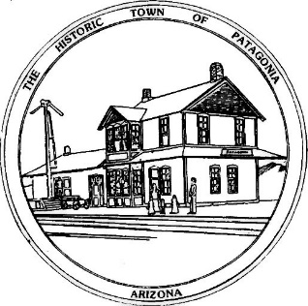

NOTICE OF MEETING AND PUBLIC HEARING

PLANNING AND DEVELOPMENT COMMITTEE

Pursuant to Articles 14-2-C-3 and 14-2-C-4 of the Code of the Town of Patagonia, Notice is hereby given to the General Public that the Planning and Development Committee of the Town of Patagonia will CONDUCT A PUBLIC HEARING TO CONSIDER THE FOLLOWING APPLICATIONS FOR USE PERMITS:

KEVIN AND MARY McKAY ARE REQUESTING A USE PERMIT FOR 308 NAUGLE AVENUE (parcel # 106-35-060) FOR A PLANT NURSERY AND OUTDOOR GIFT SHOP.

SPECIAL MEETING AT 5:00 P.M. FEBRUARY 23, 2022

THE MEETING WILL BE HELD AT

TOWN HALL

310 MCKEOWN AVENUE

PATAGONIA, AZ

AND VIA ZOOM MEETING, I.D. 957-511-4862 PASSCODE # 338501

Dated this 4th Day of FEBRUARY 2022

_______________________________
Ron Robinson, Town Clerk

