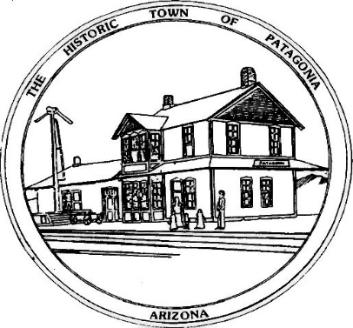
Town of Patagonia Tree Permit Application Form
THE PURPOSE OF THIS PERMIT IS COVERED IN TOWN CODE SECTION 9-3-6
PLANTING, PRUNING OR REMOVING TREES ON PUBLIC PROPERTY PROHIBITED
THIS PERMIT IS AN ALLOWANCE OF ANY PERSON OR ORGANIZATION WHO WISHES TO CONFORM TO THE CODE TO DO TREE PLANTING, PRUNING OR REMOVING ON PUBLIC PROPERTY IN ACCORDANCE WITH THE TOWN TREE AND PARK PLAN
Name of person applying for the permit____________________________
Committee Name or Organization_________________________________
Address_______________________________________________________
Phone#__(___)__________________Email__________________________
Sketch of tree(s) locations below: include landmarks such as buildings & streets

