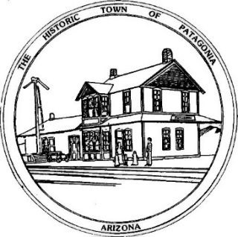
TOWN OF PATAGONIA
PLANNING AND DEVELOPMENT MEETING
November 18, 2021 6:00 P.M.
Zoom Meeting I.D. 957-511-4862 Password 338501

AGENDA

1. CALL TO ORDER

2. ROLL CALL

3. APPROVAL OF MINUTES FROM October 5, 2021 and October 27, 2021 MEETINGS

4. CALL TO THE PUBLIC A. R. S. §38-431-01(H): AT THIS TIME, THE PUBLIC WILL ONLY BE RECOGNIZED TO SPEAK ON AGENDA ITEMS LISTED FOR PUBLIC INPUT PURSUANT TO TOWN CODE SECTION 2-5-6. ANY MEMBER OF THE PUBLIC IS ALLOWED TO ADDRESS THE COMMITTEE, SUBJECT TO A REASONABLE TIME SET BY THE COMMITTEE PURSUANT TO THE ARIZONA OPEN MEETING LAW. AT THE CONCLUSION OF THE CALL TO THE PUBLIC, INDIVIDUAL MEMBERS OF THE COMMITTEE MAY RESPOND TO CRITICISM MADE BY THOSE WHO HAVE ADDRESSED THE COMMITTEE, MAY ASK STAFF TO REVIEW THE MATTER, OR MAY ASK THE MATTER BE PLACED ON A FUTURE AGENDA. HOWEVER, MEMBERS OF THE COMMITTEE SHALL NOT DISCUSS OR TAKE LEGAL ACTION ON MATTERS RAISED DURING AN OPEN CALL TO THE PUBLIC UNLESS THE MATTERS ARE PROPERLY NOTICED FOR DISCUSSION AND LEGAL ACTION.

OLD BUSINESS – None
NEW BUSINESS

5. DISCUSSION AND POSSIBLE ACTION ON RELOCATION OF EAST SANTA CRUZ COUNTY FOOD BANK FROM 222 THIRD AVE TO A PROPERTY OWNED BY ARIZONA MINERALS AT 722 HARSHAW ROAD, PATAGONIA AZ.

6. UPDATE ON INSTALLATION OF ANTIQUE SOUTHERN PACIFIC RAILROAD CABOOSE IN DOC MOCK PARK TO BE USED AS THE SKY ISLAND TOURISM VISITOR CENTER.

7. ADJOURN.

