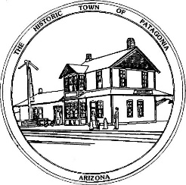

NOTICE OF SPECIAL MEETING

THE TOWN OF PATAGONIA

TOWN COUNCIL

PURSUANT TO A.R.S. 38-431.02, NOTICE IS HEREBY GIVEN TO THE MEMBERS OF THE PATAGONIA TOWN COUNCIL AND THE GENERAL PUBLIC THAT THE PATAGONIA TOWN COUNCIL WILL HOLD A

SPECIAL TOWN COUNCIL MEETING

AT 6:00 P.M. NOVEMBER 17, 2021

THIS MEETING WILL BE HELD AT

TOWN HALL

310 MC KEOWN AVENUE

PATAGONIA, AZ

WITH PARTIAL PUBLIC PARTICIPATION IN THE MEETING AND

VIA ZOOM MEETING I.D. 957-511-4862 PASSWORD 338501

DATED THIS 15TH DAY OF NOVEMBER 2021.

TOWN OF PATAGONIA

___________________________

RON ROBINSON

TOWN CLERK

