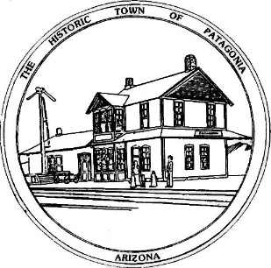

NOTICE OF SPECIAL COUNCIL MEETING

THE TOWN OF PATAGONIA

PURSUANT TO A.R.S. 38-431.02, NOTICE IS HEREBY GIVEN TO THE MEMBERS OF THE PATAGONIA TOWN COUNCIL AND THE GENERAL PUBLIC THAT THE PATAGONIA TOWN COUNCIL WILL HOLD A

SPECIAL MEETING

AT 6:00 P.M. NOVEMBER 1, 2021

IN TOWN HALL COUNCIL CHAMBERS,

310 MCKEOWN AVENUE PATAGONIA, ARIZONA

DATED THIS 28TH DAY OF OCTOBER, 2021.

TOWN OF PATAGONIA

___________________________

RON ROBINSON

TOWN CLERK

