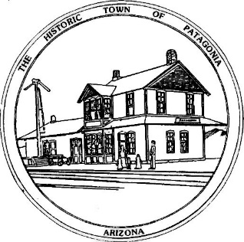

NOTICE OF MEETING AND PUBLIC HEARING

PLANNING AND DEVELOPMENT COMMITTEE

Pursuant to Articles 14-2-C-3 and 14-2-C-4 of the Code of the Town of Patagonia, Notice is hereby given to the General Public that the Planning and Development Committee of the Town of Patagonia will CONDUCT A PUBLIC HEARING TO CONSIDER THE FOLLOWING APPLICATIONS FOR USE PERMITS:

Kayla Lewis-Simpson and partners are requesting a use permit for “The Queen of Cups” a small scale restaurant offering food and wine, located inside 317 W. McKeown Avenue.

David King and Patty Barraza are requesting a use permit for a 2 day Swap Meet event once per month located on their property at 132 Naugle Avenue.

SPECIAL MEETING AT 6:00 P.M. OCTOBER 27, 2021

THE MEETING WILL BE HELD AT

TOWN HALL

310 MCKEOWN AVENUE

PATAGONIA, AZ

AND VIA ZOOM MEETING, I.D. 957-511-4862 PASSCODE # 338501

Dated this 11th Day of October, 2021

_______________________________
Ron Robinson, Town Clerk

