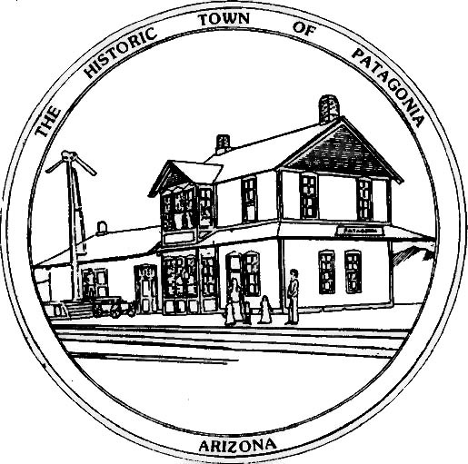
PUBLIC NOTICE

THE TOWN OF PATAGONIA IS REQUESTING ALL GARBAGE

CUSTOMERS, PLEASE BAG YOUR GARBAGE. LOOSE

GARBAGE IS A HEALTH HAZARD AND COMPROMISES THE

HEALTH OF OUR SANITATION DEPARTMENT. AGAIN,

PLEASE BAG ALL GARBAGE TO PREVENT ANY HEALTH

ISSUES WITH OUR SANITATION DEPARTMENT.

THANK YOU,

Ron Robinson

