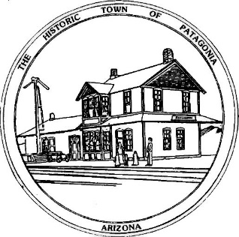

NOTICE OF MEETING AND PUBLIC HEARING

PLANNING AND DEVELOPMENT COMMITTEE

Pursuant to Articles 14-2-C-3 and 14-2-C-4 of the Code of the Town of Patagonia, Notice is hereby given to the General Public that the Planning and Development Committee of the Town of Patagonia will CONDUCT A PUBLIC HEARING TO CONSIDER THE FOLLOWING APPLICATIONS FOR USE PERMITS:

Zander and Heidi Ault are requesting a use permit to convert the former Pilates Building located at 295 McKeown Ave. into a Retail Bicycle Parts/Bare necessities to Bikers and Hikers with a beer and wine bar.

Mary Tolena is requesting a use permit to change 542 Harshaw Road to a facility for gatherings and events like workshops, camps and community meetings.

Aari Ruben is requesting a use permit for 436 Naugle Avenue to convert the former Cose Buone Restaurant to an Adult Use Marijuana Recreational Establishment.

SPECIAL MEETING AT 6:00 P.M. JULY 14, 2021

THE MEETING WILL BE HELD AT

TOWN HALL

310 MCKEOWN AVENUE

PATAGONIA, AZ

AND VIA ZOOM MEETING, I.D. 957-511-4862 PASSCODE # 338501

Dated this 29th Day of JUNE, 2021

_______________________________
Ron Robinson, Town Clerk

