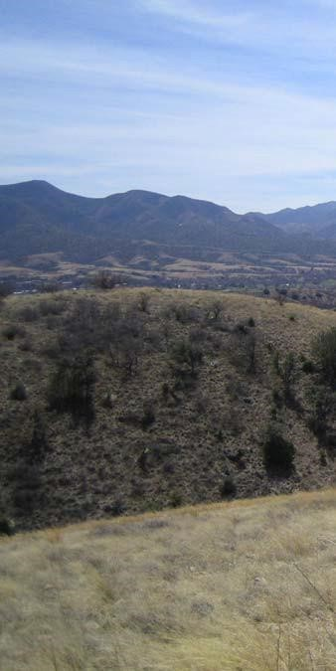
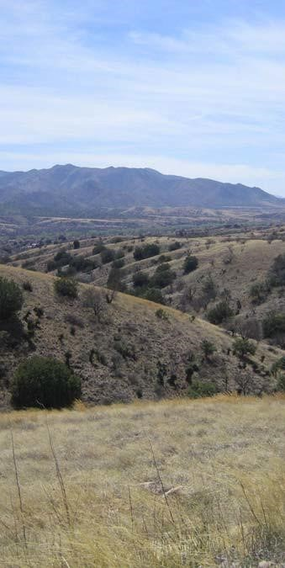
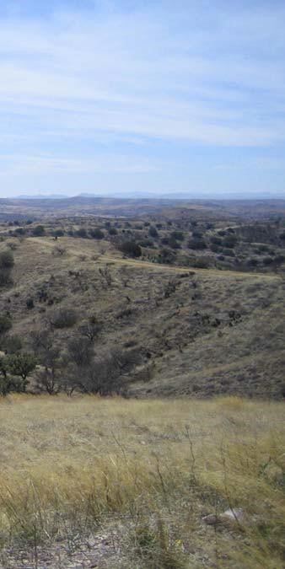
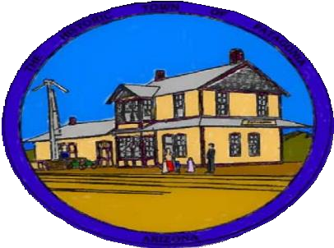
P
a
t
a
g
o
n
i
a

General Plan
2009
2020

0

RESOLUTION NO. 09-04

A RESOLUTION OF THE MAYOR AND COUNCIL OF THE TOWN OF PATAGONIA, ARIZONA, ADOPTING
THE TOWN OF PATAGONIA GENERAL PLAN UPDATE, A GENERAL PLAN FOR MUNICIPAL
DEVELOPMENT POLICY PURSUANT TO ARIZONA REVISED STATUTES, A.R.S. §9-461 ET. SEQ., ESTABLISHING PLANNING GOALS, OBJECTIVES AND POLICIES; AND CONSIDERING EACH OF THE PLAN ELEMENTS REQUIRED BY STATUTE AS WELL AS OTHERS DETERMINED ESSENTIAL BY THE TOWN.

WHEREAS, the Town of Patagonia desires to establish policies for continued improvement of living quality for its citizens, preserving its unique character, and guiding community growth in ways that are consistent with its citizens' values; and,

WHEREAS, an open public participation process has provided direction for Patagonia's future which was derived from the ideas, commentary, priorities, preferences, review and suggestions offered by residents, business people, civic organizations and representatives of local institutions; and,

WHEREAS, the General Plan Update serves as a framework for municipal preparedness and planning; and,

WHEREAS, the Town wishes to be in full compliance with the State of Arizona Growing Smarter legislation requirements; and,

WHEREAS, advisory comments pertaining to the General Plan document have been sought from those agencies and jurisdictions specified by A.R.S. §9-461.06(C) to be included in the sixty-day statutory review period and the written comments and public hearing testimony received pursuant to such required review have been duly considered; and,

WHEREAS, a public hearing to receive public comments on this plan was held by the Patagonia
Planning and Zoning Committee on January 20, 2009; and,

WHEREAS, this plan was then reviewed and additional comments were considered by the Town Council on February 11, 2009; and,

WHEREAS, a public hearing to receive public comments on this plan was held by the Town Council on February 25, 2009, at which time the Council tentatively approved the plan and directed staff to prepare the adopting resolution.

NOW, THEREFORE, BE IT RESOLVED BY THE MAYOR AND COUNCIL OF THE TOWN OF PATAGONIA, ARIZONA as follows:

Resolution No. 09-04
Page 2

SECTION 1. ADOPTION OF PLAN.

The Town of Patagonia hereby adopts the Town of Patagonia General Plan Update, Section I, General Plan Introduction, and Section II, General Plan Elements (Land Use Element, Circulation Element, and Energy and Water Resources Element).

SECTION 2. EFFECTIVE DATE.

The Town of Patagonia General Plan Update shall be effective from and after April 11, 2009 New Date.

PASSED AND ADOPTED by the Mayor and Council of the Town of Patagonia, Arizona, this 11th day of March 2009. New Date

Gary

H.

Gay,

ayor

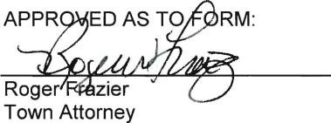

Acknowledgements

The Town of Patagonia 2009 General Plan was partially funded by a grant through the Arizona Department of Commerce. Supplemental funding was provided by the Patagonia Regional Community foundation with matching funds provided by the Town.

The following persons and committees were instrumental in preparing the 2009 General Plan:

Town Council
Meredith Aronson
Gary Gay, Mayor
Meg Gilbert
Kevin McKay
Gilbert Quiroga

Planning and Zoning Committee / General Plan Advisory Committee
Steven Smith, Chairman
Abbie Zeltzer
Adrienne Halpert
Saul Lieberman
Virginia Thiers

Other Important Contributors
Citizens of Patagonia
Mr. McKenzie’s Class, Patagonia Union High School
Randy Heiss, Patagonia Town Manager
Matthew C. Brown, Photos

The Plan was reviewed by the Town Planning and Development Committee, and minor amendments recommended to the Town Council in March of 2020. The Patagonia Town Council approved the revised Plan on (Date).

Table of Contents
- Introduction ................................................................................................................................. 1
  - Preface ..................................................................................................................................... 4
  - How to Use This Plan .............................................................................................................. 7 C. Patagonia’s Vision ................................................................................................................... 7
D. Citizen Participation ................................................................................................................ 8 E. Planning Assumptions and Principles ....................................................................................... 9
  - Plan Administration ................................................................................................................11
  - Statutory Plan Requirements ...................................................................................................17
- General Plan Elements ............................................................................................................... 18
  - Land Use Element ...................................................................................................................18
  - Circulation Element ................................................................................................................32
  - Energy and Water Resources Element .....................................................................................41

Formatted:

Space

Before:

0.15

pt
Formatted:

Indent:

Left:

0
",

Right:

0
",

Space
Before:

0.15

pt
David Williams, A.I.C.P Jeremy Knapp Stephanie Bernoski
Delete

Table of Contents ii Patagonia General Plan

List of Tables
Table 1—Major Plan Amendment Land Use Criteria Within Town Limits ........................................ 14
Table 2—Major Plan Amendment Land Use Criteria Outside Town Limits ....................................... 15
Table 3—2025 Growth Assumption for Patagonia ............................................................................. 19 Table 4—Traffic Volumes ................................................................................................................. 33
Table 5—Road Classifications........................................................................................................... 34

List of Figures
Figure 1—Regional Location .............................................................................................................. 3
Figure 2—Planning Area ..................................................................................................................... 5
Figure 3—Significant Features .......................................................................................................... 22
Figure 4—Future Land Use, Planning Area ....................................................................................... 30
Figure 5—Future Land Use, Incorporated Area ................................................................................. 31
Figure 6—Circulation Plan ................................................................................................................ 37
Lists of Tables and Figures iii Patagonia General Plan
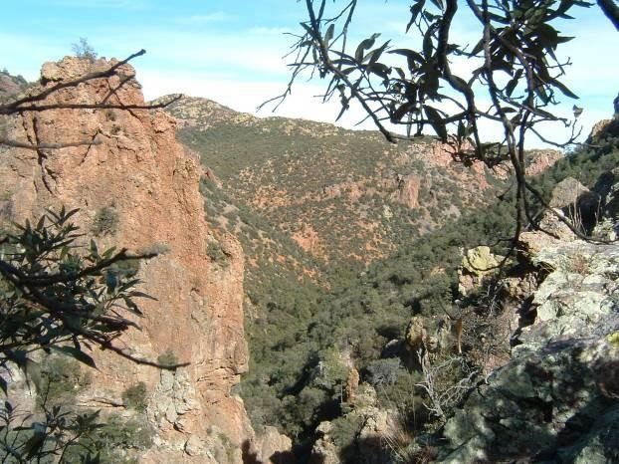
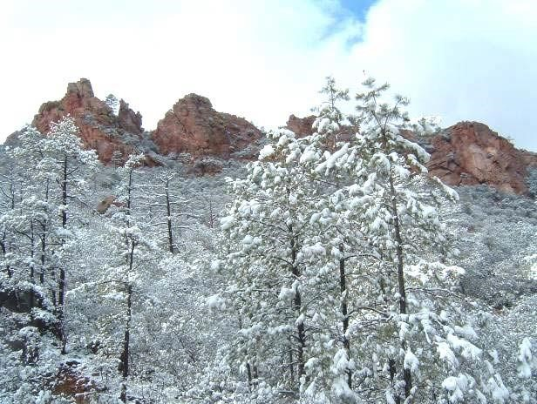

Patagonia General

Plan

1
Introduction

I.

Introduction

The Town of Patagonia is appropriately proud of its history and distinctive character. The
community
is quirky and likes it that way. Patagonia’s spirit is easily confirmed by a single visit. Situated at over
4
,000 feet elevation, among the hills south of the Santa Rita Mountains and in the riparian corridor of
Sonoita Creek, Patagonia is specta
cularly rich in both natural and human assets. Protecting and
‘sustainably’ building upon these unique assets and town character is the distinguishing vision of the
community.

Town and nearby county residents endeavor to maintain and enrich a symbi
otic and sustainable
relationship with their magnificent environment. The provision, locally, of jobs and affordable
housing, coupled with progressive environmental stewardship are keys to long
-
term sustainability of
the Town.

According to a report by
Arizona State University’s Morrison Institute:

“
Sustainability is the condition of existence which enables the present generation of humans
and other species to enjoy social well
-
being, a vibrant economy, and a healthy environment,
and to experience witho
ut compromising the ability of future generations of humans and other
species to enjoy the same.”
1

Patagonia seeks to be a sustainable community, as evidenced by citizen input during the development
of this General Plan. This citizen
-
driven Plan articulat
es the community’s agreed upon vision and
overall goals, and includes supporting policies and recommendations for specific actions that help
move the community towards its vision.

This General Plan is a vital document to the decision
-
makers and the citize
ns of Patagonia as the Town
moves forward. It supplies the outline needed to plan for the orderly and efficient development of the
Town, and the preservation and strengthening of Patagonia’s distinctive community character.

1

Source: Sustainability for Ar
izona: The Issue of Our Age,
Arizona Policy Choices 2007

General Plan Purpose
The primary purpose of the 2009 Town of Patagonia General Plan is to provide a tool for the community to guide decision-making and coordinate development, maintenance and preservation efforts over the coming 20-year period. The General Plan also responds to and exceeds Arizona's Growing Smarter statutory requirements.

Recognizing ongoing development pressure due to Arizona’s population growth, active mining proposals and the overall attractive living quality that characterizes Patagonia, the Mayor and Town Council formed a citizen-based planning committee. The committee, in conjunction with extensive public input, assisted in the development of a plan that expresses their vision of a unique, prosperous, and diverse community with adequate supporting services.

In its adopted form, the Patagonia General Plan shall serve as a general guide for the Town Council, the Planning and Zoning Development Committee, Town staff, citizens, as well as public and private interests regarding development in and around the Town of Patagonia.

The General Plan is intended to provide a framework for all of the interrelated functions of the Town of Patagonia. To help understand what a General Plan is and does, we can say:

The General Plan is:
- an expression of the spirit and vision of the community
- a framework for future decision making
- a means of preserving and enhancing quality of life
- a statement of Town policy
- a legal requirement under Arizona State Law

The General Plan is not:
- a tool to promote special interests
- a rigid, unchanging or inflexible document
- a detailed policy or ordinance for specific properties or areas - a zoning map

Patagonia welcomes users of The Patagonia General Plan. Inquiries regarding the General Plan should be made to:

Town Manager
310 McKeown Avenue, P.O. Box 767
Patagonia, AZ 85624 (520) 394-2229

Introduction 2

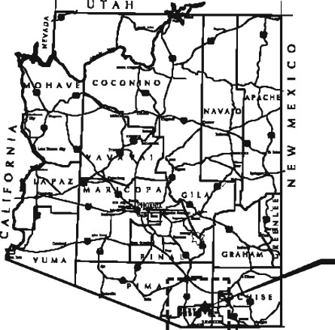
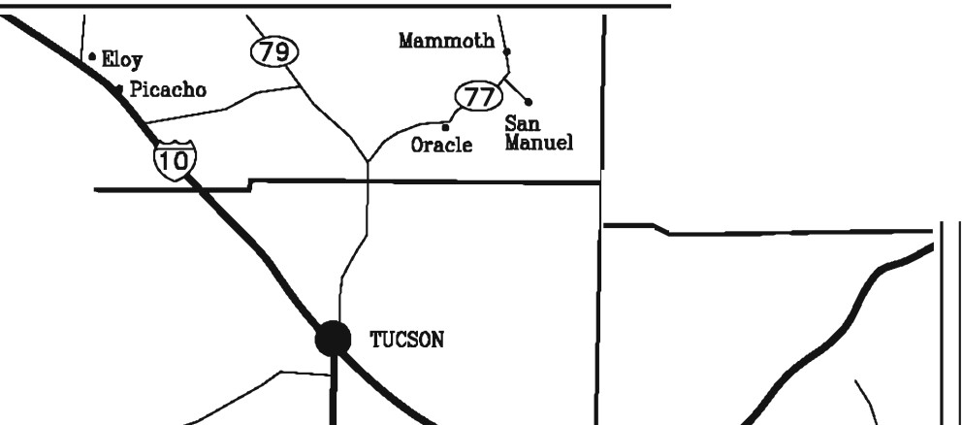
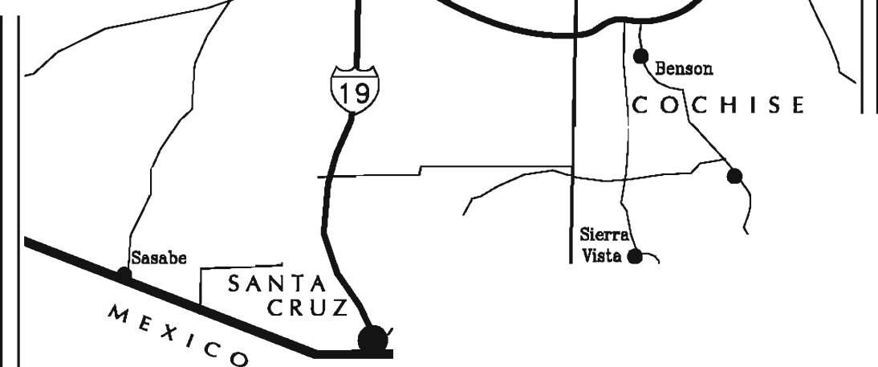

ARIZONA

,
\
f
E
,t

1

rr:11·1·11·r

-
■
-

•

Co

._

_.

h
Town of

Patagonia

GENERAL

PLAN

REGIONAL
CONTEXT

Town of
Patagonia

)

Safford

Pl NA

L

GRAHAM

PIMA

Tombstone

PAT.ONIA

@

Nogales

Palominas

@

-----
T"'Naco

FIGURE

1

Date:

9
-
2
-
2008

A. Preface
The Patagonia General Plan represents a statement of ‘who we are’ as a community and serves as an expression of expectations for the next twenty years. The content of this Plan is driven by citizen input and serves as a tool to help guide and shape the physical development, preservation, and maintenance of the Town.

Required by Arizona Statutes, the previous Patagonia General Plans was were created and adopted in 2001 and and 2009 by Patagonia’s leaders. The Plan and is required to be updated and re-adopted at least once every 10 years. The Patagonia General Plan conforms to the letter and spirit of Arizona’s Growing Smarter requirements, adopted in 2000, to guide municipal planning and growth management with enhanced public involvement.

Included within the Patagonia General Plan are two required elements: Land Use and Circulation, and a third, unique element: Energy and Water Resources. This third element was added at the direction of the Planning and Zoning Develpoopment Committee to provide clear emphasis on important community values and issues related to sustainable energy and water resources. These elements are intended to support the future needs of the community.

The Patagonia General Plan is a guide. The General Plan Elements are interrelated and intended to be considered collectively. It is important that the Plan Elements do not stand alone as users are strongly urged not to rely on select, excerpted statements. Rather, they are encouraged to consider all the subject matter of the Patagonia General Plan as a whole.

Patagonia, like many towns, is clearly impacted by activity in the immediately surrounding areas of Santa Cruz County. The Patagonia Planning Area expands the geographic base of Patagonia’s influence beyond the present town limits to these unincorporated areas.

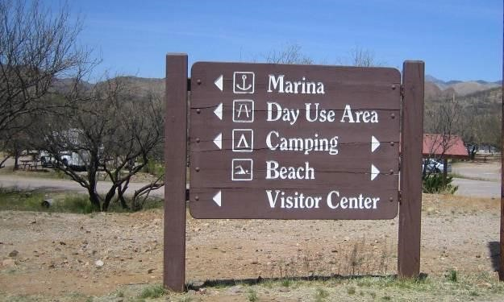
Coordination with Santa Cruz County plays a fundamental role in ensuring compatible and efficient development and adequate provision of essential infrastructure and services. The adopted Santa Cruz County Comprehensive Plan is fully supported by Patagonia and this General Plan. The Patagonia Planning Area (Figure 2) includes approximately 76 square milesextends three miles in all directions beyond the official town limits . The Town hopes must work to exert a positive influence on growth and development issues under Santa Cruz County’s jurisdiction. A strong, cooperative relationship between the Town and the County is crucial in implementing the agreed upon goals for both jurisdictions and ensuring the best possible living quality for Town and County residents and visitors.

Introduction 4

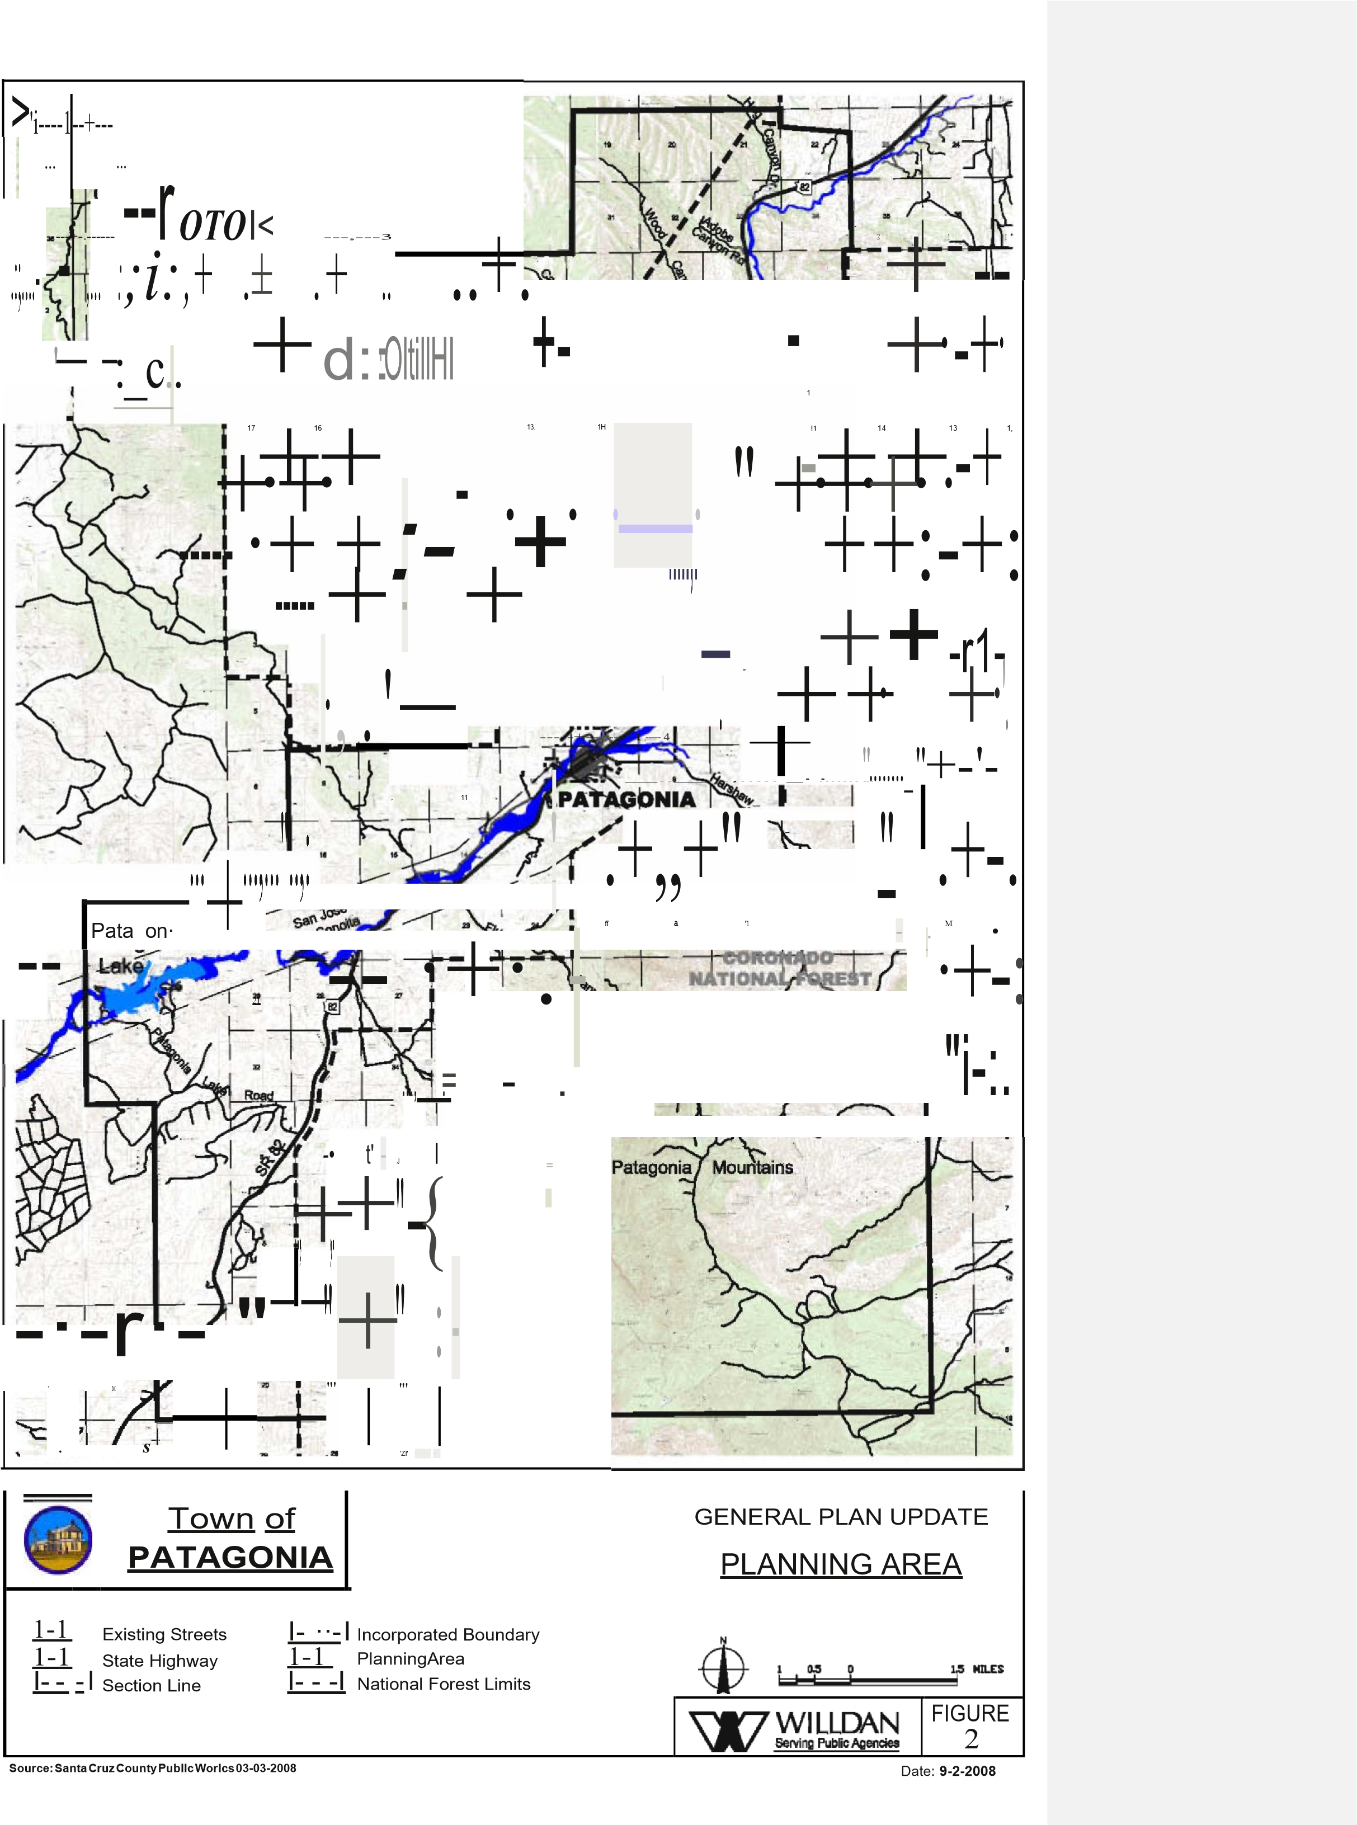

Local History²
The history of Patagonia has been shaped largely by local economic forces related to mining, ranching and tourism. The railroad that signaled the height of past economic times in the Town is gone, along with most mining activity. The 21st century has revealed the Town’s strongest asset- its people.

The Town was incorporated in 1948 with the prospect of receiving about $10,000 a year in State tax revenues for needed public improvements. Mining, cattle ranching, civic pride, and the New Mexico and Arizona Railroad, taken over by Southern Pacific in 1897, were the driving forces that shaped Patagonia through the 1950s. As many of these activities declined, the people of Patagonia coalesced to help each other and the Town. Local organizations such as the Woman’s Club and Rotary Club led efforts to preserve and maintain the Town. Included in these efforts where were the establishment of the Public Library, relocation of the historic train depot and dedication of the railroad right of way as a town park.

By the 1960 and 70s, tourism became the primary economic force in the Town. In 1968 the Sonoita Creek was dammed to form Patagonia Lake, now a state park. Patagonia has enjoyed popularity as a tourist destination with attractions such as Patagonia Lake, The Nature Conservancy’s Patagonia-Sonoita Creek Preserve, movie making, and outdoor recreation. The community has recently garnered a reputation as a growing arts community.

Beginning in about 2009 extensive mineral exploration has been conducted and significant deposits have been discovered at old mine sites in the Patagonia Mountains. The renewed potential mining activity could have a significant impact on the Town’s future development.

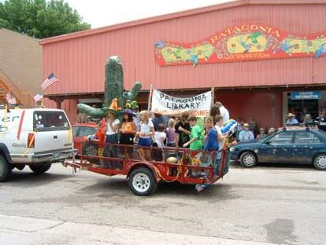
The Town has worked carefully to protect its character. Change has often been rejected when considered incompatible with the Town’s uniqueness. In return, citizens have supported the Town government and helped bolster revenues thorough volunteer efforts as major fiscal challenges faced Patagonia in the 1980s and 90s.

This Introduction Section contains:

The Town of Patagonia is resourceful, friendly and supportive. It is with these characteristics in mind, the community has prepared its General Plan.

- Guidance for using the General Plan document,
- Town Planning Vision,
- Basic Assumptions and Planning principles, and • Directions for administering the General Plan.

2
Excerpted from the Patagonia General Plan 2001 and Lisa Waite Bunker’s “The Early Years of the Patagonia Library:
1957-1976.”

B. How to Use This Plan
The Patagonia General Plan outlines a vision for Patagonia’s long-range health and sustainability based on the aspirations of the community. It is a general expression of the future Town of Patagonia. The Plan provides specific focus through the creation of an overall vision and the identification of strategic goals, objectives and specific implementing policies and recommendations to guide public and private decisions related to the development and the provision of services in the Town and in the Patagonia Planning Area.

The General Plan provides guidance to citizens regarding the physical development of the community. It allows public agencies and private interests to design projects that will enhance the character of the community, preserving and improving the overall quality of life for Patagonia residents. The Plan is a guide to Town management, Town departments, Town Council and the entire community.

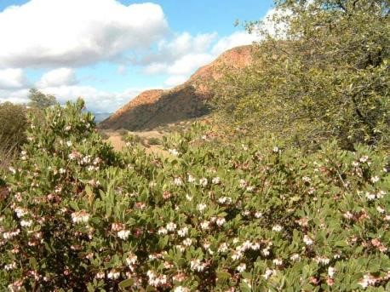
The Town of Patagonia General Plan is divided into two sections:
Section I: Introduction including:
- Preface
- How to Use This Plan
- Patagonia’s Vision
- Citizen Participation
- Planning Assumptions and Principles
- Plan Administration
- Statutory Plan Requirements

Section II: General Plan Elements including:
- Land Use
- Circulation
- Energy and Water Resources

C. Patagonia’s Vision
Through a series of public meetings, including three community-wide public workshops in 2001, a vision statement evolved from extensive citizen input. Citizens recognize the unique character of their Town and have identified those most cherished attributes that are to be built upon in the coming decades.

PATAGONIA’S VISION
Patagonia is a friendly small town in a scenic natural setting. The Town has a strong community spirit that encourages excellence in quality of life, education, and local businesses representative of the residents’ individualistic character. Patagonia is sustainable, ecologically and economically. Affordable housing, fiscal stability, environmentally sound building and business practices, and ecologically-based land stewardship are essential goals.

Patagonia values its unique and distinct character as evidenced by its community sense of humor and acceptance of individualism.

These ideas set a solid foundation for the planning assessments and recommendations that follow. Patagonia maintains a commitment to preserving its unique character and to continued living quality improvements.

D. Citizen Participation in 2009 Plan
The content of the Patagonia General Plan is citizen-driven. Public involvement served a vital role in determining the future directions Patagonia should take. Citizens of all ages and interests provided input during 2008 in identifying those aspects of the Town that are most important to preserve and improve.

In addition to Town staff, a General Plan Advisory Committee (GPAC) was utilized to provide direction and feedback for this General Plan. The Committee was composed of the Town’s Planning and Zoning Development Committee and held open meetings at which members of the community were free to comment, provide feedback and offer suggestions during the plan preparation process. The Committee met regularly over several months to provide guidance during plan preparation of the 2009 Plan.

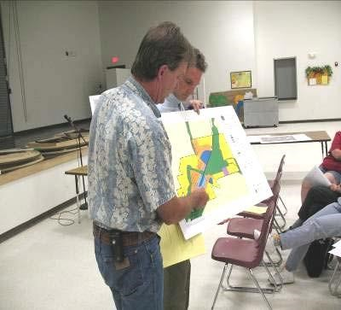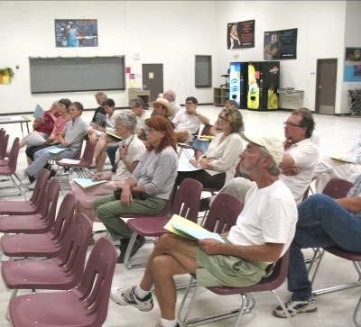
A concerted effort was made to include residents from various income levels, areas of the community, interest organizations and backgrounds. Notices were distributed widely in the small community and the Town’s library website was available to provide information.

The General Plan public participation process was highlighted by work sessions with the
Community Coalition of Eastern Santa Cruz County and with a classroom of students at Patagonia High School. Additionally, three community-wide public workshops addressed background and purpose of the Plan, identification of community assets, values and goals.

Approximately 90 informal survey forms were completed to help identify key points for the future vision and community issues related to each of the Plan Elements. Finally, citizens and high school students participated in a mapping exercise to chart future locations for homes, business and community facilities.

Student observations relating to Patagonia’s unique character and friendly people were particularly poignant. Community pride and a sense of place were revealed through student- completed surveys, comments and maps.

E. Planning Assumptions and Principles
The General Plan for Patagonia includes recommendations and analyses of current and future conditions. Due to potential economic and political changes throughout the region, the Town has little or no control over many external forces that will influence its future. Anticipating these changes, it is necessary to identify some of the more significant general conditions that appear likely to prevail in the future. There are a few fundamental assumptions that assist in organizing Patagonia’s General Plan principles. If the following assumptions prove to be incorrect, it may be necessary for Patagonia to re-evaluate goals and objectives identified in the
General Plan. Town development policies coincide with these basic directions.The Town Council asked the Planning and Development Committee to review the 2009 Plan and recommend possible changes in planning assumptions and plan elements based on current and potential future conditions. This 2020 Plan reflects the Committee’s recommendations for updates to the Plan.

Planning Assumptions:

- 1. The Town of Patagonia and the Patagonia Planning Area will continue to experience development pressure and an increase in total population. Development activity in Santa Cruz County, and residential construction in and around town are bringing more people to the area along with demands for services and goods.

- 2. The Town’s land use strategy is to continue to support mixed-use development and to not require separation of all land uses. The Future Land Use Plan (Figure 5) shows the community’s envisioned land use within the incorporated area. Actual future land uses will be determined based on compatibility of proposed land uses with existing uses through the issuance of Use Permits. Use permits will be required for all uses other than single-unit residential use. Use Permits are intended to further the goals and policies of the General Plan ensuring that primarily non-residential uses and structures do not adversely affect the integrity, enjoyment and quality of life of nearby residential uses. Use permitting is intended to protect the overall health, safety, welfare and character of the community while minimizing any infringements on individuality.
- 3. Patagonia will continue to support and embrace its unique small-town culture. The natural setting and friendly lifestyle of the Town meets the needs of individuals and families seeking the characteristics of a small town and rural lifestyle.

- 4. Resource extraction, mining, will continue to be a community and county-wide issue. A proposed mine in the Santa Rita Mountains, the Rosemont Mine, along with potential mining in the Patagonia Mountains and other areas, are significant threats to the natural environment, community character and public safety. Additionally, the Town’s tourism economy is strained by mining activity.Potential heavy industrial activity in the area surrounding Patagonia will continue to be a community and county-wide issue. Such activity could potentially threaten our natural environment, community character and public safety.

- 5. Agriculture, tourism and recreation will continue to be principal economic activities of the Planning Area. The area will continue ranching and cattle operations along with other agrarian and equestrian activities. Visitors will continue to travel through the area for its outstanding recreational opportunities.

- 6. Traffic will increase on State Highway 82 (Naugle Avenue) along with safety and noise concerns. As Santa Cruz County, and to a lesser degree Patagonia, continue to grow, average daily traffic, including truck traffic on Highway 82 in Patagonia, as the only through corridor, will increase.

- 7. The affordability of housing will continue to be a concern. Due to limited supply of in-town lots served by water and sewer, housing Housing affordability is expected to continue to decline. Current poor market conditions are temporary; rental Rental options are limited and housing costs overall continue to increase.

Planning Principles:
Patagonia’s planning process has established some basic principles that provide clear guidance for the community goals contained in each General Plan Element. These principals cannot be assumed; the Town must actively support them.

- 1. Ensure land use compatibility. To support continued excellent living quality in town, compatibility between neighboring land uses must be promoted and embraced by the community.

- 2. Alternative regulations including nuisance controls will be used to promote community livability and land use compatibility. The Town has established nuisance controls and will need to expand and effectively enforce those regulations. Proposed expansion of existing regulations should be carefully considered so as not to cause the Town to become an over regulated environment where free spirit and individualism is lost.

- 3. Encourage continued development of ecotourism and businesses related to environmental restoration activities. Closely study and reject mining (resource extraction) proposals, which pose a threat to the environmental, economic or cultural resources of the Patagonia area. The clear majority of planning process participants was passionately opposed to the development of new mining activity in Patagonia and the Patagonia Planning Area.
- 4. Seek diverse, locally-based economic growth. The Town clearly supports business and employment growth; but does not support large-scale or formula type business expansion in Patagonia. New businesses are preferred to be homegrown. Locally- owned and operated businesses are strongly preferred over standardized, formula businesses. Larger scale employment or commercial development is directed to the Nogales International Airport area, consistent with the Santa Cruz County Comprehensive Plan.

- 5. Ensure new development projects fit the character of Patagonia. Paramount in Patagonia is the desire to preserve community character. New development can be a threat to town character if it does not conform to basic architectural, size, location, layout and operational characteristics. Design review of proposed development is strongly supported.
- 6. Require all new development to pay their “fair-share” for infrastructure and Town services and that are needed supporting facilities and public improvements, onsite and offsite, are provided. to serve the development. Development proposals are expected to coordinate with and participate in costs of infrastructure and services. A fair-share approach is preferred with n New development is expected to construct or fund infrastructure, including major off- site improvements (roads, sewer and water lines for example) needed to support its residents.

- 7. Support Santa Cruz County in guiding appropriate residential, commercial and industrial development. It is increasingly important for Patagonia to be an active partner in development-related decision-making such as rezoningsrezoning and Plan Amendments under Santa Cruz County jurisdiction. The Town supports the adopted Santa Cruz County Comprehensive Plan.

- 8. Promote the use of sustainable energy and the protection of groundwater resources. Providing leadership and stewardship is important in employing new energy technologies and applications that improve community sustainability. Water is the most critical resource in Patagonia.

F. Plan Administration
The purpose of this section is to provide administrative direction, criteria and procedures for compliance with State Statutes. Plan maintenance and feedback on Plan performance are addressed as well.

1. General Plan Adoption
In accordance with Arizona Revised Statutes (9-461.06-J), the Patagonia General Plan is effective for up to ten years. The General Plan can be updated or readopted at any time at the discretion of the Town; however it must be updated or readopted within ten years from the date of adoption. As conditions change, including development patterns or the emergence of new technologies and economic trends, the General Plan will require a comprehensive update.
The Patagonia General Plan is adopted by a two-thirds majority vote of the Town
Council. At a minimum every ten years, a new General Plan or the currently effective
General Plan shall be submitted for adoption or re-adoption. Major amendments to the General Plan must also be approved by a two-thirds majority vote of the Town Council as further detailed in the following Major Amendment subsection.

The process of General Plan adoption entails three key steps. The Plan is provided to outside agencies including Santa Cruz County, the South Eastern Arizona Governments Organization (SEAGO), and the State Department of Commerce for a review period of at least 60 days. The Patagonia Planning and Zoning Development Committee will review the General Plan at a public hearing. Finally, the Patagonia Town Council holds a public hearing for final public comment and adoption.

2. Relationship to Other Plans
The General Plan provides direction across three Plan Elements. Future, mMore detailed functional Functional “Plans” for community design, water, wastewater, circulation, economic development or parks and trails plans for example, can serve to implement the General Plan. These plans should be consistent and provide refinements for individual functions, disciplines or geographic areas of the Patagonia Planning Area.

As other Plans are adopted they are intended to be integrated with the General Plan. Where greater detail and direction is provided in these Plans, such directions shall prevail and will be followed.

The Santa Cruz County Comprehensive Plan provides substantial, consistent direction for the unincorporated areas outside of Patagonia. The Patagonia General Plan overlaps the County Comprehensive Plan, providing a finer focus for planning issues most impacting Patagonia, and, as such, may be used by Santa Cruz County as additional guidance for decision-making.

3. General Plan Amendments
Frequent changes to the adopted General Plan are both ill-advised and, statutorily restricted. The General Plan was prepared with significant public input and analysis of existing conditions and community needs. Permitting multiple, uncoordinated alterations undermines the community’s investment in the planning process and is counter-productive to achieving the long-term, agreed upon vision for Patagonia.

There are two types of General Plan Amendments, Major and Minor. A Major Amendment is a revision to the Patagonia General Plan text or Future Land Use Plan that has far-reaching consequences on the use of land areas, demand on available infrastructure and services and/or substantially alters or is inconsistent with specified residential density or development intensity. A Minor Amendment is any other revision to the Future Land Use Plan or text that does not meet the criteria for Major Amendment as explained below.

Major General Plan Amendment
General Plan Major Amendments are governed by Arizona Statutes, ARS 9-461.06, D and G. The statutes allow Major Amendments to the General Plan once per year. The Planning and Zoning Development Committee shall hold a public hearing on Major Amendment(s). A two-thirds vote by the Town Council is required to approve a Major Amendment.

Furthermore, tThe statute defines a General Plan Major Amendment as a substantial alteration of the municipality's land use mixture or balance as established in the municipality's General Plan land use element.
Planning Statutes require municipalities to define the criteria to be used in determining if a proposed plan amendment effects a substantial alteration of the municipality's land use mixture or balance as established by the adopted General Plan.
Major Plan Amendments may be proposed to the Future Land Use Plan and text of the General Plan.

a. Major Map Amendment
The determination, if a map amendment is a Future Land Use Plan Major Map Amendment, are by two criteria. The criteria include land use and infrastructure.

Land Use Criteria
A Major Amendment to the Patagonia General Plan is any proposal that would result in a change of such significance as to substantially impact portions of the Town and/or its Planning Area. The criteria for determining whether or not a prospective development that differs from the adoptedchange in General Plan text and map will require a Major Amendment are based upon the relative size, in land area, and extent of change proposed. Acreages for Major Amendments (in Tables 1 and 2) are calibrated to locally appropriate thresholds. Criteria for determining a Major Amendment to the Patagonia General Plan include:

- Size in land area, and
- Extent in terms of development intensity or density and relationship to surrounding land uses.

The following changes in land use designations within the Town limits on the
Future Land Use Plan require a Major Amendment to the Town’s General Plan:

Table 1
Major Plan Amendment Land Use Criteria Within Town Limits
Current Designation | Proposed Designation | Acres to Trigger a Major  Amendment
Residential (Low Density, Medium Density) | Open Space | Not Major
Low Density Residential | Medium Density Residential | 10
Residential (Low Density, Medium Density) | Mixed use, Public Employment | 10
Mixed Use, Public, Employment | Any | 4
Open Space | Any | 2
*Please reference the Future Land Use Plan and Land Use Legend in the Land Use Element for descriptions of land use designations.

Table 1 represents the land use criteria for determining a Major Amendment for areas inside the Town limits and is separate from the infrastructure criteria. If the above thresholds are not exceeded, the amendment to the General Plan is considered minor and will be processed in accordance with the Town’s procedures for a Minor Amendment. Any aggregate change (total of all requested changes) of 40 acres or more will require a Major Amendment.

The Town has only an advisory role to Santa Cruz County regarding planning and zoning decisions in the unincorporated portions of the planning area. Town staff should request copies of zoning, plan amendment, subdivision plat, conditional use permits and site plan applications for property located within, at a minimum, 3 miles of the Town. A response letter should be provided back to the County addressing Patagonia’s planning and development-related comments on the proposed project. Table 2 lists the Major Amendment criteria for areas outside the Town limits and is intended to provide Town staff with guidance for input to Santa Cruz County when reviewing land use changes.
Table 2
Major Plan Amendment Land Use Criteria Outside Town Limits
Current Designation | Proposed Designation | Acres to Trigger a Major  Amendment
Ranch | Residential (Rural, Low Density, Medium Density) | 80
Ranch, Rural Residential | Mixed Use, Public, Employment | 25
Ranch, Rural Residential | Open Space, Resource Conservation | 320
Rural Residential | More intense Residential Category  (ex: Rural to Low Density Residential) | 40
Public, Employment | Any | 40
Open Space | Any | 20
Resource Conservation | Ranch, Residential (Rural, Low Density, Medium Density), Open Space | 20
Resource Conservation | Mixed Use, Public, Employment | 10
*Please reference the Future Land Use Plan and Land Use Legend in the Land Use Element for descriptions of land use designations.

Infrastructure and Service Criteria
Infrastructure and public services must expand to keep up with new development. Land use changes and amendments to the General Plan can have a range of impacts on public infrastructure and services. A General Plan amendment and development approval request that would place significant cost burdens on publicly funded services or municipal or private utility systems may be considered a Major Amendment. That is, where available capacities or funded capital investments for expansion (such as roads, bridges and drainage control) are insufficient to support the proposed development, the applicant would be required to pay for necessary improvements. A Major Amendment would be called for if infrastructure needs are not fully covered.

A General Plan Major Map or Text Amendment will be required when infrastructure demands are not offset by private investment or extensions to public systems. This applies in cases where the proposed amendment does not meet the minimum acreage criteria in Table 1 to trigger a Major Amendment, and the proposed amendment does not offset infrastructure and service demands as determined by the Town Manager or their designee.

b. Minor Map Amendment
General Plan Minor Map Amendments may be processed independently subject to Town policies and procedures. Minor Map Amendments are all General Plan map amendments not deemed as major using the land use, infrastructure and service criteria described above.

c. Text Amendment
Revisions to the General Plan text that help to clarify and implement the General Plan are a General Plan Minor Text Amendment. However, any text amendment that would change the dwelling unit density or intensity of any Land Use Category would be a Major Text Amendment. The General Plan Major
Text Amendment would be required to follow the same process as a General Plan Major Map Amendment. General Plan Minor Text Amendments will follow the policies and procedures as set forth by the Town.

d. General Plan Major Map/Text Amendment Process
The Town of Patagonia, in accordance with Arizona Statutes, will consider General Plan Major Map/Text Amendments at a single public hearing during the calendar year the proposal is made.

Application for a General Plan Major Map/Text Amendment will be in accordance with Town policies and procedures. The Town will provide the necessary forms and information, establish necessary fees, and will process the amendment request.

Public participation is critical to the processing of a General Plan Major Map/Text Amendment. A Public Participation Program, similar to the one applied to the General Plan preparation process, will be followed to achieve a high level of citizen participation.

The following is the basic process for a General Plan Major Map/Text Amendment:

- Applicants will attend a pre-application meeting with Town staff prior to submitting an application.
- Applications will be accepted from January 1 to June 30 for processing within that calendar year.
- At least sixty days before the Major Map/Text Amendment is noticed for
Planning and Zoning Development Committee Public Hearing, the
Town will transmit the proposal to the Planning and Zoning Development Committee and Town Council and submit a copy, for review and further comment, to Santa Cruz County Department of Community Development, South Eastern Arizona Governments Organization, Arizona Department of Commerce, and anyone who requests it.

- All Major Map/Text Amendments require a Planning and Zoning
Development Committee public hearing. The Planning and Zoning Development Committee will submit a recommendation to Town Council prior to the Town Council public hearing.
- Town Council public hearings to consider Major Plan Map/Text
Amendments will occur between October 1 and December 31 within the
calendar year the application was submitted.

- State Statutes require a two-thirds majority vote by Town Council to approve a General Plan Major Map/Text Amendment.

4. Biennial General Plan Report
The Patagonia Town Manager or his designee is responsible for compiling a Biennial Report monitoring the status of the General Plan, even in the event that no General Plan amendment has occurred. Included in the report should be an assessment of the validity of the goals and objectives and a progress statement on their incremental achievement. Problem areas or suggested updates should be detailed. The timing of the Biennial Report shall be established by Town policy.

The Planning and Zoning Development Committee actively participates in the review of the General Plan. The Committee should provide recommendations to Town staff and officials on suggested Plan refinements. Upon Committee review of the Biennial Report, it should be forwarded to the Town Council.

5. Plan Updates
In accordance with Arizona Statutes, ARS 9-461.06-J, the Patagonia General Plan Update is effective for up to ten years upon its adoption. The Plan can be re-adopted and/or updated at any time at the discretion of the Town. As conditions change the plan may require a comprehensive update.

G. Statutory Plan Requirements
The Town of Patagonia General Plan has been prepared according to Arizona Growing Smarter and Growing Smarter Plus statutory requirements.

The Patagonia General Plan contains the requisite two elements needed to satisfy the Growing Smarter/Plus requirements. The required elements are: Land Use and Circulation. The Town of Patagonia has also prepared a unique Energy and Water Resources Element, above and beyond minimum Growing Smarter/Plus requirements. All required Plan Elements respond to Planning Statute specifications including:

Land Use. The element designates the proposed general distribution, location, and intensity of residential, commercial, industrial, public and open space and agricultural uses. The Element supports development and redevelopment that reflects the character of the community.

Circulation. The element identifies the conditions and location of existing and proposed arterial routes, collector streets and other street classifications. The element discusses pedestrian, bicycle and transit services and facilities. The Circulation Element supports the proposed land use pattern outlined in the Land Use Element of the plan.

II. General Plan Elements
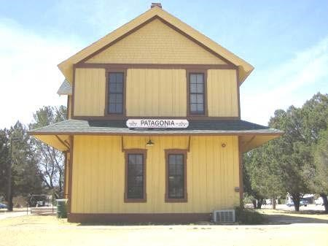
Plan Elements are the components that provide a logical structure for municipal planning. In Arizona, smaller municipalities like Patagonia are required to address two topical areas: Land Use and
Circulation. The Town of Patagonia has chosen to address an additional Element, Energy and Water Resources which are beyond the State's requirements but provide desired community
focus on sustainable community development. All Elements are considered to be interrelated parts of the entire framework for Patagonia planning.

A. Land Use Element
The Land Use Element establishes an outline for goals and objectives with following implementation policies and recommendations. This element designates the intensity, location and extent of public and private uses of land. In addition to addressing the distribution of land uses, this chapter addresses other closely related topics, including population, housing, and public service issues.
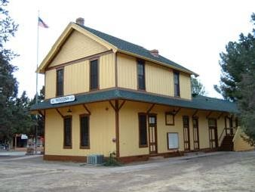

1. Future Conditions
This section details Patagonia’s preferences with regard to future growth and development patterns based on guidance from the Town’s General Plan Advisory Committee (GPAC) and well-attended public workshops in 2008.

Sustainable Development Preferred
Citizen input during preparation of the 2009 General Plan guided the creation of preferences for sustainable development. Development variables were evaluated by attendees at a community-wide General Plan Public Workshop and subsequently refined by additional GPAC and public input.

In 2009 cCitizen input expressed a preference for limited, moderate growth in Patagonia. No growth and rapid growth scenarios were rejected. Over the next 20 years, growth in both population and employment is expected and preferred to be limited to an increase of about 50%, or about 400 to 500 individuals. Such moderate growth was preferred 2 to 1 by process participants. These growth preferences are retained for this 2019 update of the General Plan.

Key Principles for future land use and the local economy included:

• 1. For areas that are approved for additional development in the unincorporated areas surrounding Patagonia, conservation-based communities are preferred over conventional subdivisions and development.
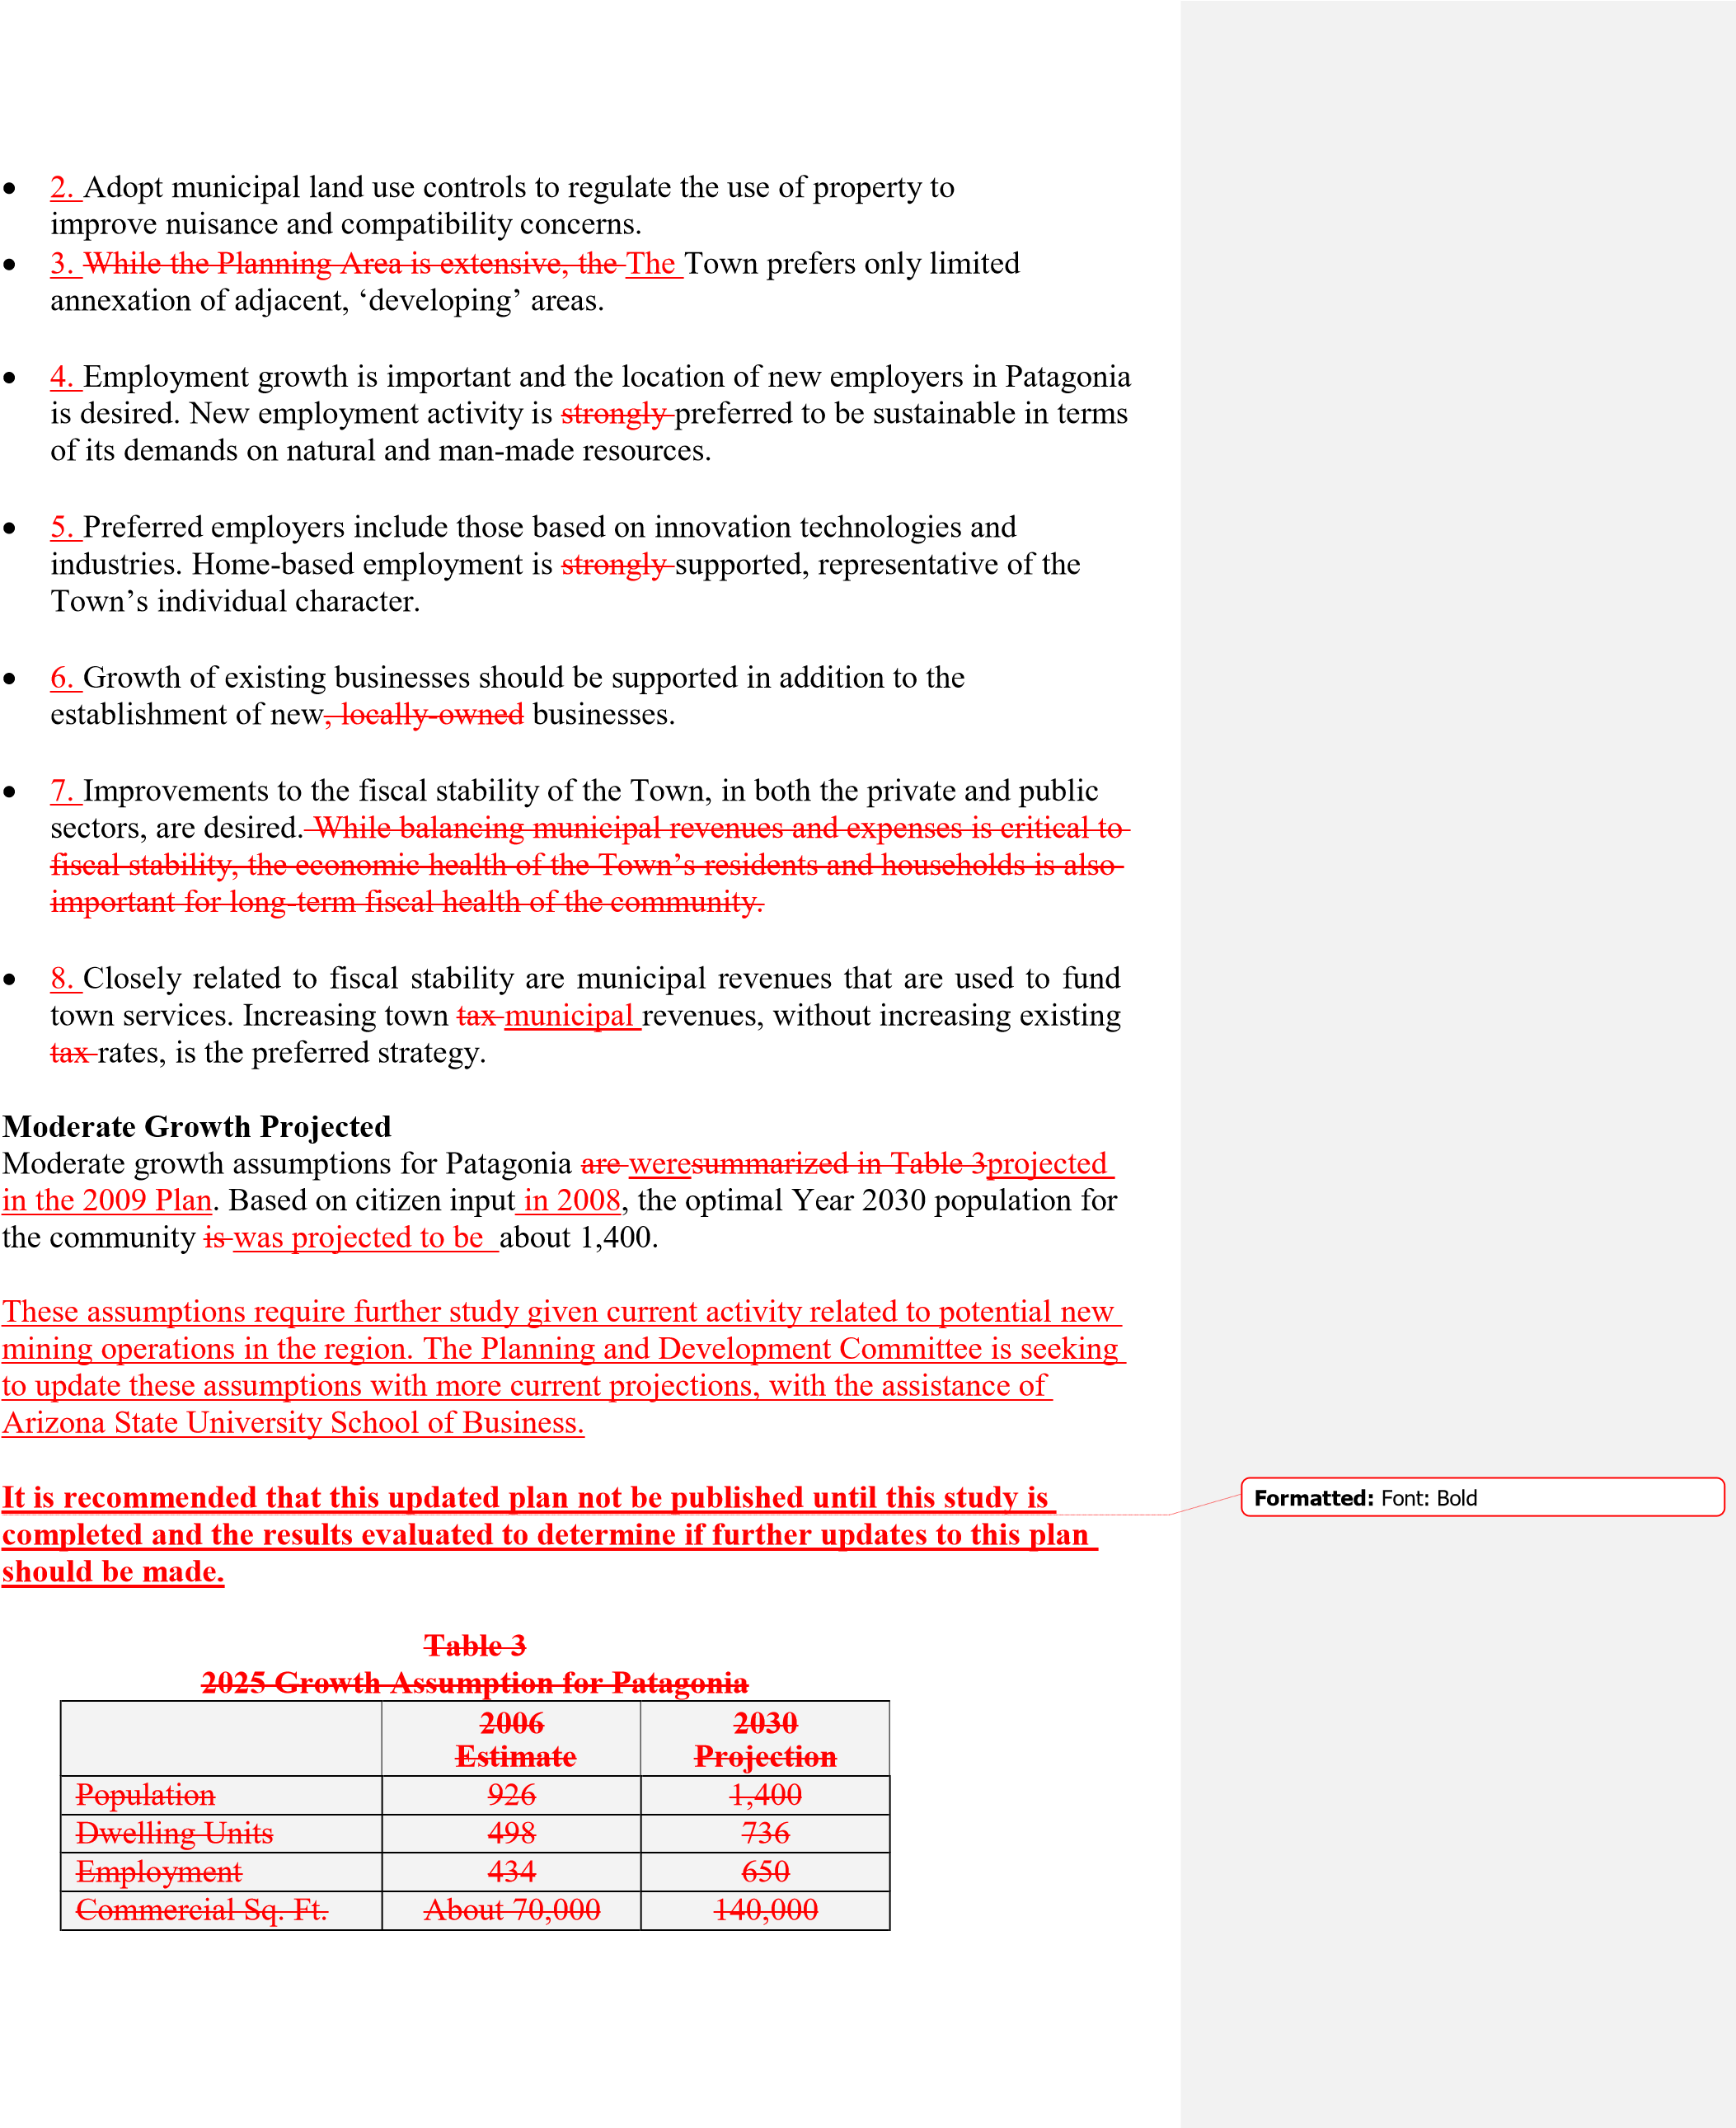
*
Data provided by Town of Patagonia and DES; projections by Willdan

The Town currently has about 1.9 persons per dwelling, relatively low for Arizona with an average of about 2.4 persons per dwelling. This figure is generally associated with retirement communities in Arizona. Many households in Patagonia have only one or two residents. The projection for Year 2030 uses 1.9 persons per household to project the future number of dwellings as a function of population growth. It may be reasonable to expect that household size will increase over the next 20 years, although Arizona’s status as a retirement friendly state almost assures continued growth in our retirement population, and hence, smaller household sizes. Square footage of future
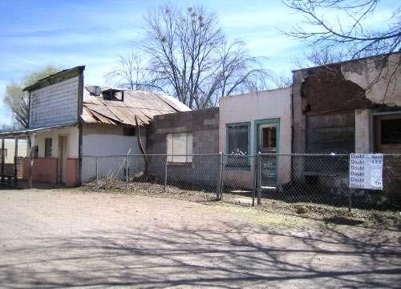
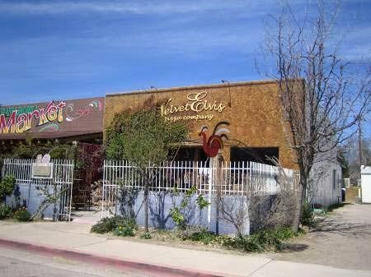
commercial uses has been estimated using a planning guideline of 200 square feet per
household, for a total of about 140,000 square feet in the year 2030.

2.

Current

Conditions

Land Use Patterns

The Town of Patagonia is
unique in Arizona
as it does not have the most commonly used
land use controls in the United States; zoning.
Zoning typically serves to segregate different
land use types, residential, commercial and
industrial. The purpose of zoning is to
mitigate or prev
ent conflicts among land use
types through segregation or the creation of
zoning districts.

Physically, Patagonia is split by Highway 82 (Naugle Avenue) and McKeown Avenue.
The Town is primarily residential. The majority of businesses, shops, restaurants,

and
other hospitality
-
related uses are located on Naugle and McKeown Avenues between
Second and Fourth Avenues. Moving away from the highway, uses are principally
single family residential with scattered home
-
based and small businesses. Home
occupations a
nd services based from homes, are common in town and can be found on
nearly every block.

The Town is also divided by Sonoita Creek, a significant riparian corridor in Southern
Arizona. The creek provides a substantial open space corridor including the Nat
ure
Conservancy’s Patagonia
-
Sonoita Creek Preserve. The Nature Conservancy properties
are located primarily west of town but do include a substantial area of land on the east
side of town at the confluence of Harshaw and Sonoita Creeks. The floodplain of
S
onoita Creek incorporates over one
-
half the area of the Town, significantly impacting
the character of Patagonia.

Without zoning, Patagonia has developed into a
truly mixed use community where homes,
businesses and commercial activities generally
co
-
ex
ist well. There are concerns in the
community regarding nuisances, character
preservation, and the protection of scenic views.
The Town has and will continue to creatively
address these issues through existing and future
Town ordinances, without the use of

zoning.

Services

Patagonia provides many services to Town residents. Some of these services benefit
County residents who live outside the Town limits. The Town provides police, fire,
library, public pool, water, sewer, sanitation, landfill, recreation/pa
rks, family health
services, and a senior center, among other services (See Figure 3, Significant Features).

Patagonia General Plan (This page corrected by the Patagonia Town Council, 3/10/10)

Providing services that county residents benefit from creates an additional demand on the Town without any additional revenue to offset service costs.

Presently the Town, in partnership with a variety of other entities, owns or operates the following services:

Services and facilities the Town owns and operates exclusively:
- Street maintenance
- Water system including wells, pumps, storage reservoirs and a distribution system,
- Wastewater system including treatment plant, lift station and collection mains,
- Patagonia Police Marshall Department including a part-time animal control officer, (the county owns the land)
- Landfill
- Town Park and gazebo & public restroom
- Cemetery
- Doc Mock Park
- Richardson Park playground
- Senior Garden apartments

Services and facilities the Town owns and operates with non-profit assistance:
- Library (Friends of Patagonia Library)
- Cady Hall (Patagonia Women’s Club)

Services and facilities owned by the Town, operated by other entities: • Patagonia Community Center (Senior Citizens of Patagonia)
- Family Health Center (medical services and maintenance by Mariposa Community Health Center., building maintenance by Family Health Center Amigos).
- Patagonia Community Garden (Patagonia Community Garden)(volunteers)
- Butterfly Garden (volunteers)
- Memorial Garden (Senior Citizens of Patagonia)
- Post office Rose Garden (the Town owns the land, Senior Citizens of Patagoniavolunteers)
- Recycle Center (the Town owns the land; Santa Cruz County owns and operates the facility.
- Post office (the Town owns the land, a private entity owns the building and leases it to the U.S. Postal Service)

Services and facilities the Town doesn’t own or operate but supports financially:
- Fire and emergency services (Patagonia Volunteer Fire and Rescue)
- Community pool (Patagonia School Districts)

Other funding activity:
The Town officially participates in discussions about grant-making from the Patagonia Community Development Fund of the Patagonia Regional Community Foundation.

Land Use 21 General Plan Elements

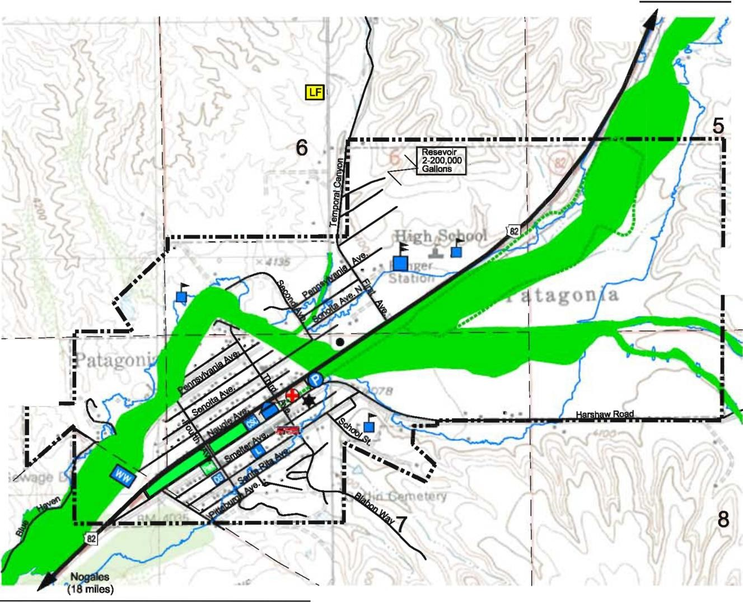  I  ■  --  ■■  -  ■  /  ....  Sonoita  (12  miles  )  ■  ■  ■  ■ | Town of  PATAGONIA  GENERAL PLAN UPDATE  SIGNIFICANT FEATURES  1-1 Existing Streets 1-1 State Highways  I• ■■• I Incorporated Boundary I-- -I Section Line  ---- Sonoita Creek Floodplain  Nature Conservancy Meta Trail  Town Hall  Post Office  Wastewater Treatment Facility  School  Police  Medical Clinic  Community Senior Center  Park  Landfill  Community Garden  Library/ Gady Hall  Fire Station  • Water Well  2:50' 0 1000' FEET l;;;;;;;;;;;;j !!!!!I  FIGURE 3
Source: Santa Cruz County Public Works 03-03-2008 Date: 9-2-2008

3. Land Use and Service Considerations
Primary land use planning and public service considerations in Patagonia include:

- 1. The compatible buildout and redevelopment of existing town lots and the wise use of remaining vacant lands. Preservation of community character and neighborhood livability, including scenic viewsheds, is essential.

- 2. The moderate to small scale of residential structures in Town should be maintained.

- 3. The development of standardized, formula-type businesses is not in character with the Town.

- 4. Zoning aside, the reasonable use of alternative regulations to promote public health, safety and welfare as well as compatibility among mixed uses.

- 5. Desire for sustainable, harmonious development, particularly in the unincorporated areas of Santa Cruz County near the Town. Cooperative planning efforts with Santa Cruz County and Nogales.

- 6. Addressing affordable housing needs and opportunities in Patagonia.

- 7. Prevention Monitoring of environmental and quality of life degradation impacts from new resource extraction operations including mining in the mountain ranges surrounding Patagonia.

- 8. Sustainability of town revenues and services as demand for services continues to increase. The costs of providing services continues to rise as the Town seeks sustainable revenue streams to support basic public services including police, water, wastewater and street maintenance.

- 9. Encouraging new development in areas where water and sewer infrastructure exists.

- Supporting healthy and growing local businesses and services that are clearly preferred based on citizen input, over non-local or formula businesses.

- 10. Sustainable employment and economic growth to improve household and municipal revenues.

- 11. Implementing appropriate design standards for commercial, industrial and, institutional development projects.

- 12. Impacts of the flood plain on existing buildings and new design and construction.

4. Goals, Objectives and Implementation Policies
Patagonia citizens clearly desire protection ofto preserve the character and qualities that are unique to the community including its friendliness and the celebration of individuality as
evidenced by locally-owned business and unique mixed-use neighborhoods. Identified issues for land use planning includes ensuring compatibility of mixed use neighborhoods, appropriate land use controls, appropriate scale and design of new businesses and new residential construction and housing affordability. Fiscal and environmental sustainability are recognized keys to the Town’s desired future. Patagonia’s land use goals and objectives promote the Town’s vision to enhance current assets, provide fiscal balance, and preserve community character and individuality. They stress the importance of retaining a distinctive identity as positive change is accomplished. The Town’s image as an excellent place to live is promoted and expanded in the overall strategy for preserving, adding and blending compatible types of residential and non-residential development.

Policies serve to provide action-oriented direction for implementing agreed-upon community objectives and goals. Responsibility for Plan implementation is community-wide including Town staff, elected and appointed officials, private interests and citizens.

Goal 1. PRESERVE COMMUNITY CHARACTER.

Objective 1: Promote living quality by ensuring compatibility among land use activities in and around Patagonia.
Policy: | Evaluate and improve regulations for controlling noise.
Policy: | Reduce public health and safety threats from utility installations.
Policy: | Work with Santa Cruz County to evaluate and establish Town minimum standards for air quality and odor control.
Policy: | Update and enforce animal control regulations. Seek funding assistance and intergovernmental support.
Policy: | Establish sign regulations to ensure outdoor advertising is compatible with community character.
Policy: | Partner with Santa Cruz County in developing and preparing zoning or other land use regulation changes impacting the Planning Area.

Objective 2: Promote development and redevelopment that is consistent and compatible with overall Town character.
Policy: | Establish clear and concise community design guidelines for non- residential construction.
Policy: | Prepare standards for formula businesses, including appropriate restrictions on locations, quantities, architecture, size and signs.
Policy: | Establish a review process, including a conditional use permit requirement, for construction proposals for all non-residential development.
Policy: | Preserve and renovate vernacular architecture where appropriate.
Policy: | Maintain consistent residential scale; very large residences are not consistent with the Town’s character.
Objective 3: Encourage infill development on properties served by Town infrastructure.
Policy: | Identify those vacant or under-utilized lots and parcels of land that are currently served by Town water, wastewater and paved streets.
Policy: | Offer reasonable incentives to promote infill development when in the Town’s best interest as determined by the Town Council.

Objective 4: Support affordable housing opportunities in Patagonia.
Policy: | Avoid actions that serve to reduce the stock of existing affordable housing options including rental properties.
Policy: | Encourage the construction of housing products such as attached townhomes and apartments in appropriate locations.
Policy: | Offer appropriate incentives for affordable housing such as permit fee waivers for new home construction.

Objective 5: Reduce the amount of light pollution created by human activity.
Policy: Prepare, adopt and enforce a light pollution control ordinance.
Policy: Provide public education and information on low-impact outdoor lighting techniques.

Objective 6: Maintain communication with Santa Cruz County regarding land use and development decisions impacting the Town and the Planning Area.
Policy: | Establish ongoing and timely communication with Santa Cruz County staff and Board of Supervisors regarding land use and development issues.
Policy: | Make recommendations consistent with the Town’s adopted  General Plan to the Board of Supervisors’s on  Comprehensive Plan amendment, rezoning, use permit and subdivision cases.

Goal 2. PROVIDE LEADERSHIP IN THE STEWARDSHIP AND PROTECTION OF THE RURAL CHARACTER AND SCENIC QUALITIES OF THE PATAGONIA AREA.

Objective 1: Protect significant natural resources including Sonoita Creek and Patagonia Lake.
Policy: | Evaluate public and private proposals and actions to determine impacts on the area’s watershed including Sonoita Creek,  Harshaw Creek, Red Rock Creek, and groundwater resources.
Policy: | For construction over 25 feet high, require viewshed analyses assessing potential impacts to important scenic views.
Policy: | Limit patio wall heights to four feet to preserve scenic views, allow taller walls only with a conditional review process.

Objective: Discourage mining and other activities that damage or detract from Patagonia’s environmental and scenic quality.
Policy:
Policy:
and policies.

Goal 3.
ITS RESIDENTS.

Policy:
Policy:
Policy:

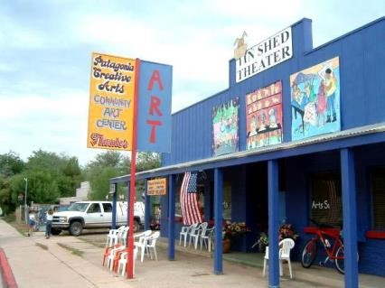
Policy:
Adopt formal opinions on development proposals outside the
Town that impact the area’s character or natural resources,
such

as the Rosemont Mine.

Provide input to agencies and other units of government
regarding Town preferences and development goa
ls, objectives
ENSURE LONG
-
TERM FISCAL STABILITY FOR PATAGONIA

AND
Objective

1
:

Support sustainable land uses that provide business and employment
opportunities for residents of Patagonia.

In cooperation with
area realtors, prepare and distribute an
inventory of appropriate, available sites for businesses,
industries and affordable housing options such as multi
-
family
residences.

Assess basic fiscal impacts of development proposals with regard
to expect
ed revenue generation and public service

costs.

Consider infrastructure contributions in determining impacts.

Continue to manage town resources conservatively while seeking
sustainable revenue streams to support town

services.

Objective

2
:

Capitalize on economic opportunities created by Highway

82.

Encourage
the
expansion of existing and
the
construction
development
of new, compatible,
locally
-
owned

businesses

within the Town and
planning area
.

Support tourist
-
based or other
employment or revenue
generating locally
-
owned, compatible, commercial

development.

5.

Land Use

Recommendations

Consistent with Land Use Goals, Objectives and Policies, the following
recommendations help guide Plan

implementation:

□

1.

Update Town Code
nuisance
regulations relating to animal control,
noise, outdoor lighting, air quality and
odor control. Include a public
participation process to ensure adequate
opportunity for citizen

input.

□

2.

Prepare and adopt Design

Guidelines

for residential and non
-
residential development to preserve and enhance the
character of the Town. Guidelines and standards are recommended for both
redeveloped
residential properties, as well as for commercial uses.

□

3.

Ensure new construction is designed in consideration of flood plain
Policy:

requirements as appropriate.
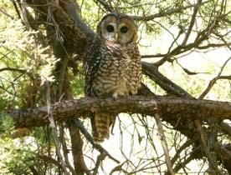
□

4.

Establish a conditional use permit process that includes design
standards for any formula
-
type businesses or other major projects that are
pro
posed. The process should include public hearings focused on compatibility
before the Planning
and
Zoning
Development
Committee and Town

Council.

□

5.

Remain proactive regarding land use proposals in the Planning Area. The
Town
has
adopted an official position on proposed mining
will continue to monitor
heavy industrial activity
in the area and should continue to formally communicate on
significant land use issues in Eastern Santa Cruz

County.

□

6.

Adopt limits on patio wall heights t
o preserve scenic views and promote
neighborliness. A maximum height of four feet is recommended with a process to
consider appropriate

exceptions.

□

7.

Monitor development proposals in Santa Cruz County, provide input to
Board of Supervisor’s decisions and

support the implementation of the Santa
Cruz County Comprehensive

Plan.

□

8.

Support proposals that provide, maintain, or improve affordable
housing opportunities in the

community.

□

9.

Identify suitable lots and support infill development or redevelopment
opportunities that are compatible and improve the efficient use of town

services.

□

10.

Analyze and consider fiscal impacts of development proposals. Explore
sustainable options for improving town revenues.

6.

Future Land Use Plan and Land Use

Legend

The Future Land Use Plan describes the types of future land uses accommodated within
Patagonia and the Town’s Planning Area. In some cases, future designations may not
match existing uses of land as future, preferred uses have been identified. The
following categories describe the land use designations used in the Town’s General Plan
and shown on the Future Land Use plans. Each designation identifies the intended
range and intensity of land uses. The land use categories used in the Patagonia Planni
ng
Area are intended to be consistent with the Santa Cruz County Comprehensive

Plan.

Non
-
residential uses, such as home
-
based businesses, have traditionally been a part of
the land use mix in residential areas of Patagonia. Those uses continue to be suppo
rted

in predominantly residential areas as long as they are relatively low impact and do not interfere with the enjoyment of property by neighboring owners.

Ranch – (R)
This category recognizes ranching and related activities as a major land use within the planning area. The principal land uses in this category are very low-density residential, ranching, agriculture, viticulture, low intensity/low traffic tourism, resource conservation and accessory uses. The maximum density of this designation is less than 0.025 dwelling units per acre, or one dwelling per 40 acres.

Rural Residential – (RR)
The rural residential category promotes the continuation of the rural character that is common across much of the Patagonia area. Rural areas may include farming and small scale livestock operations along with low density residential uses. The maximum density of this designation is .25 dwellings per acre, or one dwelling unit per 4 acres.

Low Density Residential – (LDR)
The low density residential designation accommodates semi-rural development. The maximum density of this designation is 1 dwelling unit per acre.

Mixed Use Residential – (MUR)
The mixed residential category is characterized by existing town neighborhoods of predominantly single-family homes co-mingled with small, home based businesses. Single-family attached, single-family detached and multi-family housing units are envisioned in this category. The maximum density of the category is 12 dwelling units per acre.

Core Area - Mixed Use – (CA-MU)
This designation is intended to provide the opportunity for a variety of land uses activities interspersed with one-another; primarily for higher density residential integrated with retail, services and employment uses in areas accessible to infrastructure and public services. Affordable housing is supported. Appropriate exceptions for higher density (greater than12 dwelling units per acre) affordable housing that meets community needs are encouraged. Division of lots or “lot splitting” in discouraged.

Public – (P)
The public category provides for public or institutional uses such as school campuses and their attendant facilities (playgrounds, ball fields, hard courts, etc.) hospitals, churches, water treatment facilities, landfill sites, public library facilities, Town offices, public cemeteries, infrastructure and utilities sites.

Employment – (E)
The employment land use category is a broad designation intended to accommodate numerous types of development including office and commercial uses allowing for varying scale and intensity. The scale and intensity of new development needs to be consistent with Town character. While a large facility, perhaps over 7,000 square feet, might be appropriate on Harshaw Road, it would not fit the character of the Town’s central business areas on Naugle or McKeown Avenues. Employment sites are to be integrated, through design and siting, with adjacent residential or other activities.

Open Space – (OS)
The open space category designation identifies open space sites and corridors intended for public recreation including parks and preserves. This designation includes developed parks, nature preserves, natural areas, and the floodway of Sonoita Creek. Where open space is designated for State Trust Lands, a minimum residential density of one dwelling per acre is recognized.

Resource Conservation – (RC)
The resource conservation designation is to protect existing public lands, preserve open space and to accomplish conservation objectives including land, air, water, forest, and wildlife resources. Maintaining and improving environmental quality in these areas is vital.

Town of  PATAGONIA | Ranch (40 ac/du)  .. .I Rural Residential (4 ac/du)  .... . Employment  Public  Open Space  --  ..  ......,I Resource ConseNation | GENERAL PLAN UPDATE  FUTURE LAND USE PLAN  PLANNING AREA  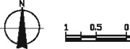  1,5 Nil.ES
-I Existing Streets
-I State Highway
- ··- I Incorporated Boundary -I Planning Area
- - -I National Forest Limits
- - - I Section Line
 |  |  | FIGURE 4
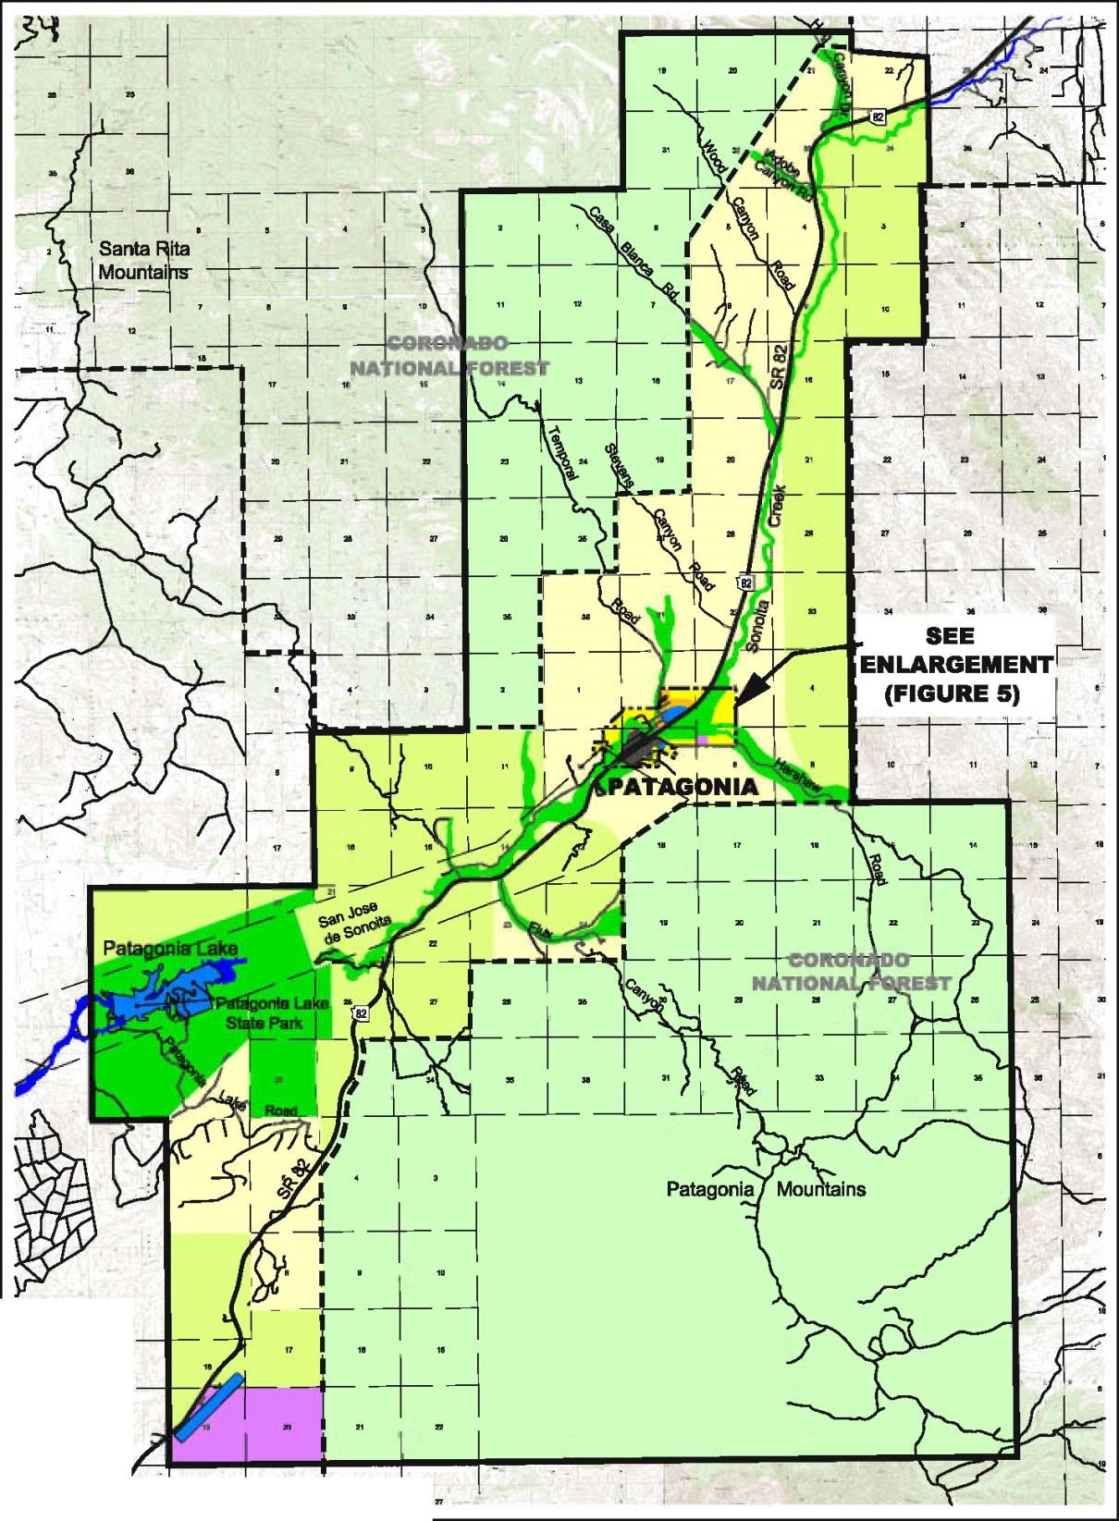
Source: Santa Cruz County Public Works 03-03-2008 Date: 1-29-2009

-
·1·

..

!!
I,

..

,

,•·
,

..

-

..

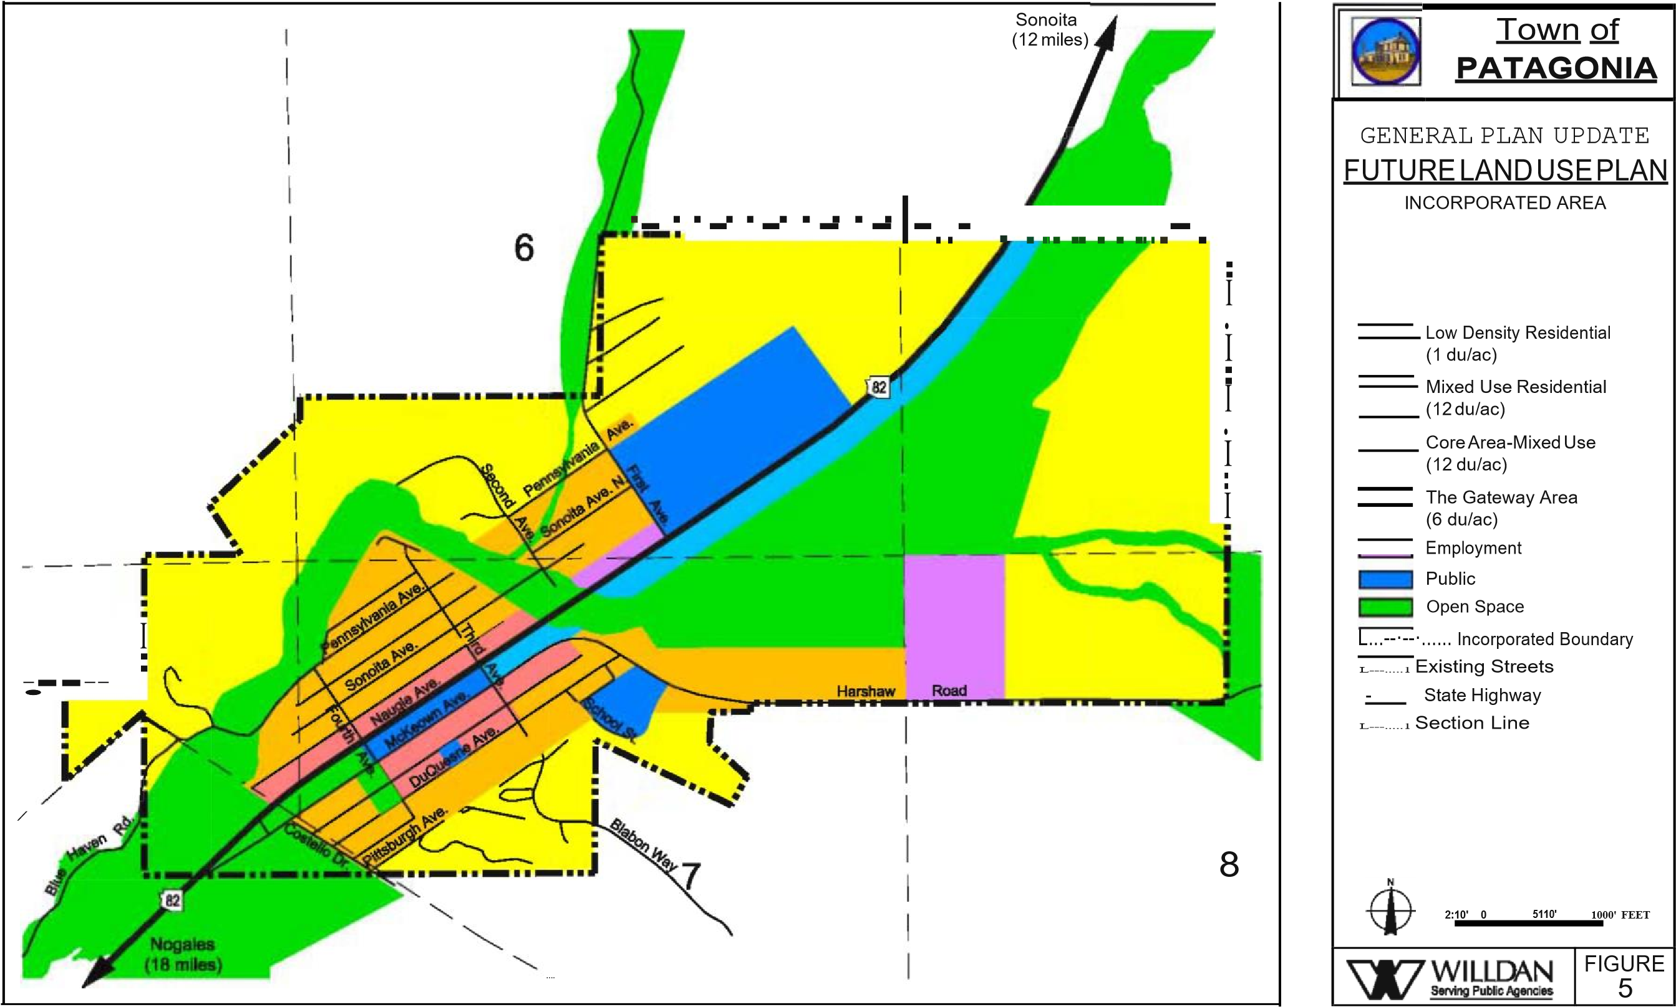
Source: Santa Cruz County Public Works 03-03-2008 Date: 2-17-2009

of travel.

1. Current Conditions
Patagonia’s circulation structure is primarily composed of a grid system of local streets and one State Highway, which runs through the center of town. Several roads, paved and unpaved, provide access to the surrounding unincorporated areas of Santa Cruz County including
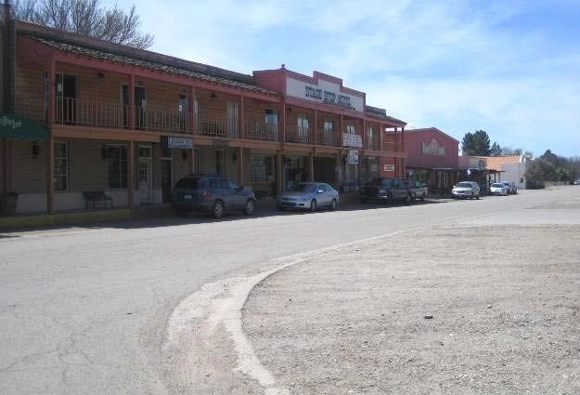
Harshaw Road, Temporal Canyon
B.

Circulation Element

The Circulation Element addresses anticipated short
-
term and long
-
term transportation and
circulation needs. It supports land use
goals and recommendations with intensions to ensure
the efficient movement of people and goods, to promote compatibility between transportation
modes and land use, and to reduce the adverse air quality impacts of transportation.

The Circulation Element is

integral to the other plan elements and has implications for future
development in the Town of Patagonia and the planning area. The element supports all modes

Haven Road. Traffic issues revolve largely around Highway 82 (Naugle Avenue) as it
serves higher volumes of through traffic, and of particular concern is truck traffic.

Highway 82 runs th
e north and south length of Patagonia’s planning area. It provides
access to Nogales, 18 miles south
-
west of Patagonia, where it connects with Interstate

19
. North of Patagonia, Highway 82 leads to Sonoita (approximately 12 miles) and
crosses SR 83. SR 83
connects to Interstate 10 at a point 23 miles to the north.

Patagonia is composed mostly of a compact town center with interconnected two
-
way
roads. Naugle Avenue (Highway 82), an ADOT maintained highway, functions as the
primary arterial
serving regional and local traffic. The highway runs the length of the
planning area.

Traffic calming devises, which help reduce speeds and improve pedestrian safety, are
used on Naugle Avenue entering/exiting Patagonia. Rumble strips on the inbound lane,

are located at both ends of Town. They serve to alert traffic to oncoming congestion
and pedestrian crossings by creating noise and vibration.

The same noise and vibration
is also a nuisance to Town residents as the sound of tire noise created by the pave
ment
modifications can be heard through most of the

community
.

There are no traffic signals in Patagonia and highway traffic does not stop when passing
through town. Stop signs provide intersection control.

Road/First Avenue, Red Mountain Court/S. Third Avenue and Blue
Regional Connections
Roadway Network
Traffic Volumes
Traffic volume is influenced mainly by two factors: population and land use, both of which are increasing throughout Arizona. These factors, along with economic and seasonal changes in truck traffic, are contributing to increased travel on all State Routes, including Naugle Avenue through Patagonia.

The Arizona Department of Transportation (ADOT) annually measures vehicular traffic on State highways. Traffic counts reported by ADOT for Naugle Avenue are shown in Table 4. In 2007, there were 2,200 300 to 2,300 200 average trips per day at the intersection of Third Avenue in Patagonia. In 2018 theses trips per day declined to 2,119 and 1,882, respectively. Trucks, both single and combo combined, comprised 9.8% of this traffic in 2018, or about 200 trucks per day. Comparable truck statistics are not available for 2007. ADOT projects these traffic volumes to increase to 3,417 and 3,000, respectively by 2040. Accordingly,

Table 4
Traffic Volumes
Highway 82 (Naugle Avenue) | Average Daily Traffic (ADT)
 | 2007 2018
North of Third Avenue (Sonoita) | 2,300 2119
South of Third Avenue (Nogales) | 2,200 1882
*
Source: ADOT, 2007 Traffic Counts
Due to increasing population and industrial activity at the Nogales port of entry, Naugle Avenue is expected to carry increased volumes of non-local traffic, particularly truck traffic, during the 20-year planning period. Iissues related to public safety and noise is are expected to grow as well.

2. Functional Classification
Most roadways in Patagonia are two-way local streets serving local facilities and residential neighborhoods. Nearly all of the local streets are paved and have a speed limit of 25 miles per hour, with the exception of McKeown Avenue, which is 15 miles
per hour.. The Town has five rural collector streets that are two lane paved roads:; First Avenue, Third Avenue, Fourth Avenue, McKeown Avenue and Harshaw Road, are two lane paved roads with 25 miles per hour speed limits.. Rural collectors provide internal circulation within neighborhoods and connections to the Highway. Naugle Avenue is the Town’s only arterial road. A large two-lane paved road, with a speed limit of 30-45 miles per hour., the The arterial supports higher traffic volumes and connects to the regional roadway system.
The following are examples of Patagonia streets and their functional classifications:

Table 5
Road Classifications
Street Name | Functional Classification
Highway 82 (Naugle Avenue) | Arterial
Third Avenue | Rural Collector
Fourth Avenue | Rural Collector
McKeown Avenue | Rural Collector
Harshaw Road | Rural Collector
Pennsylvania Avenue | Local Street
*
Source: Town of Patagonia and Willdan

3. Pedestrian and Bicycle Circulation
Non-motorized circulation is a pollution-free form of transportation that is fully supported by Patagonia citizens. Patagonia’s town layout and size provides many opportunities for alternate forms of transportation within the community including walking and biking.

Few roads in Patagonia include sidewalks or crosswalks. Many residents walk in streets or alleys in relative safety due to low traffic volumes. One crosswalk serves the Town, crossing Naugle Avenue at Third Avenue. A sidewalk is located along most of the north side of Naugle Avenue. Sidewalk additions and improvements are a priority for
Patagonia, and future enhancements will be identified in the Town’s Capital Improvement Plan.

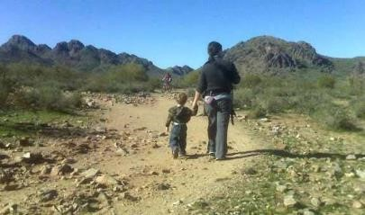
Patagonia currently has few pedestrian and bicycle pathways within Town. Under current circumstances, limited and disconnected sidewalks can make walking in congested areas along McKeown or Naugle Avenues unsafe. Crosswalks and intersection lighting may be needed at the busiest intersections including along Naugle Avenue and where student traffic is heaviest: near the community’s schools.
4.

Transit

Patagonia has very limited alternative transportation. The Senior Citizens of Patagonia currently operates a transportation program, restricted to low income and disabled persons and senior citizens.

5. Rail Service
There is no longer rail service in Patagonia. The New Mexico & Arizona Railroad, later bought by Southern Pacific Railroad, was built in the late 1880s and ran through the

middle of town, parallel to and south of the current highway Highway 82 alignment. The line ran
from Nogales to Sonoita mainly to serve prospering mines and cattle ranches in the area. While historic events surround the rail, it has been abandoned and dismantled for nearly over a half a century. The Town Hall and a significant amount of town property, including the Town Park, are former railroad properties.

6. Air Service
The Nogales International Airport is located approximately 10 miles southwest of Patagonia near Nogales. The general aviation airport is owned by Santa Cruz County and accommodates single and multi-engine and private aircraft and small jets. and It is becoming an increasingly busy facility. Although No no commercial passenger airlines serve this airport., commercial freight traffic is handled.

The County has designated the airport area a major, future employment center.

The Tucson International Airport (TIA), located approximately 50 miles northwest of Patagonia, is the closest airport accommodating commercial passenger aircraft.

7. Circulation Considerations
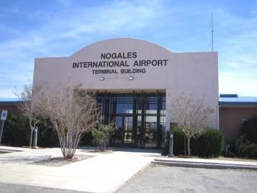
During the planning process the community identified circulation related issues including the following:

- 1. Truck Traffic
Through truck traffic on Naugle Avenue creates a major significant noise nuisance and, potential safety hazards and parking problems within Town. All traffic, including trucks, on Naugle Avenue is expected to increase in the future.

- 2. Traffic Signal Not Desired
Citizens prefer no traffic signals on Highway 82 due to additional noise and pollution created by starting and stopping traffic.

- 3. Safety Concerns
Pedestrian travel can be unsafe with limited sidewalk connections through Town and a single crosswalk across Naugle Avenue. Citizens have cited the need for additional sidewalks and crosswalks particularly for providing safe access to all schools.

- 4. Non-motorized Transportation
Citizens desire to Maintain maintain and enhance separate pedestrian, bike and horse pathways throughout Town. Future changes in the Town’s circulation system should reduce dependency on the automobile.
- 5. Speed Control
One of the most common concerns regarding traffic in Patagonia was is the need to improve closely monitor and maintain speed control. All traffic, including trucks, border patrol and cars were cited as ‘speeding through town.’ Higher traffic speeds contribute to traffic noise levels and threaten public safety.

- 6. Roadway Grading and Construction in County Areas
Additional review and improved permitting procedures may be needed to control the proliferation of new roadway grading and construction in County areas near the Town.

8. Circulation Plan
The Circulation Plan, coordinated with the Future Land Use Element Plan, indicates existing and anticipated future roadway improvements along with multi-use pedestrian trail and path locations. For Patagonia, improvements to make walking and bicycling enjoyable, safe and efficient will be as important as necessary street improvements.

The Circulation Plan includes a possible direct connection for Harshaw Road to Naugle Avenue intended to route truck traffic around downtown. The key to this improvement is an expensive bridge crossing of Sonoita Creek. Specific improvements related to drainage, paving and pedestrian crossings are indicated on the Plan.

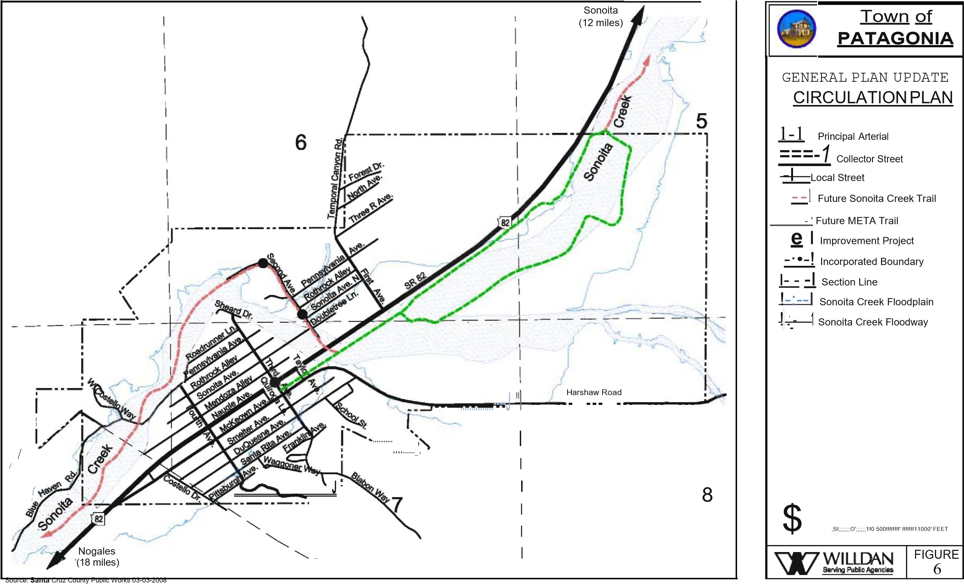
Date: 4-6-2009

9. Goals, Objectives and Policies
Circulation Goals and Objectives support citizen desires to develop a multimodal circulation system that will be both safe and efficient. Policies serve to provide action- oriented direction for implementing agreed-upon community objectives and goals. Responsibility for Plan implementation is community-wide including Town staff, elected and appointed officials, private interests and citizens.

Goal 1. ESTABLISH AND MAINTAIN A SAFE AND ENJOYABLE CIRCULATION SYSTEM FOR PEOPLE, BICYCLISTS, EQUESTRIANS, AND MOTOR VEHICLES.

Objective 1: Provide for in-town pedestrian circulation (sidewalks, paths, and trails) needs, including the needs of the elderly and handicap. .
Policy: | Identify and prioritize most needed sidewalks and bike paths.
Policy: | Systematically complete missing sidewalk links and install benches and other street furniture as appropriate.
Policy: | Partner with community service organizations in improving and expanding local trails.

Objective: Establish regional trail connectionsSupport the maintenance and development of local hiking and biking trails.
Policy: | Support the creation of a trail along Sonoita Creek from Sonoita to Patagonia Lake.Cooperate with the Arizona Trail Association to enhance the trail through the Patagonia region.
Policy: | Support the Mountain Empire Trail Association and other trail
development projects serving the Patagonia area.

Objective 2: Provide for bicycle and equestrian circulation needs.
Policy: Develop a non-motorized circulation master plan.
Policy: Identify routes, destinations and supporting facilities such as staging areas, bike racks and benches.

Objective 3: Provide adequate vehicular circulation systems including the State Highway, town streets and alleyways and County roads.
Policy: | Identify alignments, potential funding and appropriate timing for needed roadway improvements.
Policy: | Pursue funding opportunities for local street system maintenance and improvements.
Policy: | Adopt off-street parking requirements for new homes.
Policy: | Coordinate Town and ADOT roadway improvement projects.

Goal 2. MINIMIZE NEGATIVE IMPACTS FROM OF STATE HIGHWAY 82 TRAFFIC.

Objective 1: Reduce noise and roadway deterioration impacts.
Policy: Initiate Maintain high-profile enforcement of Town speed limits on Naugle Avenue.
Policy: Explore and implement additional traffic calming and noise
reduction options.
Policy: | Identify techniques, includingConsider local regulations, to reduce noise associated with truck operations, including enginebraking including vehicle operation techniques..
Policy: | Work with ADOT to update operational and traffic control for the portion of Highway 82 impacting the quality of life in Patagonia.
Policy: | Study and implement noise attenuation alternatives including the use of barriers and native plants along the highway right of way.

Objective 2: Expand and enhance safe crossings of Highway 82.
Policy: Upgrade the existing pedestrian crossing at Third Avenue and Naugle Avenue.
Policy: Identify locations and needed design features for additional crossings of Naugle Avenue.

Goal 3. ENSURE ACCESS TO SAFE AND CONVENIENT TRANSIT AND AIR FACILITIES.

Objective 1: Support safe operations and appropriate, employment-based land uses at the Nogales International Airport.
Policy: Work with Santa Cruz County and the City of Nogales to ensure implementation of the preferred employment uses adjacent to the airport.
Policy: Provide feedback to Santa Cruz County on operational impacts.

Objective: Provide a safe place for helicopter operations in Town for emergency service.
Policy: Establish guidelines and adopt restrictions on helicopter operations.
Policy: Identify primary and secondary helicopter landing areas.

Objective 2: Improve transit services.
Policy: Support regional efforts to establish transit service.
Policy: Partner with non-profit and for-profit transit providers where a public benefit can be shown.

10. Circulation Recommendations
Consistent with Circulation Goals, Objectives and Policies, the following recommendations help guide Plan implementation:

- 1. Initiate Maintain a high-profile enforcement program, including signage, to reduce truck speeds on Naugle Avenue.

- Study and implement a noise-limiting ordinance for trucks and other vehicles traveling through Town.

- Consider extending the 30 mile per hour speed zone to a longer length of highway, perhaps the entire Town limits.
- 2. Maintain a working relationship with ADOT officials with primary focus on pedestrian crossing and truck noise improvements. Pursue agreements with ADOT for additional restrictions or traffic calming on Highway 82.

- 3. Identify and prioritize, based on public safety benefits, the most needed sidewalk, pathway and trail improvements. Support to the greatest degree feasible, community trail improvement efforts.

- Construct sidewalk improvements for the south side of Naugle Avenue.

- 4. Adopt an off-street parking/alley a policy requirement requiring for new home construction to provide off street parking in order to improve circulation and emergency vehicle access.

- 5. Prepare a Circulation Master Plan to document community preferences and coordinate efforts to improve vehicular and non-vehicular circulation. Transportation related issues such as noise attenuation, transit and special needs services should be considered.

- 6. Work with ADOT to encourage trucks to use I-19 as an alternate route and support study of the Tucson I-10 truck bypass.

- 7. Expect developers, including projects located in the County and impacting Patagonia, to participate in financing and/or constructing new, off-site transportation facilities and other infrastructure, including bridges, drainage structures and wastewater systems that serve their projects.

- 8. Promote transportation services for non-driving public including seniors and youth. Participate in regional communications and efforts to improve transit services.

Utilizing available energy resources efficiently and supporting the development of renewable energy sources provides a long term benefit to all community members. Similarly, while Patagonia has adequate water supplies today, wise use and conservation are key. This Element addresses basic energy and water resource needs that not only apply locally in Patagonia, but are reflective of global issues as well.

1. Existing Conditions
Energy
Sulphur Springs Valley Electric Cooperative provides electric energy service for the greater Patagonia community. Demands for energy are generally increasing as population in the Patagonia Planning Area, and southern Arizona increases. While electrical service is readily available, customers do experience occasional interruptions in service. Some homes provide their own electrical power through individual solar collection systems.
Water
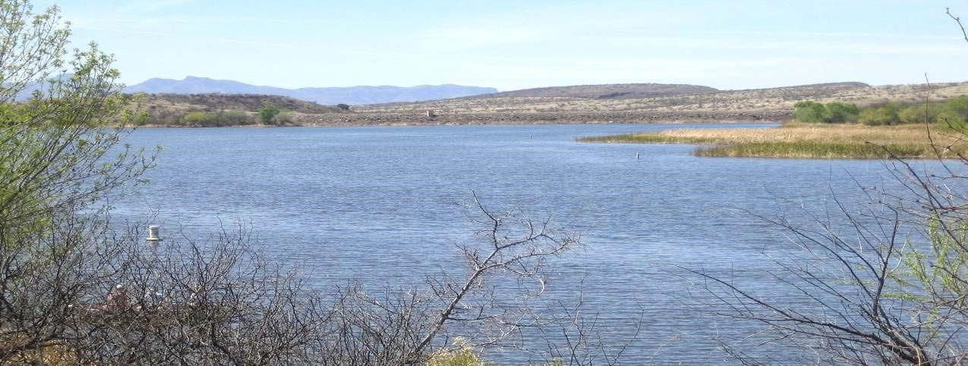
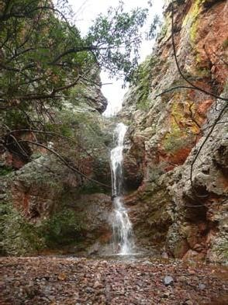
The Town of Patagonia is the water provider for area provides water for most Town residents. An assured water supply requirement is in affect for all new development. The Town water supply is served by the Sonoita Creek and Harshaw Creek drainages. The U. S. Forset Service has designated these drainages, which encompass 89,000 acres, as the Municipal Watershed of the Town. The Town’s system includes 2 wells, pumps, two storage facilities and distribution system. Total reservoir capacity is 400,000 gallons. There are about four five and a half miles of distribution pipe and approximately 420 426 connections. Water resources are derived from groundwater pumping from the Sonoita Creek Basin.
C.

Energy and Water

Resources

The Town produces effluent from its wastewater treatment plant on Costello Avenue. Currently, effluent, which meets federal water quality standards, is not re-used in the community and is released into Sonoita Creek.
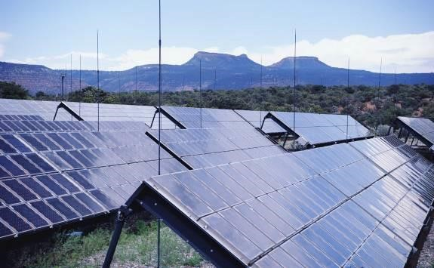
The
Planning Area

region

includes significant surface water resources in Sonoita
Creek
, Harshaw Creek

and Patagonia Lake. Sonoita Creek has been the subject of
extensive conservation efforts and currently includes The Nature Conservancy’s
Sonoita Creek Preserve, a significant env
ironmental, recreational and educational
resource in the community. Patagonia Lake State Park provides a valuable regional
recreation opportunity and is a significant water and wildlife habitat resource.

2.

Energy and Water Resources

Issues

Planning
considerations for energy and water resources in Patagonia include:

□

1.

The community desires improved sustainability and is poised to provide
leadership on energy and water resource management.

□

2.

Protection of water quality for surface and groundwater r
esources is

paramount.

The Town needs to be very vigilant of any industrial or other activity in the
Sonoita/Harshaw creek drainages that could impact water quality or availability.

□

3.

Achieving conservation of water resources through efficient plumbing a
nd
outdoor water use reduction programs.

□

4.

Development of alternative energy sources including solar and wind;
reducing dependence on fossil

fuels.

□

5.

Improved reliability of existing electrical service and the establishment of

provider
-

based energy
saving and solar credit

programs.

□

6.

Implementation of Green Building practices.

3.

Goals and

Objectives

Energy and Water Resource Goals and Objectives support citizen desires to promote the
use of sustainable energy sources and protect the community
’s most valuable resource:
water.

Policies serve to provide action
-
oriented direction for implementing agreed
-
upon
community objectives and goals. Responsibility for Plan implementation is

community
-
wide including Town staff, elected and appointed
officials, utility providers,
private interests, and citizens.

Goal 1. IMPROVE ENERGY EFFICIENCY AND PROMOTE
SUSTAINABILITY OF THE BUILT ENVIRONMENT IN PATAGONIA.

Objective: Promote sustainable building practices and techniques for residential and non-residential construction, including existing home and business improvements/expansions.
Policy: | Explore and implement retro-fitting Town facilities to reduce energy and water use.
Policy: | Adopt updated plumbing and energy codes that reduce energy and water use.
Policy: | Promote green building practices and the adoption of a green building program for Patagonia and Santa Cruz County.
Policy: | Carefully evaluate new power transmission line proposals regarding environmental impacts and service/capacity improvements.

Goal 2. SUPPORT THE USE OF SUSTAINABLE ENERGY SOURCES IN PUBLIC AND PRIVATE APPLICATIONS.

Objective: Encourage the use of sustainable energy applications for residential and non- residential construction.
Policy: | Provide information and other assistance on available federal, state, and other solar and wind energy grants.
Policy: | Identify alternative fuel suppliers and sources available to community members.
Policy: | In conjunction with Sulphur Springs Valley Electric Co-op, develop incentives to reduce energy use and promote renewable energy use.

Objective: Provide leadership in the development and use of sustainable power.
Policy: | Promote the creation of a public-private partnership dedicated to the development of a sustainable power generating facility.
Policy: | Provide citizen education programs on reducing energy and water use.
Policy: | Promote the use of basic energy saving devices like outdoor clotheslines.

Goal 3. SECURE AN ADEQUATE WATER SUPPLY FOR THE COMMUNITY.

Objective: Preserve the quality and quantity of community water supplies.
Policy: | Work with the Arizona Department of Water Resources, Arizona Department of Environmental Quality and other agencies to manage local groundwater quality and supply.
Policy: | Discourage Closely monitor industrial, such as mining, and other development that could negatively impacts ground and surface water quality.
Policy: | Protect surface water resources including Sonoita Creek and Patagonia Lake.
Objective: Promote community water conservation.
Policy: | Require the use of water saving devices in new construction and building additions through Town building codes.
Policy: | Promote the use of water harvesting techniques on properties throughout town.
Policy: | Study the area’s water resources to determine ‘safe yield’ amounts and provide direction for future land use decisions.

6. Recommendations
Implementation of General Plan Goals and Objectives can reduce community dependence on fossil fuels, improve environmental conditions and protect valuable water resources. The following recommendations help guide implementation:

- 1. Adopt any updated plumbing code requirements requiring water saving devices in new construction and expansions to existing structures.

- 2. Implement water harvesting program with a goal of adopting standards for new construction.

- 3. Monitor development and other activities in the watershed supporting the community for the purposes of preventing negative impacts to the area’s water supply.
- 4. Work with the U.S. Forest Service to conduct a comprehensive ground water study before any industrial activity proposing to use water from the Sonoita/Harshaw creek drainage commences. The study should include a baseline metal determination and flow rate from both drainages. The Town should request that this study be paid for by the proponents of the industrial activity and that the contractor/hydrologist be chosen by the Town and work under the direction of the Town Manager.

- 5. Provide educational programs and materials supporting water and energy conservation techniques, including resources and suppliers of alternative fuels available to Patagonia residents.

- 6. Promote the development and use of solar, wind and other sustainable energy technologies.

- 7. Encourage construction to areas where water/wastewater infrastructure is in place.

- 8. Require new development to fully fund the cost of needed system improvements for water and wastewater service.

