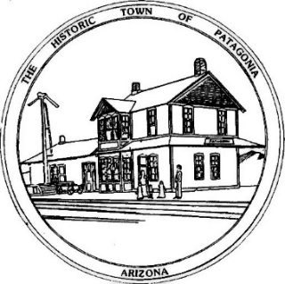
TOWN OF PATAGONIA
PLANNING AND DEVELOPMENT COMMITTEE SPECIAL MEETING
AGENDA, APRIL 6, 2021 7:00 P.M.
Zoom Meeting I.D. 957-511-4862 Password 338501

1. CALL TO ORDER

2. ROLL CALL

3. CORRECTION AND/OR APPROVAL OF MINUTES FROM: FEBRUARY 2, 2021

4. CALL TO THE PUBLIC

5. CHAIR PERSONS REPORT ON CURRENT EVENTS

OLD BUSINESS

6. DISCUSSION AND POSSIBLE RECOMMENDATIONS RELATED TO SUPPORT S.I.T.A. (THE ORGANIZATION WHICH PROMOTES TOURISM), THE NEED FOR A LARGER VISITOR CENTER, AND THE FUTURE OF EVENTS AS THE FALL FESTIVAL AND OTHERS.

7. DISCUSSION OF COMMITTEE “GUIDE BOOK” ON USE PERMITS AND OTHER DUTIES OF PLANNING AND DEVELOPMENT.

NEW BUSINESS

8. DISCUSSION AND POSSIBLE RECOMMENDATIONS RELATED TO TERMS, AND POSSIBLE STAGGERED TERMS, FOR THE P & D COMMITTEE.

9. FUTURE AGENDA ITEMS

10. ADJOURN

