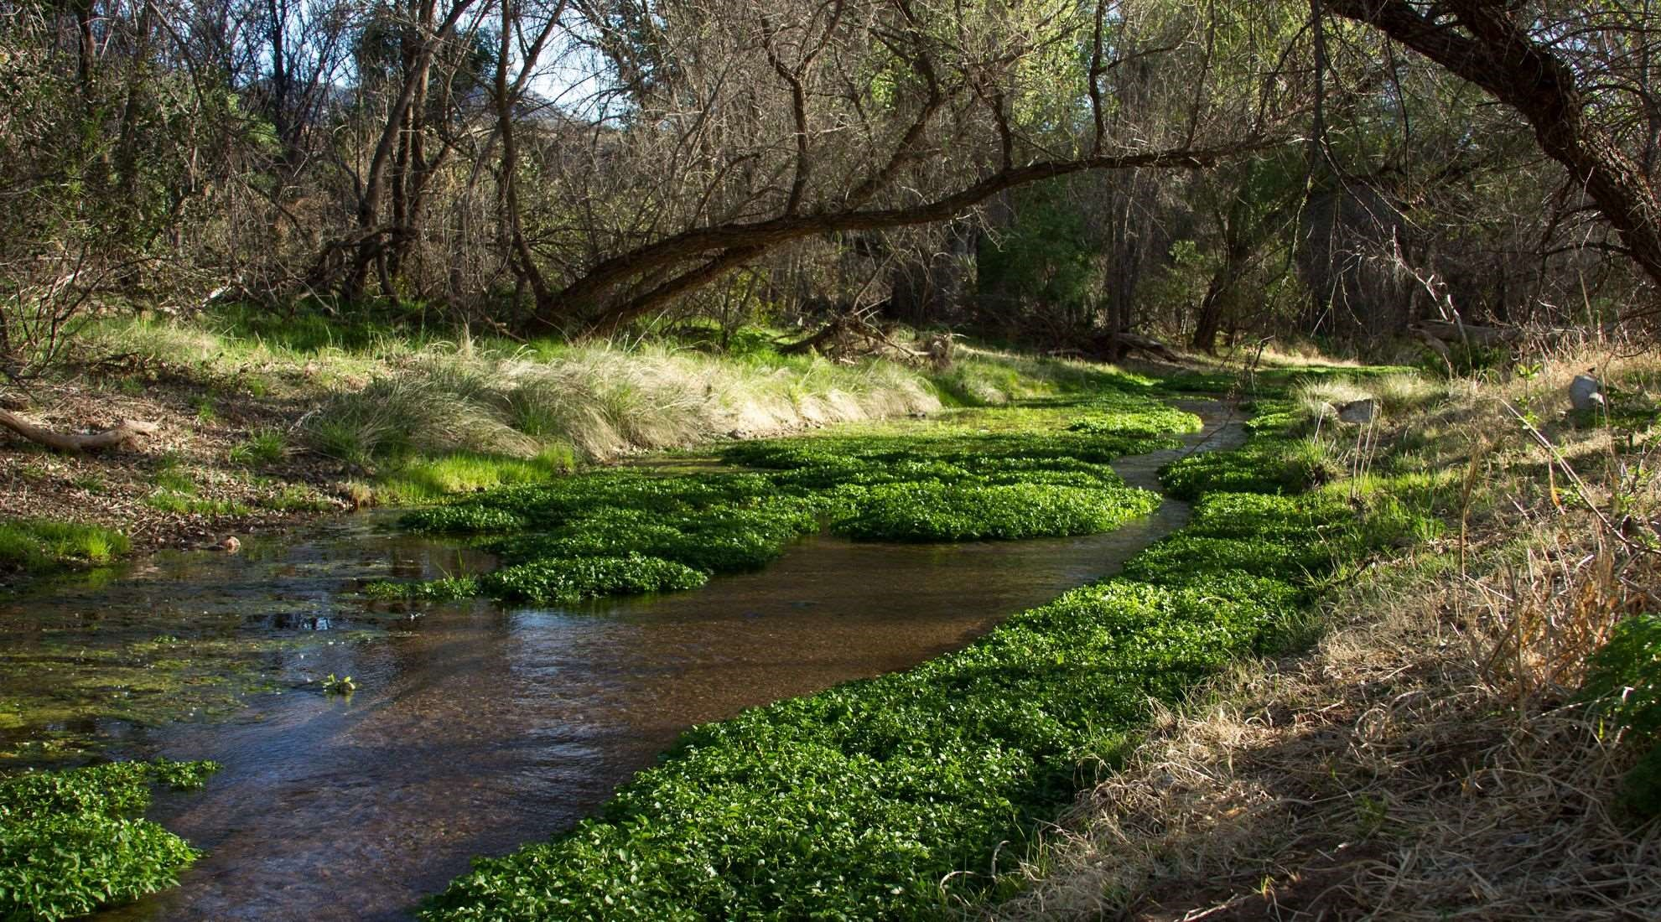

Stillwater Sciences
FINAL REPORT ◦ OCTOBER 2020
Surface Water and Groundwater Trends
Analysis for the Patagonia–Sonoita Creek
Preserve, AZ

P R E P A R E D F O R

P R E P A R E D B Y

The Nature Conservancy, Arizona Chapter

1510
E Fort Lowell Rd
Tucson, AZ 85719

Stillwater Sciences

895
Napa Ave., Suite B-4
Morro Bay, CA 93442

Stillwater Sciences contacts:
Aleksandra Wydzga, PH  Project Manager/Hydrologist  (805) 451-7544  awydzga@stillwatersci.com | Glen Leverich, PG  Geomorphologist (503) 267-9006 ext. 402 glen@stillwatersci.com

Suggested citation:
Stillwater Sciences. 2020. Surface and Groundwater Trends Analysis for the Patagonia–Sonoita Creek Preserve, AZ. Prepared by Stillwater Sciences for The Nature Conservancy, Tucson, Arizona.

Cover photo: View of Sonoita Creek in the Patagonia-Sonoita Creek Preserve, provided by The
Nature Conservancy
Table of Contents

- INTRODUCTION................................................................................................................... 1
  - Background .................................................................................................................. 1
  - Study Area Location .................................................................................................... 1
- SYNTHESIS AND TRENDS ANALYSIS ............................................................................ 4
2.1 Watershed Setting ........................................................................................................ 4 2.2 Hydrogeologic Setting ................................................................................................. 4
  - Water Uses ................................................................................................................... 7
    - Municipal water supply and wastewater treatment ............................................... 7
    - Private water supply .............................................................................................. 9
    - Mining ................................................................................................................. 10
  - Climate ....................................................................................................................... 10
  - Streamflow ................................................................................................................. 13
    - Continuous monitoring at the former USGS gage .............................................. 13 2.5.2 Periodic monitoring at the TNC Preserve ........................................................... 16
2.5.3 Seepage runs at the Preserve ............................................................................... 17
  - Groundwater .............................................................................................................. 19
  - Interactions between Climate, Streamflow, and Groundwater .................................. 23
    - Chemical and isotopic analysis ........................................................................... 23 2.7.2 Water type analysis ............................................................................................. 24 2.7.3 Baseflow recession rate ....................................................................................... 24 2.7.4 Principal component analysis .............................................................................. 25
2.7.5 Modeling ............................................................................................................. 25
- CONCLUSIONS ................................................................................................................... 27
  - Summary .................................................................................................................... 27
  - Recommendations ...................................................................................................... 27
- CITED LITERATURE ........................................................................................................ 28

Tables
Table 1. Physical dimensions of the Sonoita Creek watershed. ................................................. 4
Table 2. Summary of streamflow gaging stations on Sonoita Creek near Patagonia .............. 14
Table 3. Summary of TNC monitoring wells and GWSI index wells, listed from upstream to downstream. ........................................................................................................... 19

Figures
Figure 1. Overview map of the Sonoita Creek watershed in Santa Cruz County, Arizona......... 2
Figure 2. Map of the Patagonia-Sonoita Creek Preserve and surrounding areas. ....................... 3 Figure 3. Geologic map of the Sonoita Creek watershed. ........................................................... 6 Figure 4. Conceptual model of groundwater flow sources and directions published by Gu et al. (2008). Black arrows show groundwater flowing into Sonoita Creek near the
Preserve from the basin-fill and alluvium deposits. ..................................................... 7
Figure 5. | Volume of groundwater pumped and wastewater treated per month for the town of  Patagonia during 2004–2019 (data courtesy of the town of Patagonia, analysis by  Stillwater Sciences). ..................................................................................................... 8
Figure 6. | Average monthly pumping rate for the town of Patagonia during 2004–2019 (data courtesy of the town of Patagonia, analysis by Stillwater Sciences). .......................... 8
Figure 7. | Wells in and near Sonoita Creek Watershed from the ADWR GWSI database (from  TNC’s Conservation Plan 2020). ................................................................................. 9
Figure 8. | Well yields for selected wells in the southern Ciénega Creek groundwater basin including the area surrounding Patagonia (from ADWR Water Atlas 2009). ........... 10
Figure 9. | Long-term annual mean maximum and minimum air temperatures recorded at
atmospheric monitoring stations near Patagonia, Arizona during water years 1954–
2018 (source data from NOAA NCDC 2020, analysis by Stillwater Sciences). ....... 11
Figure 10. Long-term average of monthly total precipitation recorded at atmospheric monitoring stations near Patagonia, Arizona (1922–2019) (source data from NOAA NCDC 2020, analysis by Stillwater Sciences). ................................................................................ 12
Figure 11. Total annual precipitation (WY1923-WY2019) and the cumulative departure of
precipitation from the long-term average annual precipitation as recorded near Patagonia, Arizona (source data from NOAA NCDC 2020, analysis by Stillwater
Sciences). ................................................................................................................... 13
Figure 12. Annual streamflow volume recorded at the former USGS gage on Sonoita Creek and total annual precipitation recorded in the watershed during water years 1930–1972 (source data: USGS 2020 and NOAA NCDC 2020; analysis by Stillwater Sciences).
................................................................................................................................... 14
Figure 13. Monthly average streamflow recorded at the former USGS gage on Sonoita Creek and monthly average precipitation recorded in the watershed during water years 1930–1972 (source data: USGS 2020 and NOAA NCDC 2020; analysis by Stillwater
Sciences). ................................................................................................................... 15
Figure 14. Historical annual peak flood flows recorded at the former USGS gage on Sonoita Creek during water years 1930–1972, 1978, and 1984 (source data: USGS 2020;
analysis by Stillwater Sciences). ................................................................................ 16
Figure 15. Periodic streamflow measured at the Preserve and daily total precipitation recorded near Patagonia during 1979–2019 (source data: TNC and NOAA NCDC 2020;
analysis by Stillwater Sciences). ................................................................................ 17
Figure 16. Seepage run results from ADWR’s January 1998 study near the Preserve (adapted
from Montgomery and Associates 1999). .................................................................. 18
Figure 17. Groundwater elevations in TNC monitoring wells located on the upstream end of the Preserve and a GWSI index well (#55-809433) located in the town of Patagonia
(source data: TNC and ADWR 2020; analysis by Stillwater Sciences). ................... 20
Figure 18. Groundwater elevations in a GWSI index well (#55-624881) located upstream from the town of Patagonia (source data: ADWR 2020; analysis by Stillwater Sciences). 21
Figure 19. Groundwater elevations in TNC monitoring wells located on the middle to the
downstream end of the Preserve (source data: TNC; analysis by Stillwater Sciences).
................................................................................................................................... 21
Figure 20. Groundwater elevations from NASH and 8.5 wells compared to streamflow measured in the Preserve (source data: TNC; analysis by Stillwater Sciences). ........................ 22

Appendices
Appendix A. Rainfall-Streamflow Correlation

INTRODUCTION
The purpose of this report is to synthesize and analyze existing hydrologic data pertaining to The Nature Conservancy’s (TNC) Patagonia–Sonoita Creek Preserve (the “Preserve”) to provide a foundation upon which a strategy to protect streamflows can be developed. A separate monitoring plan will be developed to guide future data collection efforts.

1.1 Background
The perennial stream community on the Preserve supports diverse riparian and aquatic flora and fauna including 267 species of birds, four native fishes, the federally protected Mexican garter snake, and the Huachuca water umbel (TNC et al. 2020). The recently completed Sonoita Creek Watershed Conservation Plan (TNC et al. 2020) outlines specific conservation targets for riparian, aquatic, wetland, spongy upland, and floodplain communities, as well as targets for human well-being. To support these targets, the Conservation Plan recommends a synthesis and analysis of available surface-water and groundwater data to describe historic and current trends, and to support the development of a monitoring plan. This report provides this synthesis and analysis of TNC’s comprehensive dataset.

1.2 Study Area Location
Sonoita Creek is a tributary to the upper Santa Cruz River in southern Arizona. Although Sonoita Creek is primarily an ephemeral channel, a perennial reach approximately 10 miles long is located between the town of Patagonia and Patagonia Lake (Figure 1). The Preserve includes 795 acres along the perennial reach downstream of the town of Patagonia, and 120 acres along an ephemeral reach immediately upstream of the town (the Stevens parcel) (Figure 2). The primary focus of this study is the Preserve along the perennial reach. To the extent that they are relevant to the conservation of the Preserve, surface-water and groundwater data for locations outside of the Preserve are also synthesized and analyzed.

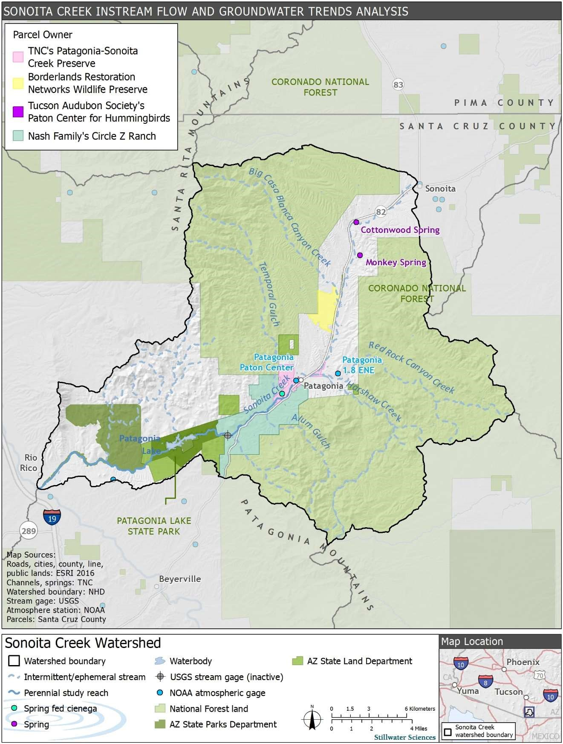
Figure 1. Overview map of the Sonoita Creek watershed in Santa Cruz County, Arizona.

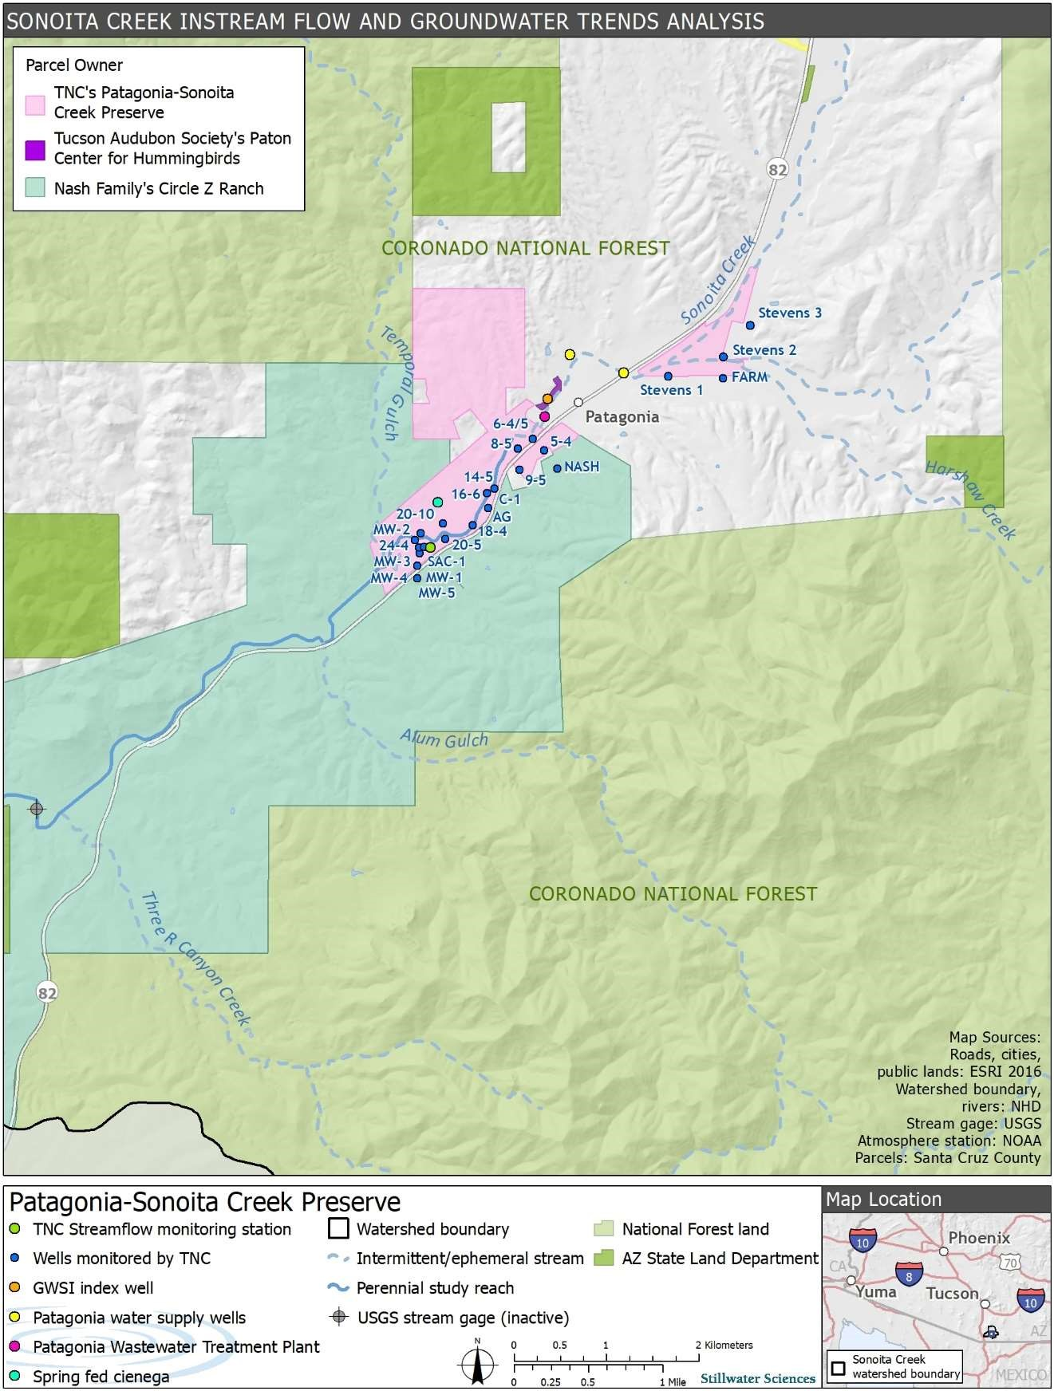
Figure 2. Map of the Patagonia-Sonoita Creek Preserve and surrounding areas.

SYNTHESIS AND TRENDS ANALYSIS
2.1 Watershed Setting
Sonoita Creek is located in the southern Basin and Range geomorphic province and is characterized by north to northwest trending mountain ranges including the Santa Rita Mountains and the Patagonia Mountains (Figure 1). Sonoita Creek flows south to southwest and has a drainage area of approximately 260 square miles. Table 1 summaries physical parameters of Sonoita Creek and its major tributaries.

The approximately 10-mile perennial reach is owned by TNC and several TNC partners, including Circle Z Ranch, Arizona State Parks Department, and Arizona State Land Department (Figure 2). The largest landowner in the watershed is the USDA Forest Service. Mineral resources including silver, manganese, zinc, lead, copper, and gold are found on both public and private lands.

Table 1. Physical dimensions of the Sonoita Creek watershed.
Watershed and subwatersheds ^{A} | Drainage area ^{B} |  | Stream relief (elev. range) ^{C} |  | Stream length ^{D} |  | Stream gradient ^{E}
 | mi² | km² | ft | m | mi | km
Sonoita Cr. (Entire) | 260 | 673 | 1,433 | 437 | 45 | 73 | 0.006
Upper Sonoita Cr.  (headwaters to  Patagonia) | 55 | 144 | 786 | 240 | 18 | 29 | 0.008
Big Casa Blanca Cyn | 19 | 50 | 2,288 | 911 | 17 | 28 | 0.033
Redrock Cyn | 32 | 82 | 1,285 | 392 | 19 | 31 | 0.013
Harshaw Cr. | 33 | 86 | 1,600 | 488 | 20 | 33 | 0.015
Middle Sonoita Cr. (Patagonia to  Patagonia Lake dam) | 62 | 160 | 309 | 94 | 14 | 23 | 0.004
Temporal Gulch | 27 | 71 | 2,225 | 678 | 19 | 30 | 0.023
Lower Sonoita Cr. (Patagonia Lake dam to Santa Cruz R.) | 31 | 81 | 334 | 102 | 13 | 20 | 0.005
- Drainages larger than 10 square miles
- Drainage area of subwatersheds derived in a GIS using the USGS’s National Hydrography Dataset (NHD)
- Stream channel relief determined in a GIS using maximum and minimum elevations of the designated mainstem channels contained in the USGS’s NHD overlain upon a 10-m digital elevation model (DEM) of the watershed
- Stream channel length determined in a GIS using stream segments in the USGS’s NHD
- Stream channel gradient determined in a GIS using the quotient of stream channel relief and length
Abbreviations: R.=river, Cr.=creek, Cyn=canyon, mi²=square mile(s,) km²=square kilometer(s), ft=feet, m=meter(s), mi=mile, km=kilometer

2.2 Hydrogeologic Setting
Sonoita Creek is ephemeral along most of its length but becomes perennial just downstream of the town of Patagonia where the valley bottom narrows and bedrock shallows, which forces groundwater to the surface and results in a perennial reach (Gray et al. 2000, Gu et al. 2008) (Figure 2). This rising-groundwater condition thus defines much of the Preserve as a
“hydrologically gaining” reach (see Section 2.5.3 for a detailed discussion). Conversely, a “hydrologically losing” reach occurs where groundwater is deeper and surface-water percolates into the streambed, resulting in decreased streamflow in the downstream direction.

Along much of its length, the stream banks, bed, and adjacent floodplains of Sonoita Creek are composed of poorly consolidated alluvial deposits. Where both the areal extent and thickness are large enough, these streamside deposits are capable of storing and transmitting substantial volumes of groundwater (Montgomery and Associates 1999). The primary sources of baseflow for the perennial reach of Sonoita Creek include Quaternary and Tertiary basin-fill and alluvial deposits (Figure 3) and saturated bedrock which is fractured, faulted, or contains interconnected primary openings (Montgomery and Associates 1999, Gu et al. 2008). A conceptual model showing the direction of groundwater flow into the perennial reach of Sonoita Creek is shown in Figure 4.

A study using sulfate isotopes in conjunction with sulfate concentration identified sources of baseflow in the perennial reach of Sonoita Creek for the period 1999 to 2003 (Gu et al. 2008). This study found that 50% to 70% of the baseflow may be derived from basin-fill and alluvial deposits (shown as light yellow along mainstem of Sonoita Creek in Figure 3). The remainder of the baseflow is derived from an equal part of water draining from Patagonia Mountains and the Santa Rita Mountains. Water from the Patagonia and Santa Rita Mountains is traced by sulfates found in acid rock drainage and does not differentiate between water delivered to groundwater via infrequent surface runoff via tributaries or mountain-block recharge (Gu et al. 2008). A recent isotopic study of groundwater movement in the Patagonia Mountains demonstrates that groundwater flows from the Patagonia Mountains to the Sonoita Creek alluvial basin via the alluvial sediments along Harshaw Creek (Schrag-Toso 2020). Furthermore, the study suggests that other potential pathways of groundwater flow from the Patagonia Mountains (e.g. Harshaw Creek fault) (Figure 3) to the Sonoita Creek alluvial basin may be obstructed by the Mountain Front fault (Schrag-Toso 2020).

A spring-fed ciénega, or wetland, is found on the Preserve (Figure 2). The Arizona Department of
Water Resources (ADWR) collected a single flow rate measurement of 70 gallons per minute (0.16 cfs) at the ciénega in 1982 (ADWR 2009). The ciénega may be hydrologically connected to shallow alluvial groundwater or deeper groundwater associated with mountain-block recharge.

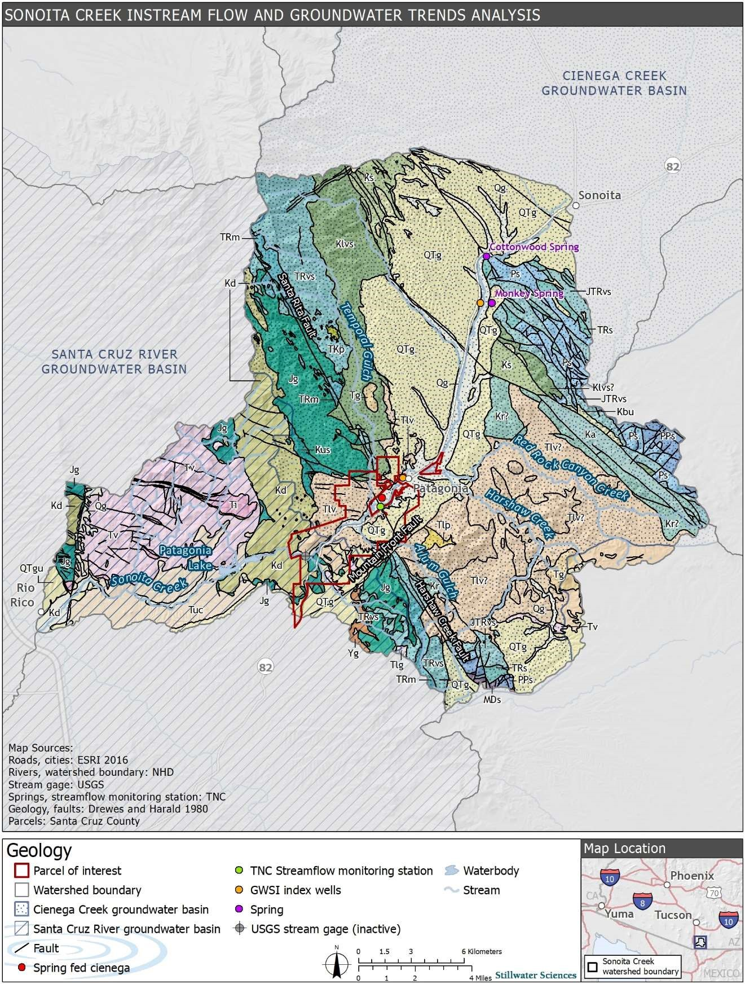
Figure 3. Geologic map of the Sonoita Creek watershed.

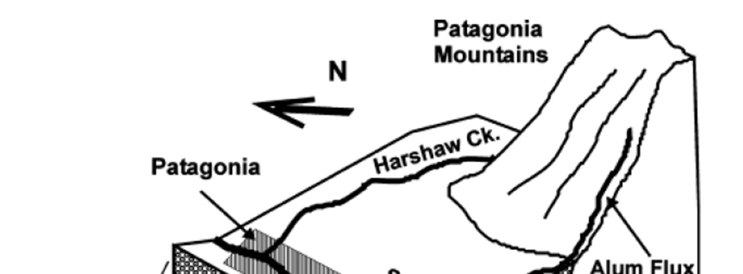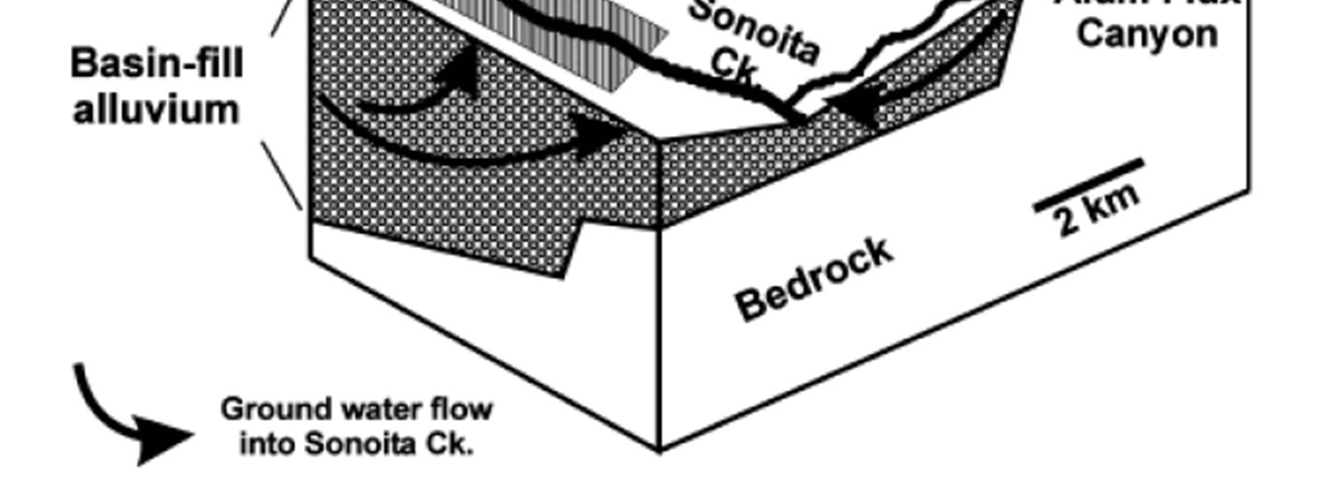
Figure 4. Conceptual model of groundwater flow sources and directions published by Gu et al. (2008). Black arrows show groundwater flowing into Sonoita Creek near the Preserve from the basin-fill and alluvium deposits.

2.3 Water Uses
2.3.1 Municipal water supply and wastewater treatment
Immediately upstream from TNC’s Preserve is the town of Patagonia with a population of approximately 950 people. Located near the center of town, two water supply wells are managed by the town to serve its residents (Figure 2). According to ADWR’s Groundwater Site Inventory (GWSI), the two wells (#55-605596 and #55-605595) are approximately 95 feet deep, screened in alluvium, and the depth to bedrock is at least 300 feet from the ground surface (Clear Creek 2018). The combined average annual rate of pumping at the wells is approximately 121 acre-feet (39.4 million gallons) (2004–2019). This amount is considerably less than the town’s municipal water right of 629 acre-feet (205 million gallons) per year (ADWR Registry #33-96392). The amount pumped has slightly decreased over the last few decades (Figure 5). On average the amount pumped varies by month, with the highest pumping occurring in June and the lowest in February (2004–2019) (Figure 6).

Wastewater from the town is conveyed via gravity to the treatment plant located southwest of town and upstream of the Preserve and is discharged in an ephemeral reach of Sonoita Creek (Figure 2). The treatment plant was constructed in 1978 and upgraded in 2004 with a capacity to treat an average daily flow of 110,000 gallons. The town treated an average of 51 acre-feet (16.5 million gallons) of effluent per year during 2004–2019. This treatment volume represents approximately 40% of the annual average water pumped from the town wells during 2004–2019. Like the amount of water pumped, the amount of wastewater treated has declined over the past few decades (Figure 5). Unlike the average monthly pumping volumes, the amount treated each month remained fairly consistent (Figure 6).
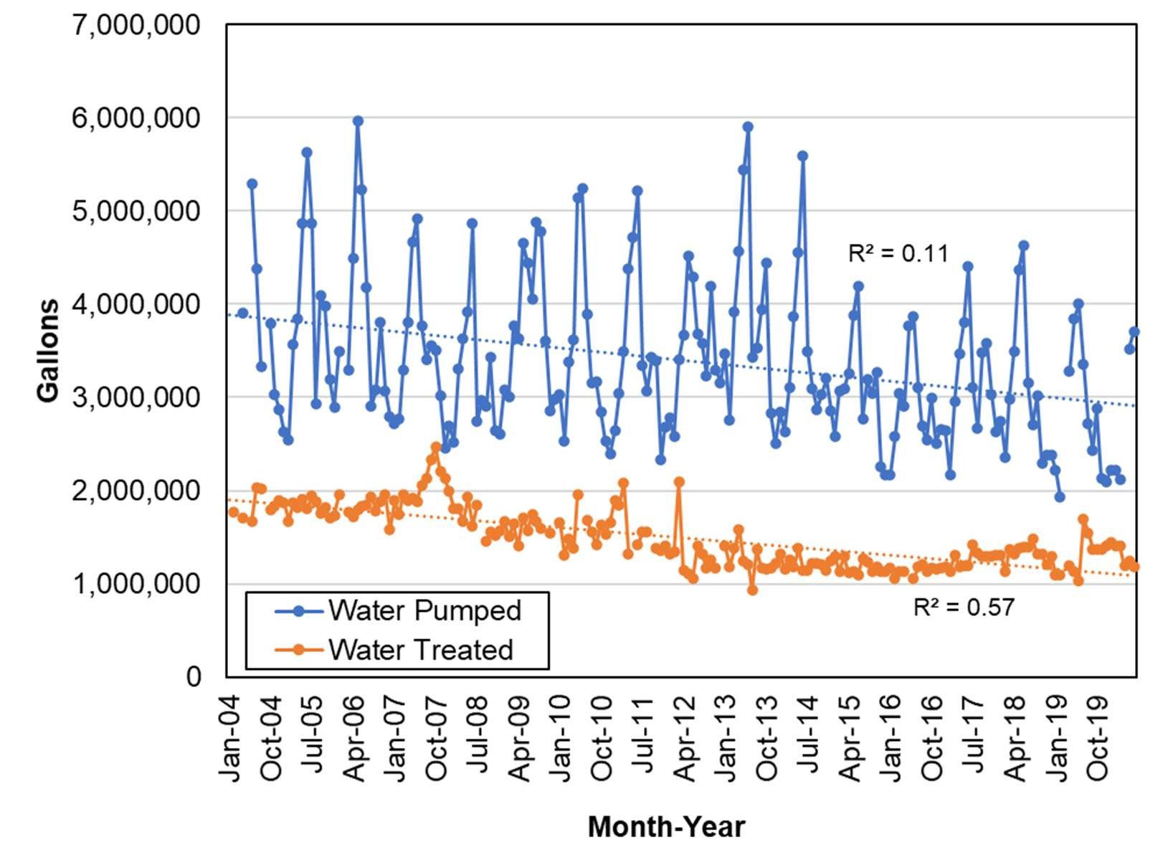
Figure 5. Volume of groundwater pumped and wastewater treated per month for the town of Patagonia during 2004–2019 (data courtesy of the town of Patagonia, analysis by Stillwater Sciences).

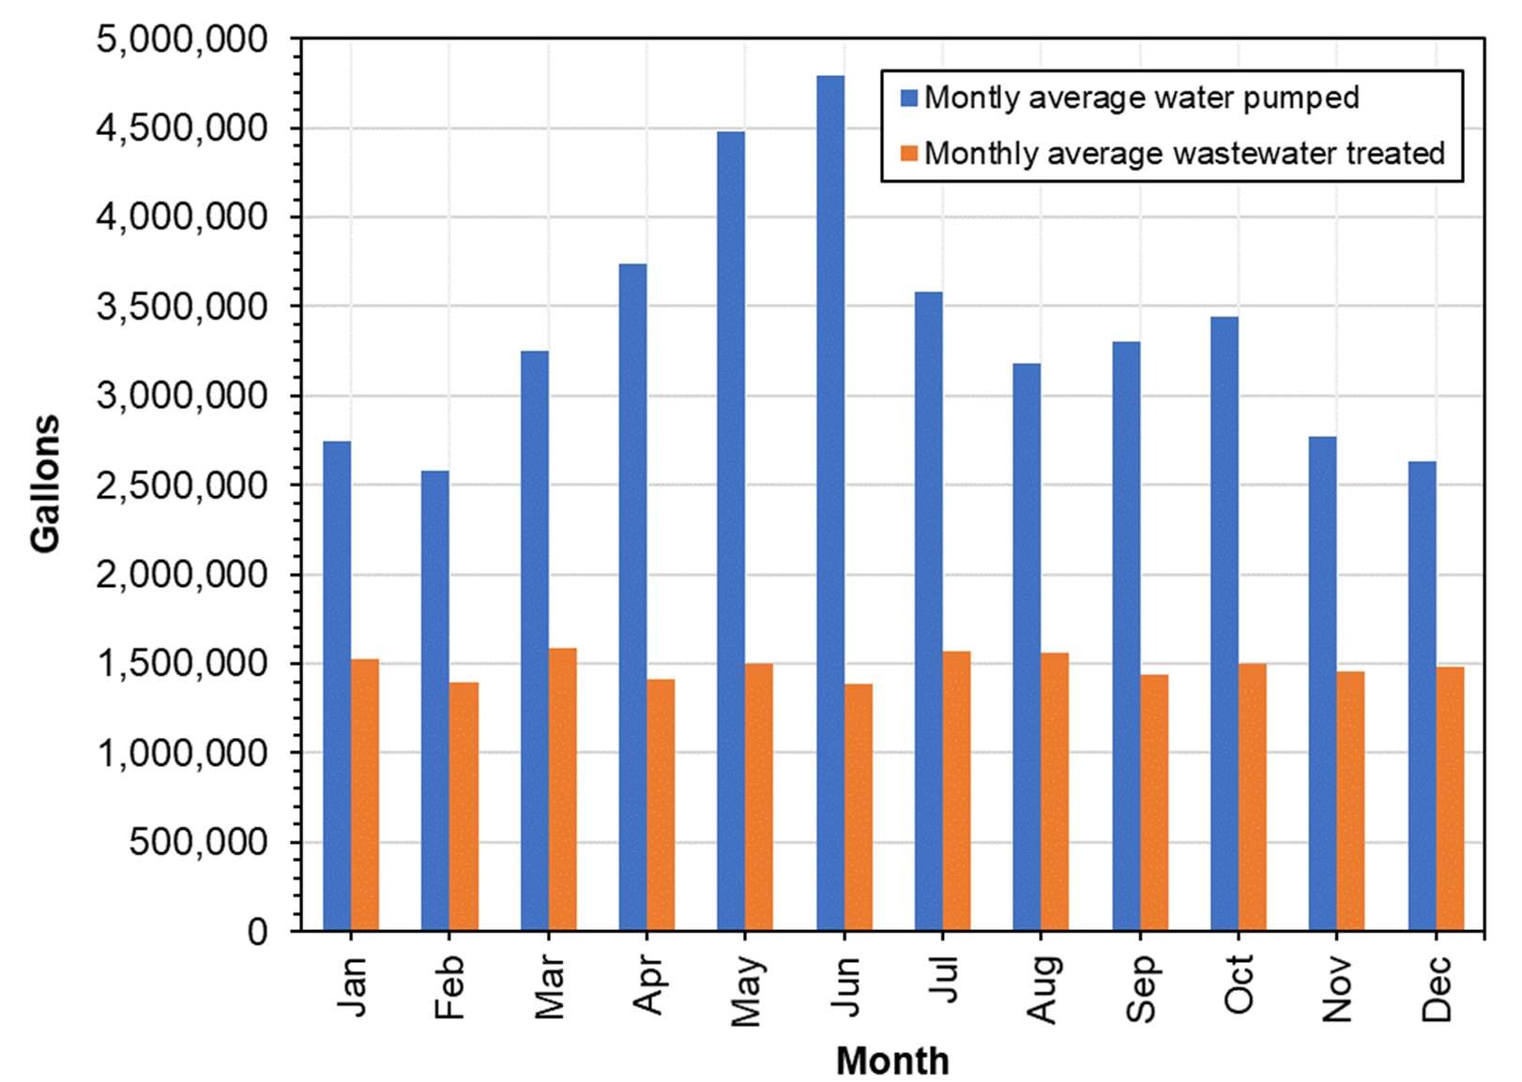
Figure 6. Average monthly pumping rate for the town of Patagonia during 2004–2019 (data courtesy of the town of Patagonia, analysis by Stillwater Sciences).
2.3.2 Private water supply
The watershed hosts numerous properties with private water supply wells and septic systems (NextGen 2017). According to the GWSI database, there are over 300 wells in the watershed used for domestic, stock, irrigation, commercial and industrial wells (Figure 7). Well yields in the Ciénega Creek groundwater basin, in which Sonoita Creek is located, range from ≤100 gallons per minute to 2,000 gallons per minute (Figure 8) (ADWR 2009).

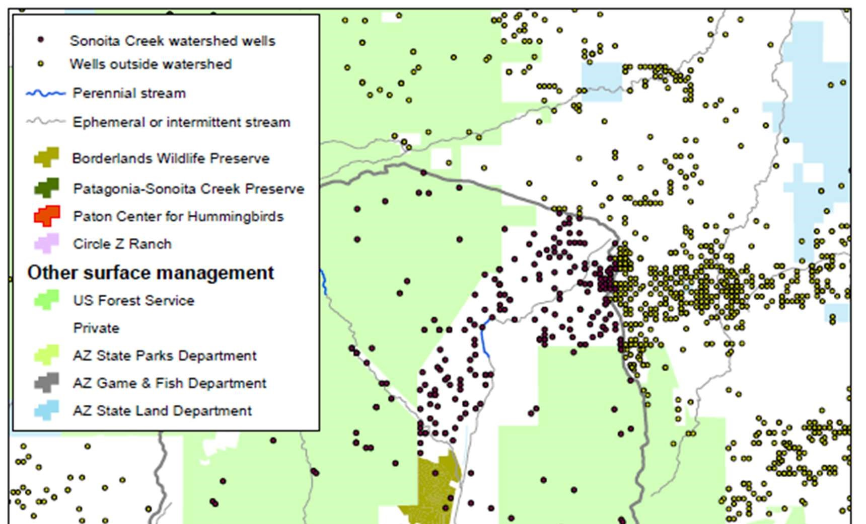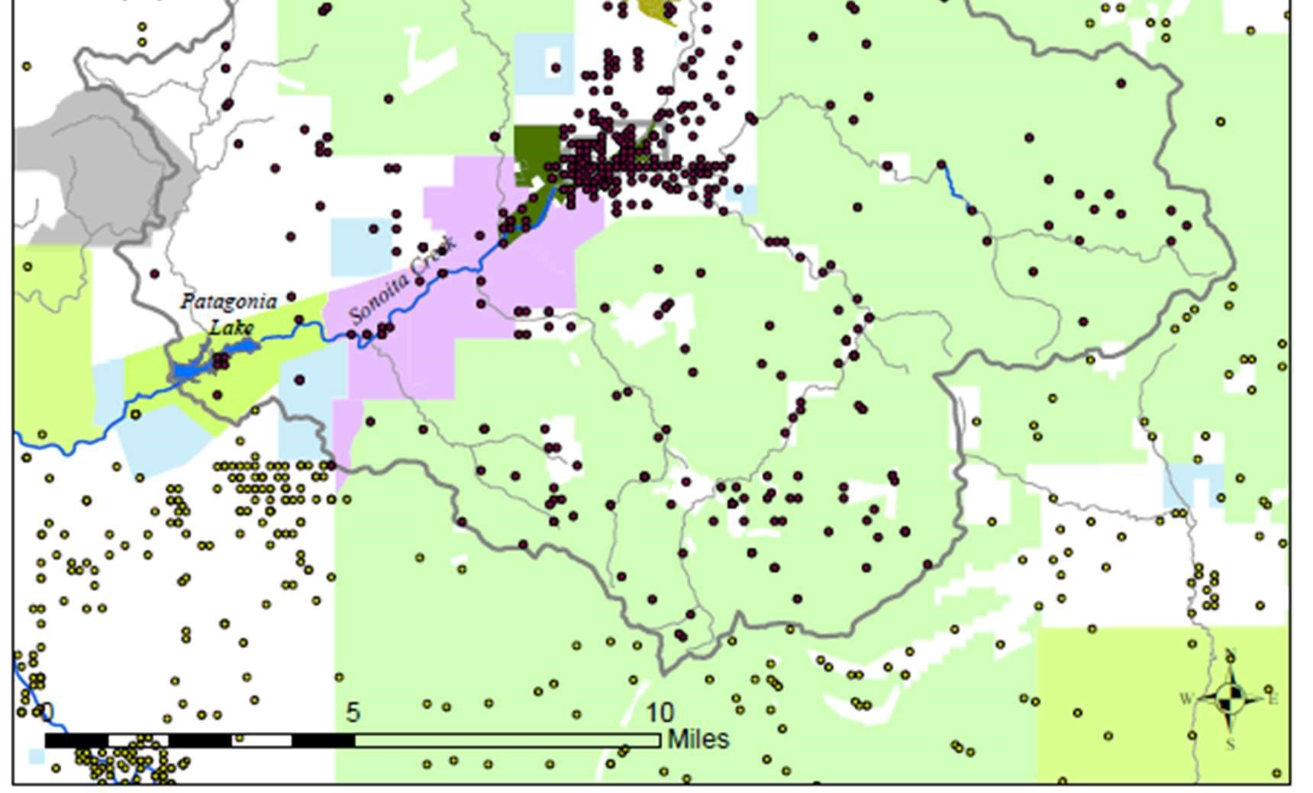
Figure 7. Wells in and near Sonoita Creek Watershed from the ADWR GWSI database (from TNC’s Conservation Plan 2020).
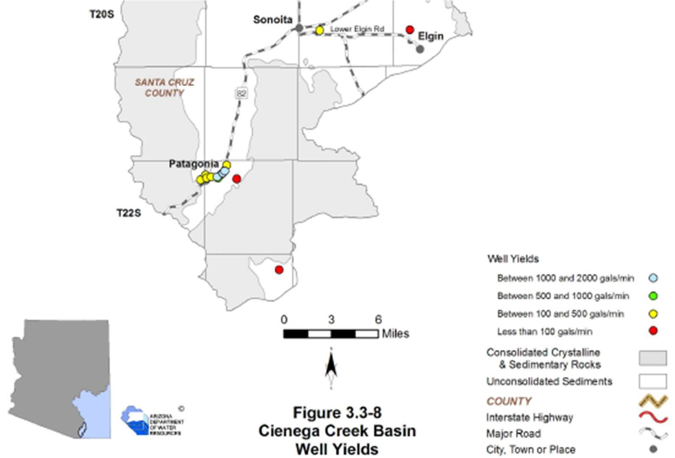
Figure 8. Well yields for selected wells in the southern Ciénega Creek groundwater basin including the area surrounding Patagonia (from ADWR Water Atlas 2009).

2.3.3 Mining
Small mining operations using shafts and tunnels have occurred throughout the Patagonia
Mountains from the 1860s through the 1960s (Patagonia Area Resource Alliance and Earth Works 2014). These shafts and tunnels can serve as conduits for groundwater movement. A new silver and manganese mine is proposed for the Patagonia Mountains in the headwaters of Harshaw Creek and Alum Gulch (M3 2014), approximately 4 miles southeast of the Preserve. Common water uses for mining during operations include rock processing and dewatering during mineral exploration and extraction phases.
2.4 Climate
Long-term atmospheric data were obtained from several active recording stations in the watershed and vicinity as published by the National Oceanic and Atmospheric Administration (NOAA NCDC 2020). The primary data used were from the Patagonia Paton Center and Patagonia 1.8 ENE stations located near the town of Patagonia, while additional nearby stations near Nogales having longer records were utilized to fill data gaps (see Figure 1 for station locations). These long-term records reveal a steady increase in annual mean minimum and maximum temperatures since 1954 (Figure 9). During 1954–2018, annual mean minimum air temperatures increased by approximately 0.2℉ per year. These long-term trends of increasing temperature are consistent with regional observations that have reported an annual mean increase of about 1.6℉ over the last century, and a predicted temperature rise of an additional 3 to 12℉ by the end of this century (USGCRP 2018). Increasing air temperatures can impact watershed hydrology through increased evaporation, decreased soil moisture, and increased wildfire frequency and severity (Garfin 2013).
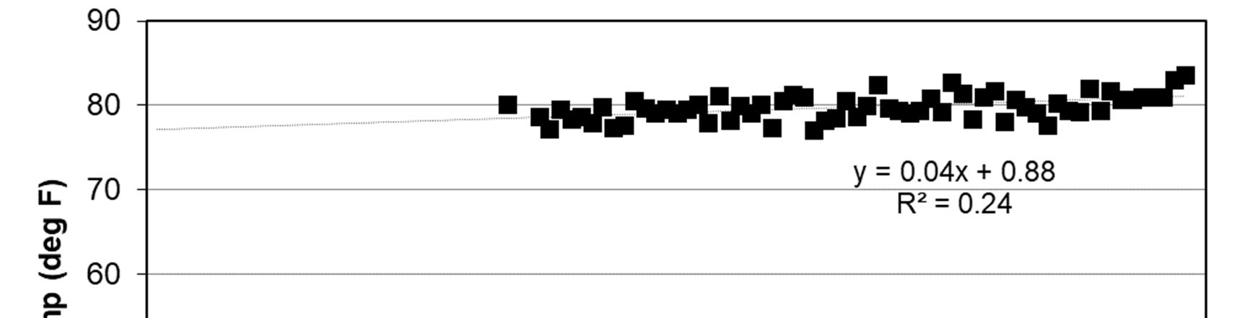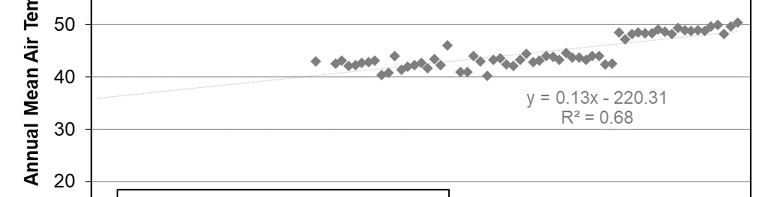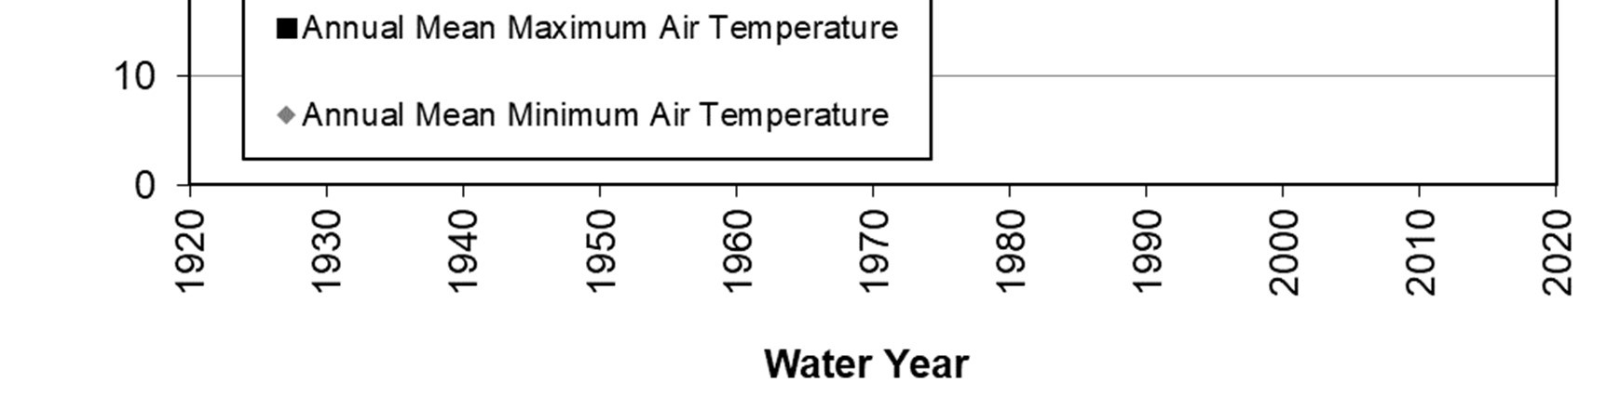
Figure 9. Long-term annual mean maximum and minimum air temperatures recorded at atmospheric monitoring stations near Patagonia, Arizona during water years 1954– 2018 (source data from NOAA NCDC 2020, analysis by Stillwater Sciences).

Precipitation patterns in the watershed are bi-seasonal, with cool, winter frontal storms arriving between December and March and tropical monsoons arriving in July through September. There is some evidence that monsoonal intensity patterns have been increasing in the southwestern United States since the 1970s (Demaria et al 2019). Monthly mean precipitation values highlight the significance of the monsoon season and show that the wettest month on record has been July, while the driest has been May (Figure 10).

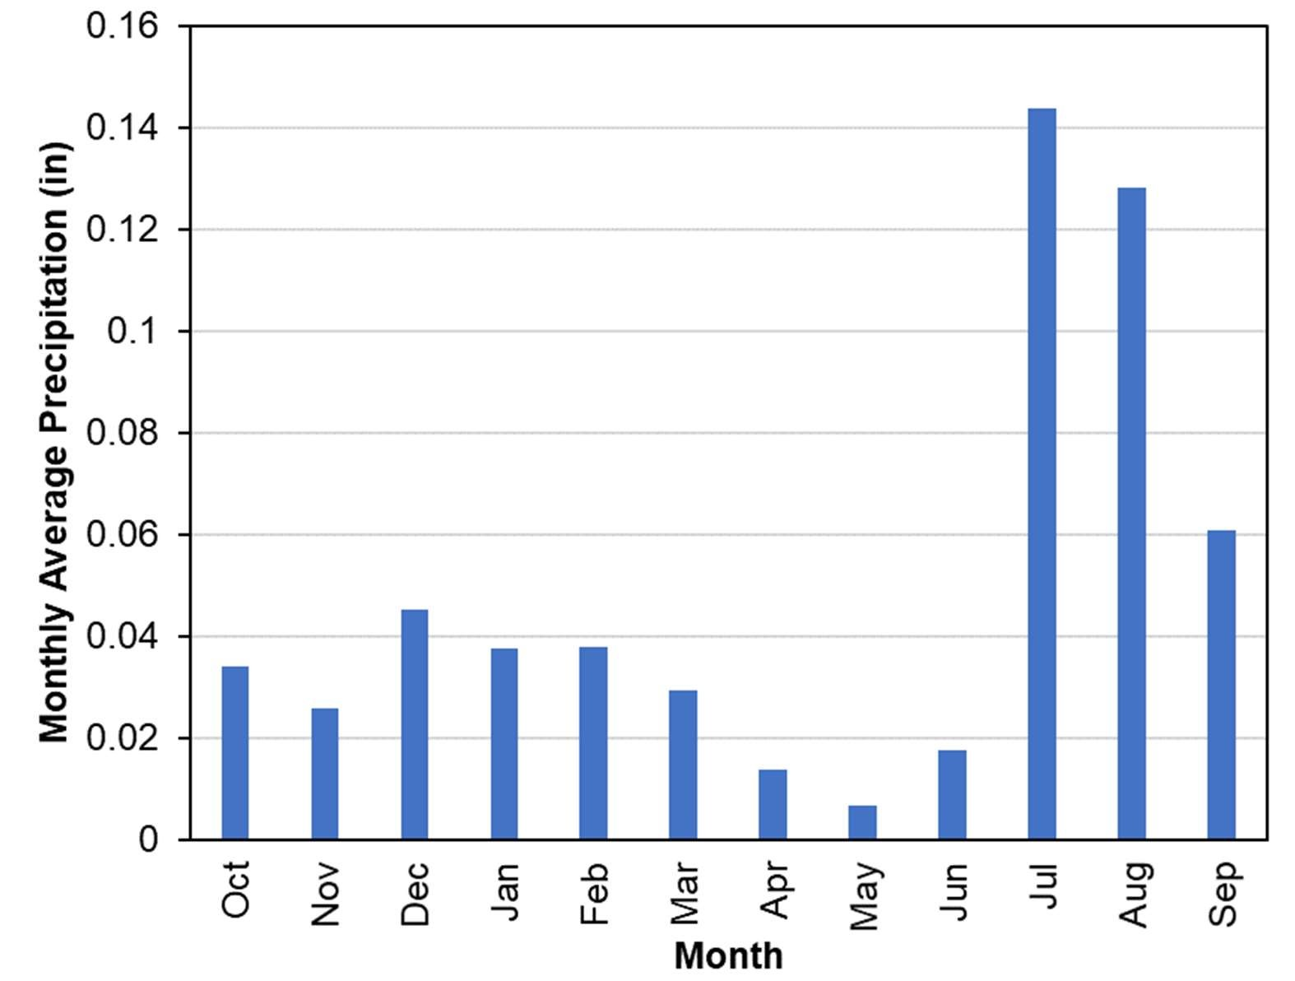
Figure 10. Long-term average of monthly total precipitation recorded at atmospheric monitoring stations near Patagonia, Arizona (1922–2019) (source data from NOAA NCDC 2020, analysis by Stillwater Sciences).

Total annual precipitation varies spatially as a function of elevation. The average annual total precipitation during 1981–2010 near the town of Patagonia (elevation 4,050 ft) was approximately 18 inches, while Mount Wrightson—the highest peak in the watershed (elevation ~ 9,450 ft)—was approximately 37 inches (PRISM 2019).

Annual precipitation totals, as depicted graphically in Figure 11 based on station records near Patagonia, exhibit substantial variability since 1923, ranging from 8.75 inches (22.2 cm) in 2009 to 29.5 inches (75 cm) in 1966. Annual water data is presented in terms of a water year (WY), rather than a calendar year, which starts on October 1st and ends on September 30th of the following year. For example, water year 2019 started on October 1st, 2018 and ended September 30th, 2019. Longer-term cyclic patterns of precipitation in the region can be visualized when plotting the cumulative departure, or the extent to which the cumulative precipitation deviates from the long-term average of annual precipitation totals. When the cumulative departure of precipitation is increasing (e.g., 1983 to 1993), more water from precipitation is generally available for groundwater recharge. Likewise, during periods when the cumulative departure of precipitation is decreasing (e.g., 1969 to 1977), generally less water is available. To highlight shorter term interannual trends, years in which the annual precipitation was above the long-term average (blue) are differentiated from below years that were below the long-term average (yellow) (see Figure 11). Although there is variation among the years, the cumulative departure of precipitation generally decreased from 1993 to 2018 indicating a period during which less water was available for groundwater recharge.
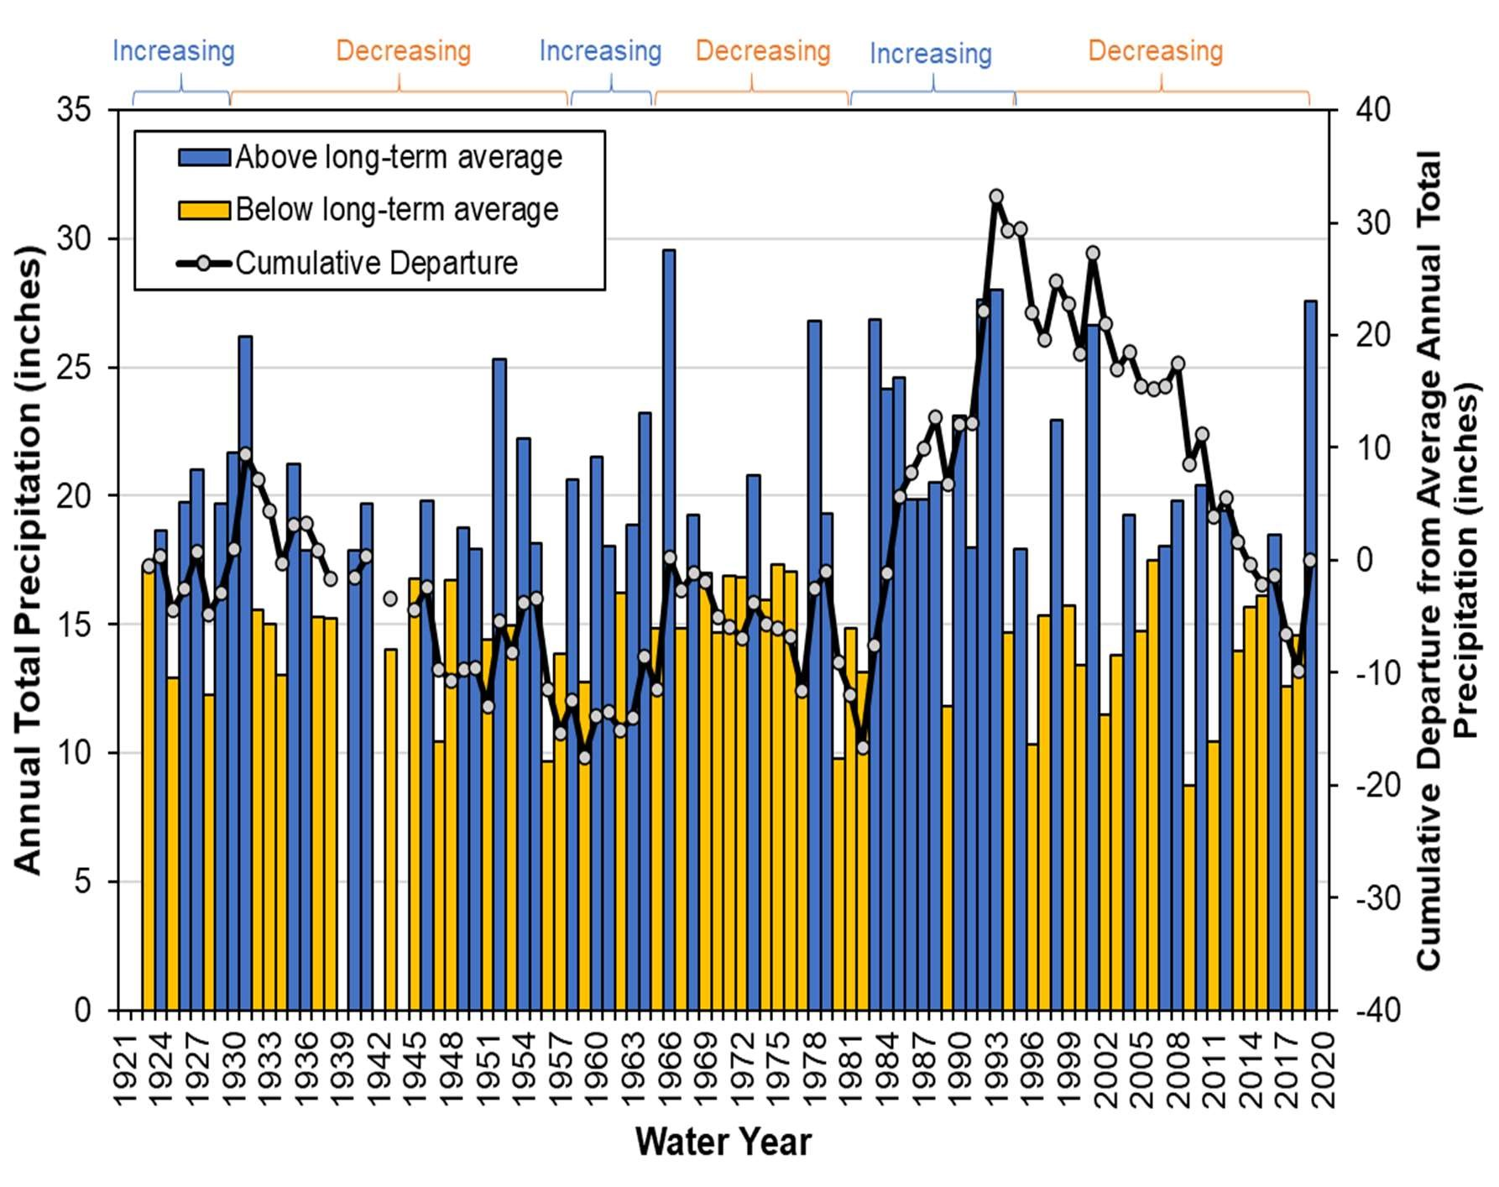
Figure 11. Total annual precipitation (WY1923-WY2019) and the cumulative departure of precipitation from the long-term average annual precipitation as recorded near Patagonia, Arizona (source data from NOAA NCDC 2020, analysis by Stillwater Sciences).
2.5 Streamflow
2.5.1 Continuous monitoring at the former USGS gage
Streamflow in Sonoita Creek above Patagonia Lake was monitored by the U.S. Geological Survey (USGS) on a continuous basis during 1930–1972 and periodically in 1978 through 1983.
The monitoring station location is shown on Figure 2 and its details are summarized in Table 2. The annual streamflow totals recorded at the former gage during 1930–1972 are depicted in Figure 12.

The stream gage data reveal that Sonoita Creek naturally experiences a wide variation of flows, punctuated episodically by short-duration but intensive channel-adjusting flood events. These traits are common to large, dryland riverine systems that periodically experience dramatic geomorphic change resulting from their flashy streamflow dynamics (Graf 1988). The wettest water year during this period was 1966, where the streamflow volume of approximately 20,400 acre-feet exceeded the long-term average by a factor of 3. While neither annual mean streamflow volume nor total annual precipitation show statistically significant increasing or decreasing trends during this period, they generally follow the same patterns of variability.
Table 2. Summary of streamflow gaging stations on Sonoita Creek near Patagonia
Gage operator  and station  ID | Gage type  (range of acceptable flows) | Period of record | Contributin g drainage area  (mi²) | Remarks from operator
USGS  Sonoita  Creek near  Patagonia  (#09481500) | All flows | Jun 1, 1930–Sep 29, 1972  (Daily mean streamflows)  Aug 7, 1930–Oct 2, 1983  (Peak streamflows) | 209 | Formerly operated gage located upstream from Patagonia Lake
TNC  PatagoniaSonoita  Creek  Preserve | Baseflows | 1979–1983  (Instantaneous streamflows)  1987–Present  (Instantaneous streamflows) | 147 | Manual measurements taken approximately five times a year during 1979–1989 and approximately monthly during 1990–2019 by TNC staff. Data do not include flood flows and are thus representative of baseflow conditions (TNC 2020).

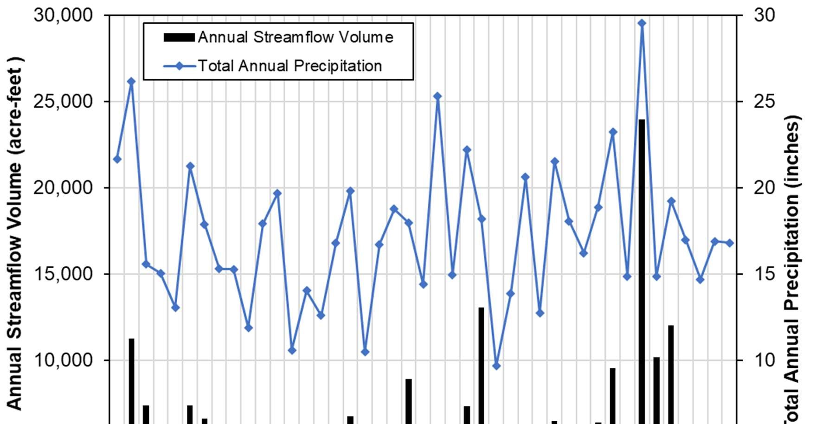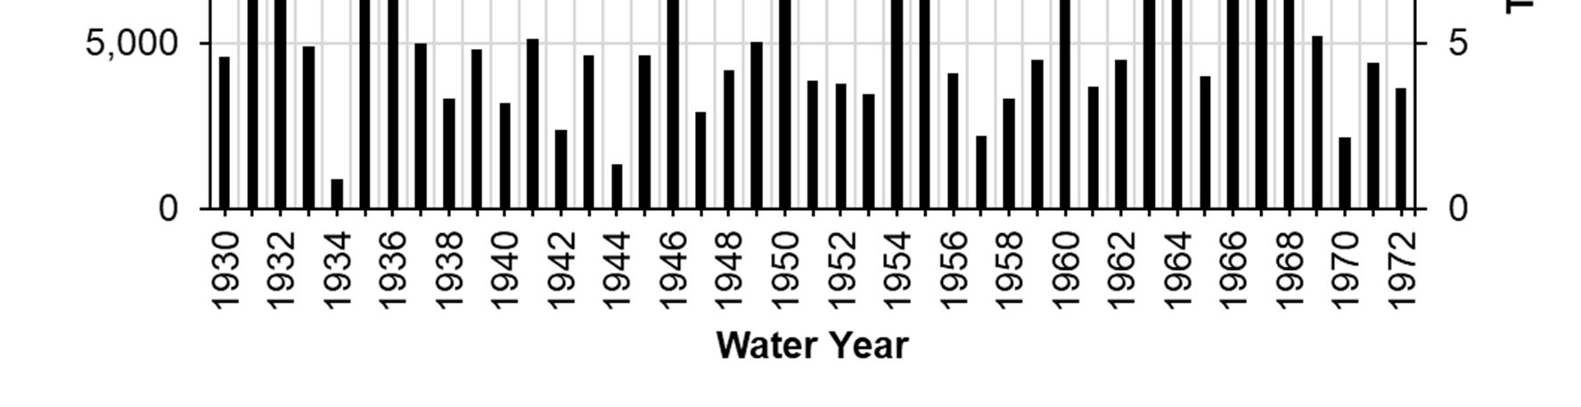
Figure 12. Annual streamflow volume recorded at the former USGS gage on Sonoita Creek and total annual precipitation recorded in the watershed during water years 1930–1972 (source data: USGS 2020 and NOAA NCDC 2020; analysis by Stillwater Sciences).

Over the entire record of the former USGS gage, August experienced the highest monthly mean flows and June experienced the lowest monthly mean flows. These patterns generally follow seasonal variability of precipitation in the watershed; however, the highest and lowest monthly mean flows occurred one month after the highest and lowest monthly mean rainfall, reflecting an approximate 1-month lag (Figure 13).

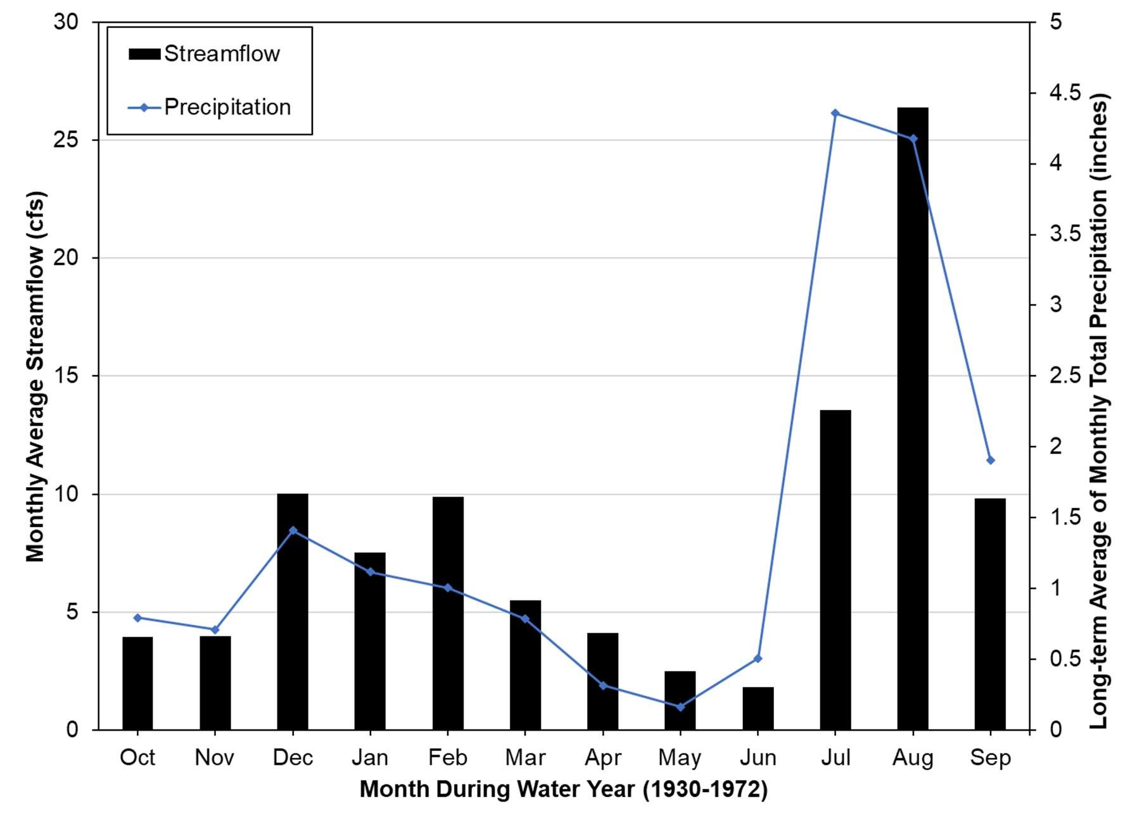
Figure 13. Monthly average streamflow recorded at the former USGS gage on Sonoita Creek and monthly average precipitation recorded in the watershed during water years 1930–1972 (source data: USGS 2020 and NOAA NCDC 2020; analysis by Stillwater Sciences).

Daily mean streamflows were approximately 8 cfs at the former USGS gage. Overall, for 90% of the time, daily mean flows were less than 1 cfs. Annual peak flows at the former gage were massive compared to the long-term daily mean flows (e.g., 14,000 cfs versus 8 cfs) and usually spanned only a few hours to days, indicating the flashy nature of the river (Figure 14). The floods of record occurred in water years 1934, 1946, and 1984; the largest occurred on October 2, 1984 (16,000 cfs), which equates to an apparent return period of approximately 46 years (Figure 14).

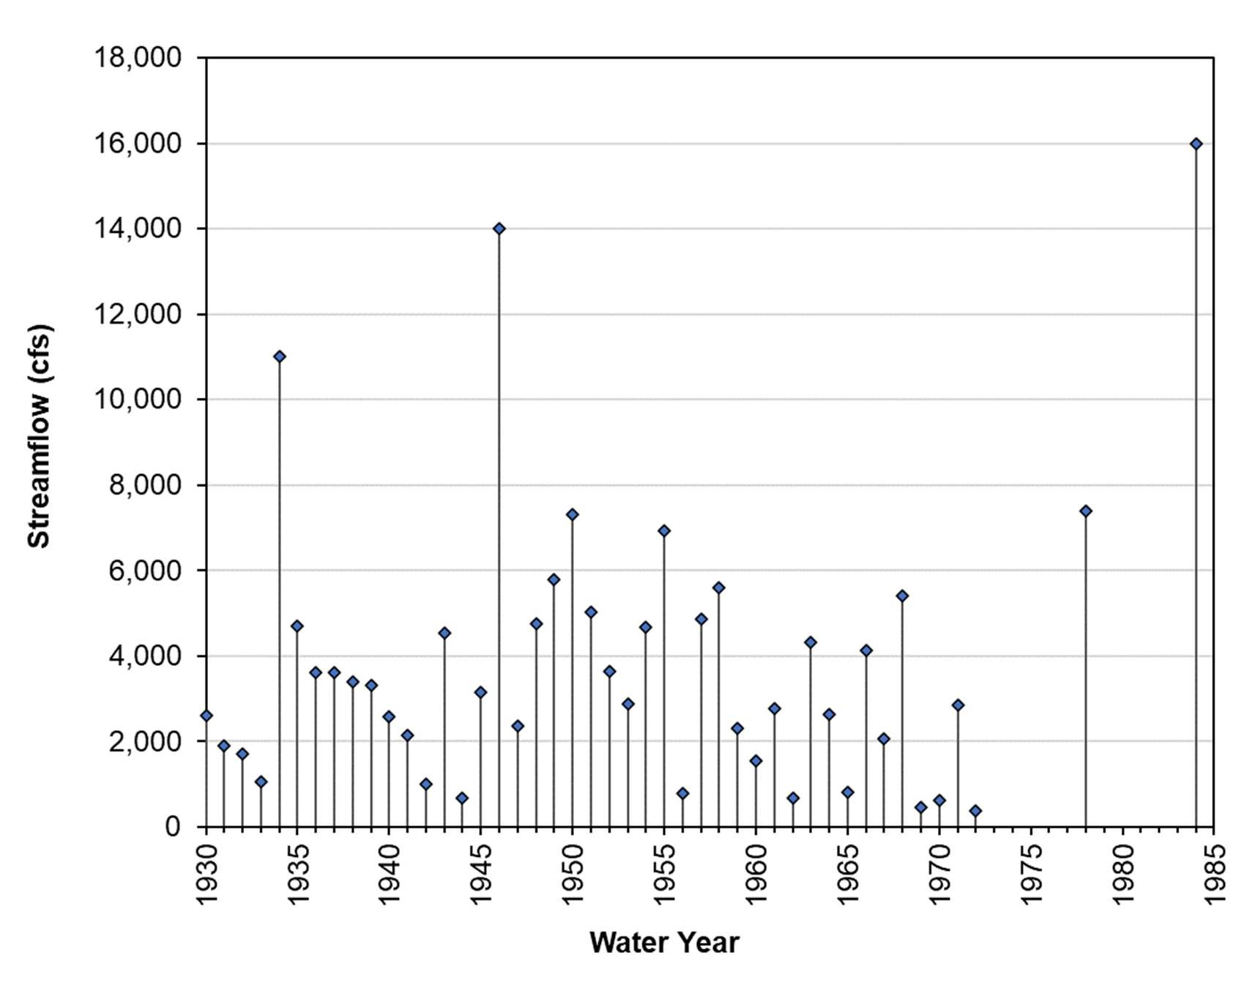
Figure 14. Historical annual peak flood flows recorded at the former USGS gage on Sonoita Creek during water years 1930–1972, 1978, and 1984 (source data: USGS 2020; analysis by Stillwater Sciences).
2.5.2 Periodic monitoring at the TNC Preserve
Periodic streamflow monitoring was conducted by TNC at the Preserve near groundwater monitoring well MW-1 approximately five times a year during 1979–1989 and approximately monthly during 1990–2019 (see Figure 2 and Table 2). At this TNC monitoring station, flows have ranged from near zero to 26 cfs with a long-term mean of 5.1 cfs (Figure 15). The measurements represent baseflow conditions and lack flood flows (TNC 2020). An examination of the total precipitation that occurred the day the streamflow was collected and the two preceding days (3-day total), reveals a lack of correlation between precipitation and streamflow at this time scale (see Figure A-1 in Appendix A), suggesting that TNC flow measurements are representative of baseflows rather than episodic storm flows. Overall, the flow data exhibit a statistically weak (R²=0.25), declining trend during the entire monitoring period (see Figure 15). In general, the baseflows were higher during 1979–2002 than during 2003–2019 and may be affected by decadal-scale precipitation patterns. From 1982 to 1993, the cumulative departure from the average annual total precipitation exhibited an increasing trend indicating a period when more water was available for recharge (see Figure 11), which appears to coincide with the increasing trend in streamflow measured at the Preserve (see Figure 15). Between 1993 and 2018, the watershed experienced a hydrologically losing period, which coincides with the generally decreasing trend in streamflow.

Richter (1992) developed a correlation between streamflow measurements at the Preserve monitoring station and the USGS gage for winter (January–May) (R² = 0.89) and summer (June– November) (R² = 0.98) in 1991 which was an above normal water year. While this data should be evaluated in future analyses (see Section 3), the utility this data may be limited due to the small dataset during a single water year.
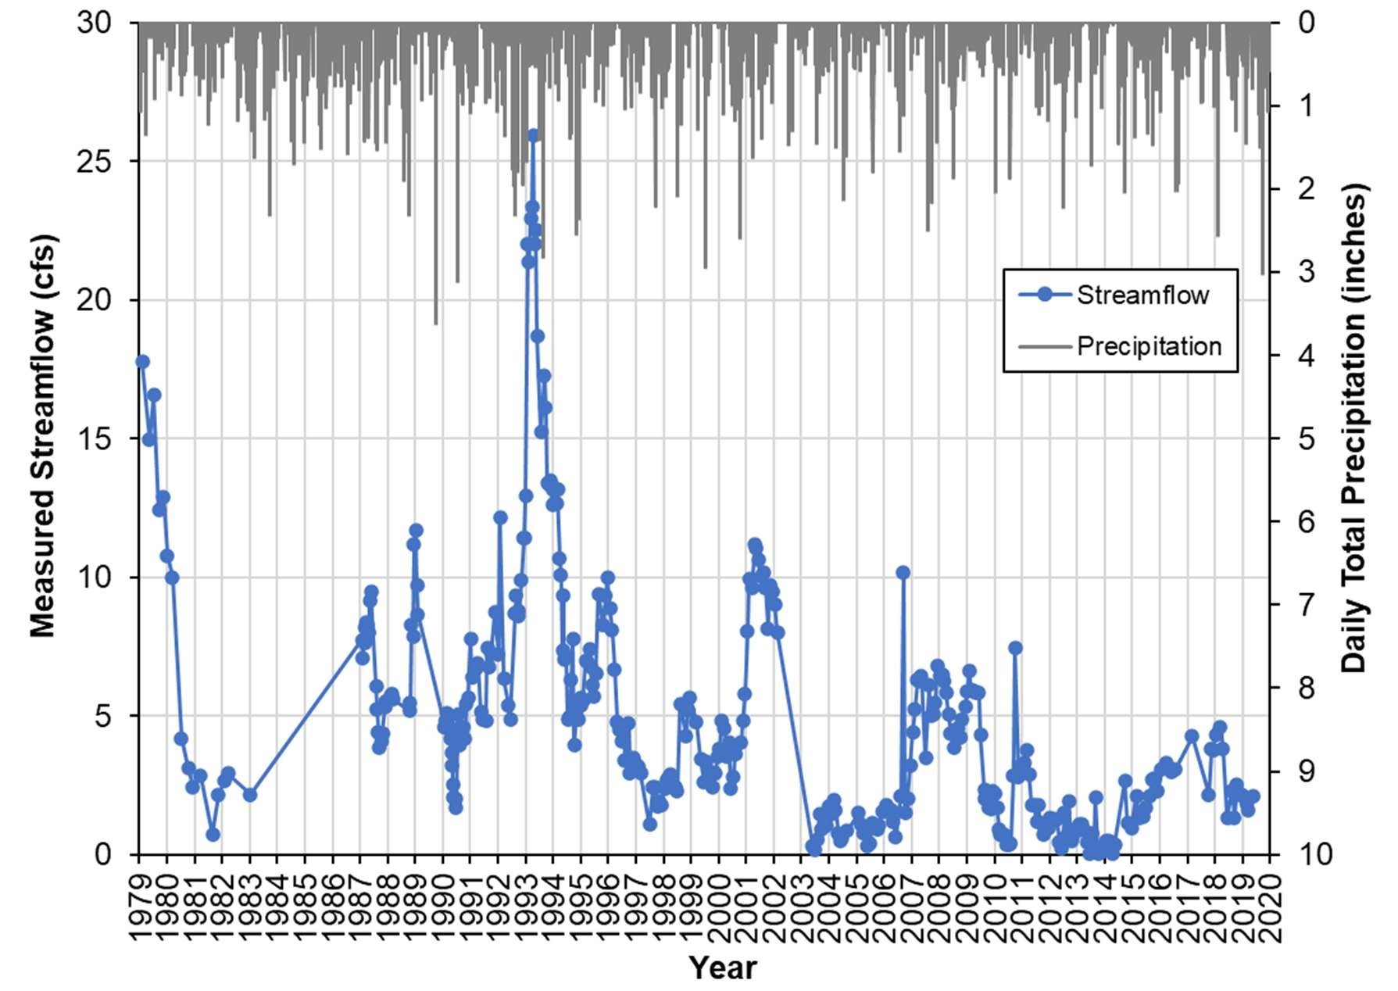
Figure 15. Periodic streamflow measured at the Preserve and daily total precipitation recorded near Patagonia during 1979–2019 (source data: TNC and NOAA NCDC 2020; analysis by Stillwater Sciences).
2.5.3 Seepage runs at the Preserve
In 1997 and 1998 three seepage runs were conducted along the perennial reach of Sonoita Creek in and downstream of the Preserve (Figure 16). Two of these seepage runs were conducted by TNC and one by ADWR. Measurements by both groups were collected in the same locations (Montgomery et al 1999). In addition, Montgomery el al (1999) collected flow measurements at a subset of locations in 1996 and 1998. Seepage runs are measurements of flow occurring along a stream or river system at the same time or near the same time to represent spatial patterns in streamflow. On average, flow measurements of seepage runs were obtained every 1,000 feet (Montgomery and Associates 1999).

The seepage runs occurred from one-quarter mile downstream of the town of Patagonia (at the head of the perennial reach) to three-quarters of a mile upstream of Patagonia Lake (approximately 6 miles) (Montgomery and Associates 1999) (Figure 16). The seepage runs demonstrated the gaining hydrologic conditions and the influence of rising groundwater across the Preserve (from approximately station 0 to station 7,000) (Figure 16). The seepage runs also determined that the location of the former USGS gage was positioned in a locally losing reach. Overall, the measured streamflow ranged from 0.54 to 6.13 cfs along the length of the perennial reach, with patterns in losing and gaining reaches being fairly consistent. Approximately 4 to 5 cfs was gained over the length of the perennial reach during the seepage runs.

Surface and Groundwater Trends, PSCP
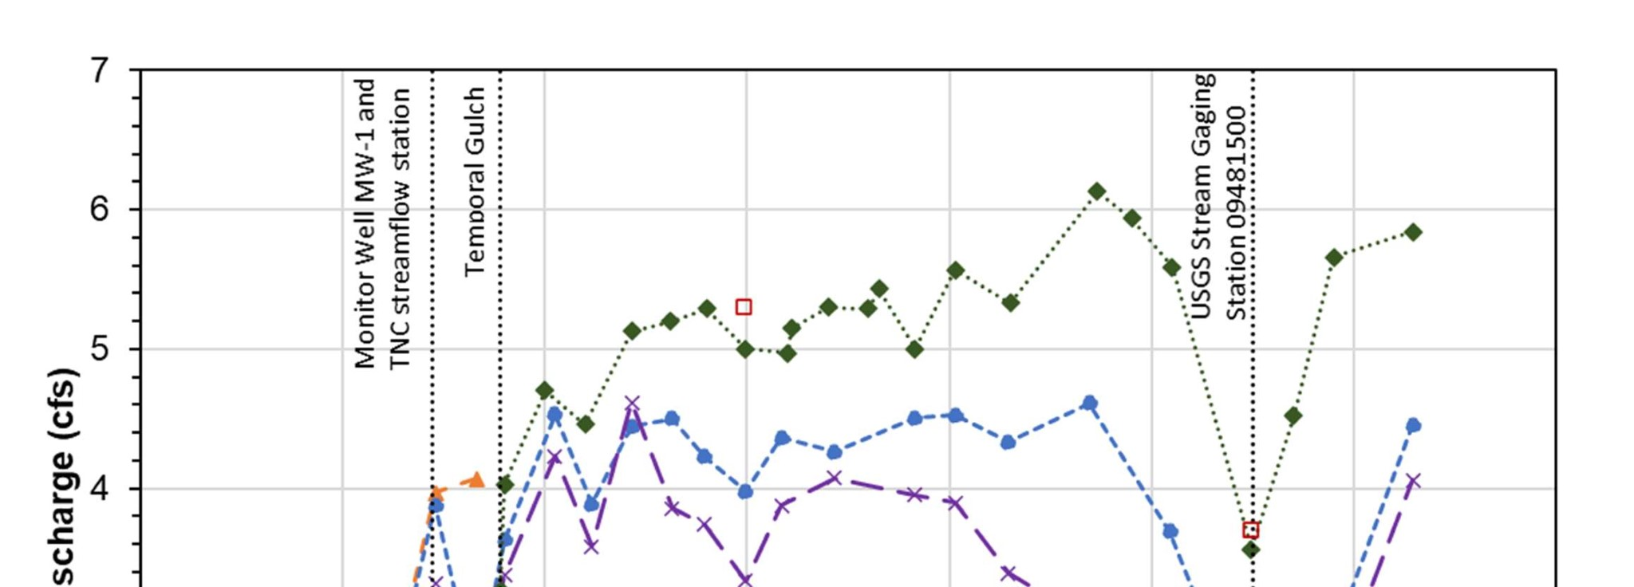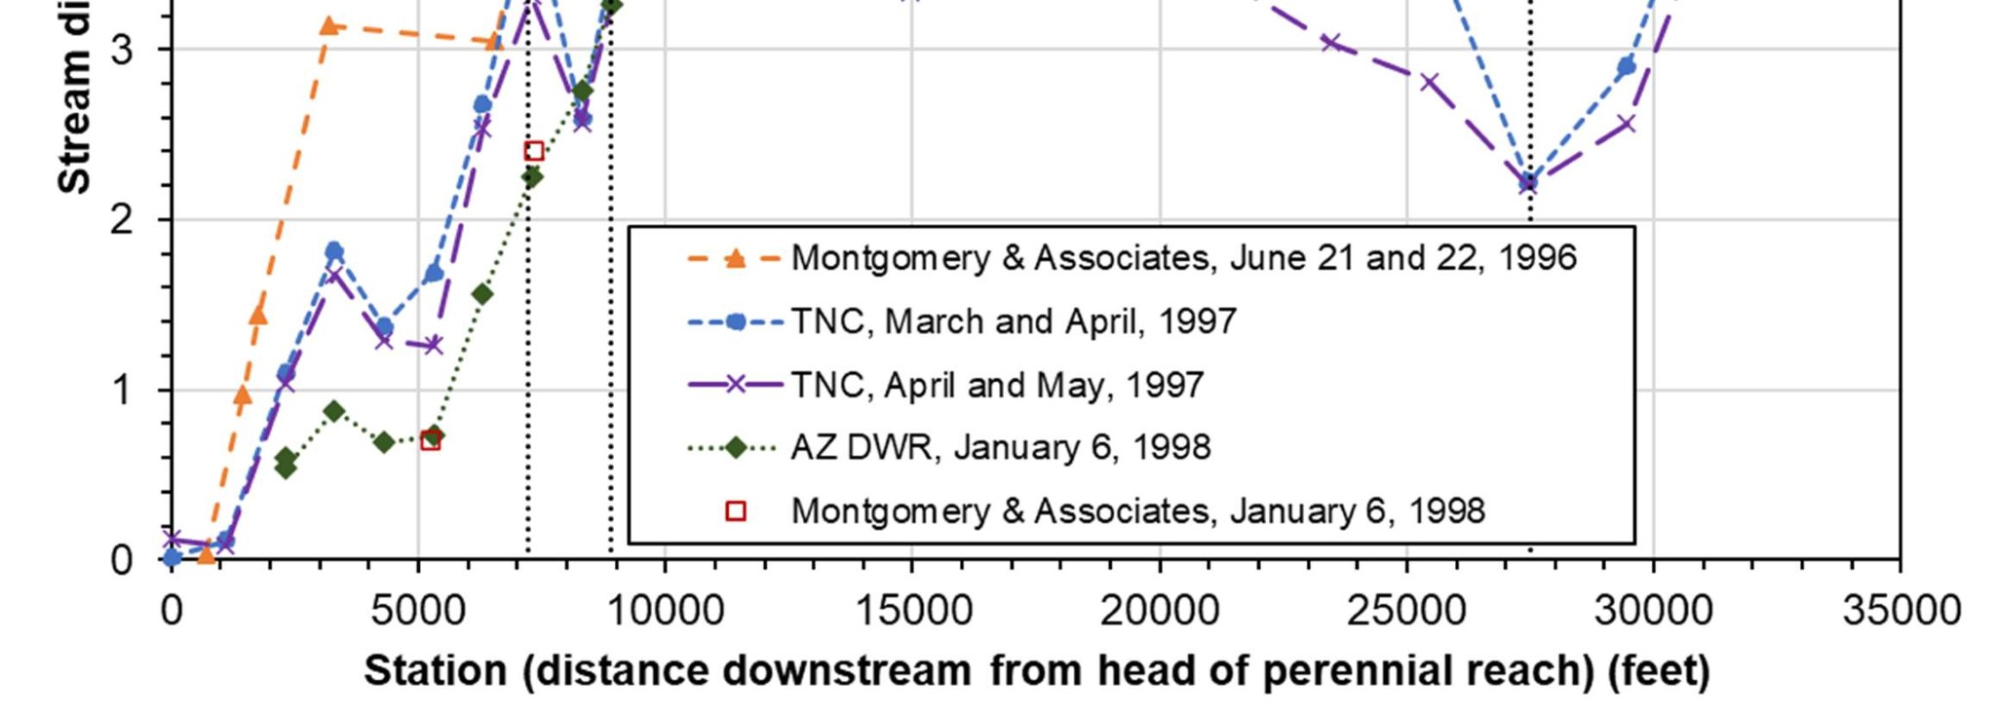
Figure 16. Seepage run results from ADWR’s January 1998 study near the Preserve (adapted from Montgomery and Associates 1999).

October 2020 Stillwater Sciences
18

2.6 Groundwater Monitoring
Groundwater has been monitored in twenty-seven monitoring wells on the Preserve (Figure 2); however, monitoring durations vary for each well (Table 3). Additionally, groundwater levels in two GWSI index wells with long-term publicly available data are included here as they provide additional context of local groundwater-level trends near the Preserve. One GWSI index well is located in the town of Patagonia (#55-809433) and the other is located approximately 7 miles upstream from the town (#55-624881) (see Figure 2). The total change in groundwater elevation over the monitoring period is reported in Table 3. To facilitate comparison between wells upstream of the Preserve, the upper Preserve, and the middle to lower Preserve, the change in groundwater elevation was calculated over two different time periods: 1993–2012 and 1993– 2018. For example, the change in the groundwater elevation in the NASH well during 1993–2012
(-13.92 feet) can be compared to the change in the GWSI index well in the town of Patagonia (-12.20 feet) for the same time period, even though the period of available data for the index well is much longer (1949–2020).

Table 3. Summary of TNC monitoring wells and GWSI index wells, listed from upstream to downstream. Change in groundwater elevation is calculated as the difference in the elevation for two time periods (1993–2012 and 1993–2018).
Well ID ^{A}  (listed from upstream to downstream) | Total period of available data | Change in groundwater elevation (feet) ^{B}
 |  | 1993–2012 | 1993–2018
Upstream of Preserve
GWSI (#55-624881) | 1949–2020 | -3.35 | -4.00
GWSI (#55-809433) | 1990–2019 | -12.20 | -5.90
Upper Preserve
6-4/5 | 1991–2001 | ND | ND
5-4 | 1991–2001 | ND | ND
NASH | 1992–2012 | -13.92 | ND^{ii}
8-5 | 1991–2012 | -5.81 | ND^{ii}
9-5 | 1991–2001 | ND | ND
Middle to Lower Preserve
14-5 | 1991–2019 | ND ^{i} | -0.34
16-6 | 1991–2019 | 0.21 | 3.14
C-1 | 1991–2001 | ND | ND
AG | 1992–2019 | ND ^{i} | 1.52
18-4 | 1993–2019 | -0.82 | -0.14
20-10 | 1991–2001 | ND | ND
20-5 | 1992–2019 | 0.14 | 1.16
MW-2 | 1998–2019 | ND | ND
24-4 | 1992–2019 | -1.43 | -1.00
MW-3 | 1998–2019 | ND | ND
MW-4 | 1998–2016 | ND | ND
MW-1 | 1998–2019 | ND | ND
MW-5 | 1998–2016 | ND | ND
SAC-1 | 1993–2019 | ND^{i} | 0.62
- Not listed are wells for which data was unavailable for this report (Stevens 3, Stevens 2, Stevens 1, FARM, and 4-7) and wells whose locations were unavailable for this report (PZ-1, PZ-2, and PZ 3).
- Data gaps in well data necessitated computing groundwater elevation changes for 1993–2012 and 1993–2018, which facilitates comparison between groundwater levels upstream of the Preserve, the upper Preserve, and the middle to lower Preserve; ND=no data available to calculate groundwater change; ^{i}=no data for this well in 2018; ^{ii}=no data for this well in 2012.
Groundwater levels in TNC wells at the upstream end of the Preserve and nearest to the town of Patagonia have generally declined during their monitoring period (Figure 17). This declining trend is consistent with declining groundwater levels in both GWSI index wells upstream of the Preserve (Figure 17, Figure 18, Table 3). Between 1993 and 2018, the watershed experienced a hydrologically losing period (see Figure 11), which appears to coincide with these observed groundwater-level declines.

Groundwater levels observed in monitoring wells located in the middle and downstream portions of the Preserve, which coincides with the previously described gaining reach, have generally remained stable (Figure 19). For example, in the seven wells for which data is available from 1993 to 2018 in the middle to lower Preserve, groundwater levels in six of the seven wells remained stable or slightly increased (see Table 3).

Some well data exhibit trends similar to streamflow patterns in the Preserve. For example, groundwater levels measured in the two wells located near the upstream end of the Preserve that have the longest monitoring records (NASH and 8-5) correlate well with streamflow measured on the same day (Figure 20, Figure 21).

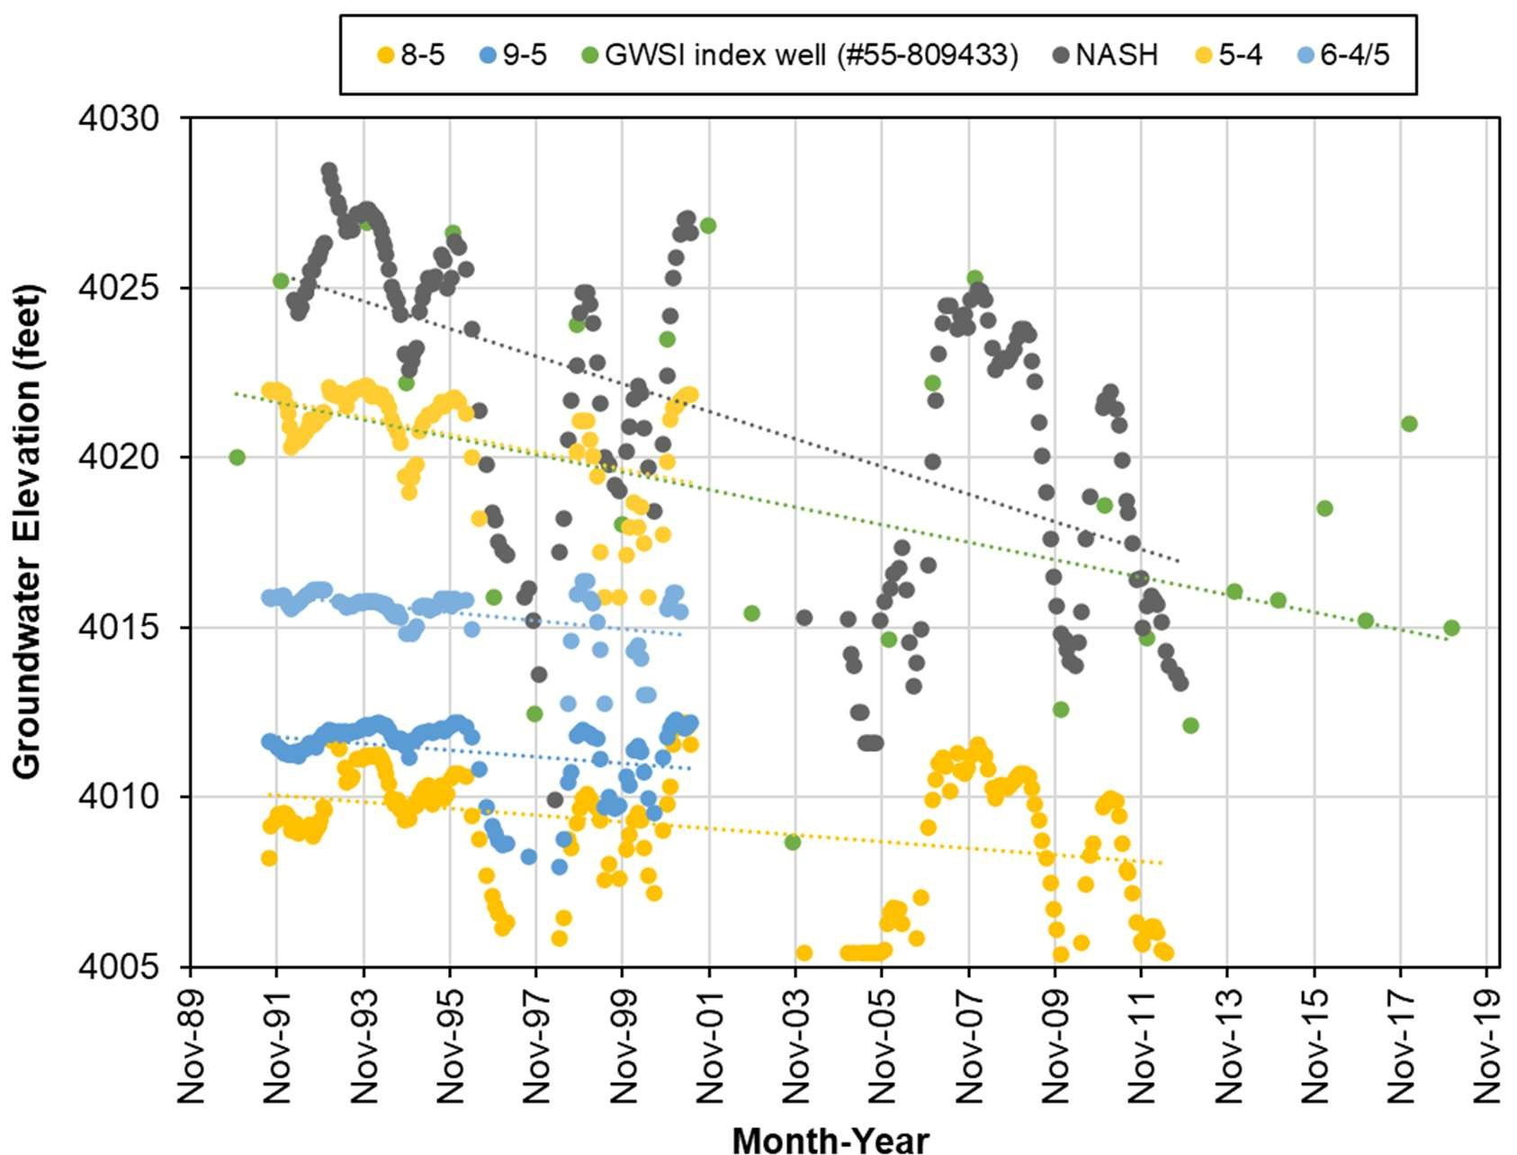
Figure 17. Groundwater elevations in TNC monitoring wells located on the upstream end of the Preserve and a GWSI index well (#55-809433) located in the town of Patagonia (source data: TNC and ADWR 2020; analysis by Stillwater Sciences).

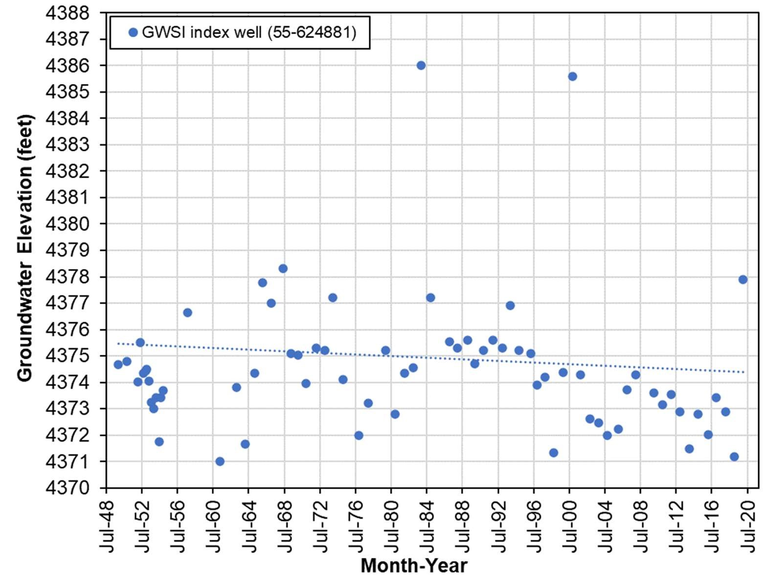
Figure 18. Groundwater elevations in a GWSI index well (#55-624881) located upstream from the town of Patagonia (source data: ADWR 2020; analysis by Stillwater Sciences).

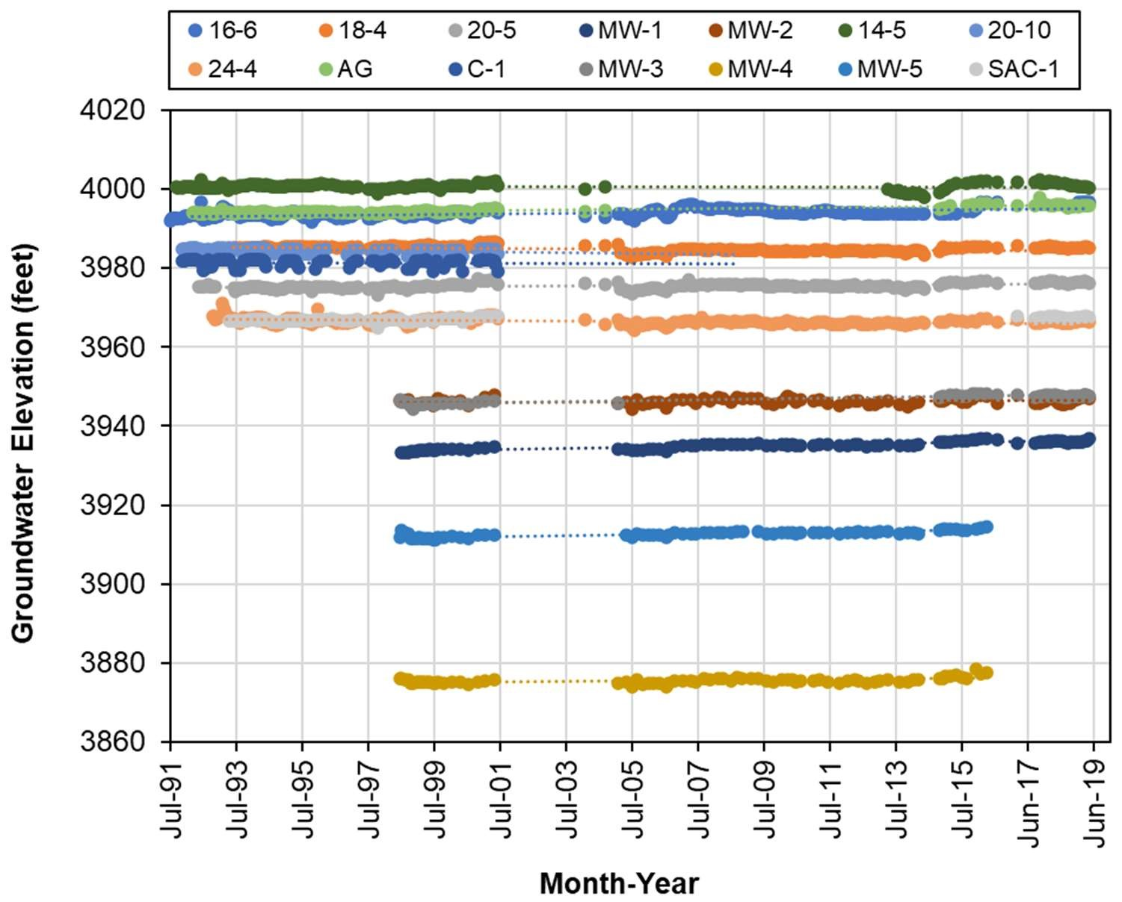
Figure 19. Groundwater elevations in TNC monitoring wells located on the middle to the downstream end of the Preserve (source data: TNC; analysis by Stillwater Sciences).
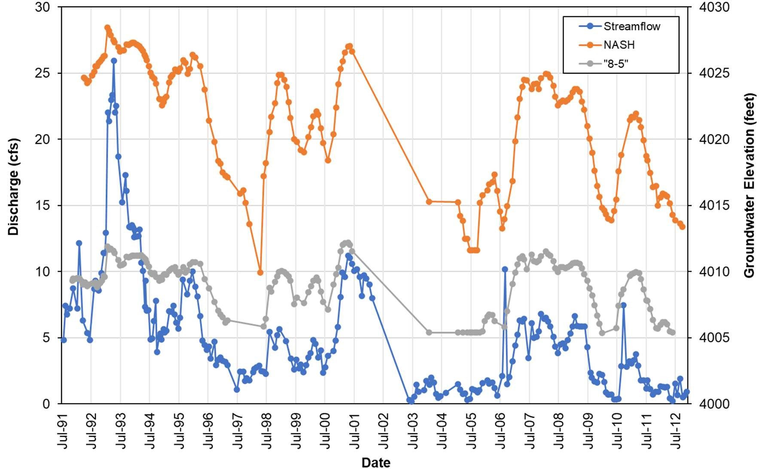
Figure 20. Groundwater elevations from NASH and 8.5 wells compared to streamflow measured in the Preserve (source data: TNC; analysis by Stillwater Sciences).

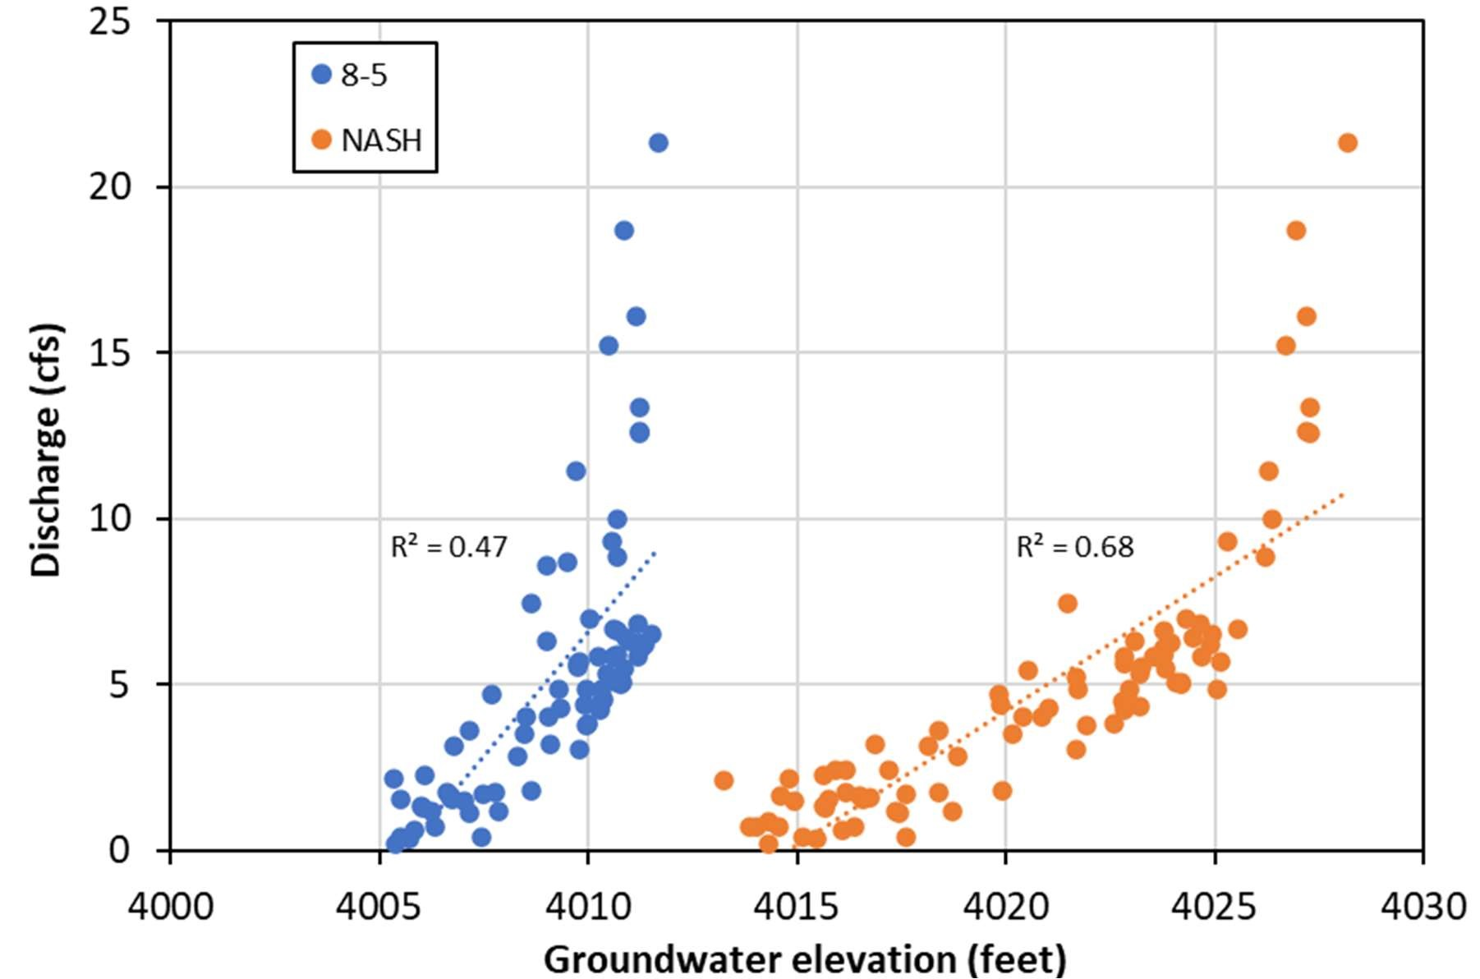
Figure 21. Regressions of groundwater elevations from NASH and 8.5 wells and streamflow at TNC’s flow station location for measurements collected on the same day (source data: TNC; analysis by Stillwater Sciences).

INTERACTIONS BETWEEN CLIMATE, STREAMFLOW, AND GROUNDWATER
A set of short-term and longer-term monitoring and analysis approaches to evaluate the compounding influence of climate, streamflow, and groundwater interactions on streamflows at the Preserve are explored in this section to help guide future monitoring activities. Although all approaches require additional data collection, the extent to which available data for Sonoita Creek can be utilized for each approach are considered.

Characterizing the interactions between climate, streamflow, and groundwater in a basin is an active area of research and there is not one uniform approach that is suitable for all basins. Characterization efforts can include field measurement, statistical analysis, or deterministic modeling (Brutsaert 2008; Lambert et al. 2011; Almanaseer and Sankarasubramanian 2012; Hanson et al. 2014; Woolfenden and Nishikawa 2014; Luhdorff & Scalmanini 2016; Killian et al. 2019). One of the main challenges of characterizing interactions between climate, streamflow, and groundwater is that the approach used must be able to distinguish between anthropogenicinduced changes to streamflow and groundwater (e.g., flow diversions, groundwater pumping) and broader climatic-induced variations in streamflow and groundwater (Barlow and Leake 2012). The multitude of approaches ranging from analysis of groundwater elevation trends and relatively coarse basin-scale water budgeting (Luhdorff & Scalmanini 2016) to basin-wide integrated groundwater-surface water modeling (Hanson et al. 2014) highlights the types of analysis available to evaluate interactions between climate, streamflow, and groundwater. Shortterm monitoring approaches lasting several days to several months are particularly useful for determining the local-scale impacts of groundwater pumping from a specific well or well field on nearby streams, but these periods individually cannot characterize the influence of climate due to their relatively short duration. Longer-term monitoring comprised of multiple relatively shortterm monitoring periods or continuous monitoring datasets that span multiple years (preferably decades) combined with various statistical analyses or modeling approaches are necessary to evaluate the influence of climate, streamflow, and groundwater.

3.1.1 Chemical and isotopic analysis
Chemical and isotopic analysis of streamflow in Sonoita Creek and groundwater in surrounding wells would provide a dataset to characterize the similarity of surface water and groundwater and potentially quantify the proportion of streamflow that is comprised of groundwater. Surface water and groundwater tend to have different chemical and isotopic concentrations due to differences in the contact time with soil minerals and evaporation (Hem 1989; Katz 1998; Shelton et al. 2010). Surface water is comprised of runoff from precipitation that has very limited contact with soil minerals and baseflow from groundwater that has a longer contact time with soil minerals, thus surface water tends to have a dynamic chemical composition (e.g., specific conductivity) that changes as the proportion of runoff and baseflow changes during the year. Groundwater tends to be more stable over time, but it may also shift over time depending on the rate precipitation infiltrates. As surface water undergoes evaporation, the ratio of hydrogen (¹H and ²H) and oxygen (¹⁶O, ¹⁷O, and ¹⁸O) isotopes change and the resulting isotopic signature in surface water is different than in groundwater, providing an ideal conservative tracer for evaluating the extent of mixing of surface water and groundwater (Gonfiantini 1986). Periodic grab samples of surface water from Sonoita Creek and surrounding groundwater wells during one or more years would potentially provide quantification of the proportion of the surface flow comprised of groundwater and identify the wells with the most similar chemical and isotopic characteristics that contribute to flows in Sonoita Creek. The collected surface water and groundwater data also would be potentially useful for calibrating a future integrated surface water-groundwater model of the area. While additional data would be collected for chemical and isotopic analysis, data from previous isotopic studies that have been conducted in the area (Montgomery et al 1999; Gu et.al 2005; Schrag-Toso 2020) would be integrated into the analysis as appropriate. However the chemical and isotopic analysis approach may be less suitable for Sonoita Creek than other approaches since a portion of Sonoita Creek is ephemeral, the perennial reach of Sonoita Creek is from recently emerged groundwater with extremely limited opportunity for evaporation, and the perennial reach of Sonoita Creek may be too short to detect spatial variations in groundwater chemical composition and identify any specific spatial relationships between Sonoita Creek and individual groundwater wells. Additionally, chemical and isotopic analysis would represent only the conditions at the time measurements are made, so this analysis would not be able to quantify longer-term climatic shifts.

3.1.2 Water type analysis
Interactions between climate, surface flow, and groundwater in the Sonoita Creek region can also be investigated by calculating precipitation exceedance probabilities at various time-scales (e.g., monthly, seasonally, and annually) from existing precipitation data in the Sonoita Creek region and evaluating correlations between Sonoita Creek flow, groundwater elevation, and monthly, seasonal, and annual precipitation thresholds. Very dry, dry, average, wet, and very wet periods in the data record can be defined for each time-scale based on precipitation exceedance probabilities. However, this type of analysis would not establish hydraulic connection between groundwater wells and surface flow, quantify how variations in groundwater alter surface flow, nor evaluate long-term climatic variations on surface flow and groundwater elevations.

Existing precipitation, streamflow, and groundwater elevation data could be utilized for this analysis, but a preliminary water type analysis conducted by Stillwater Sciences suggests that streamflow and groundwater elevation measurements did not occur frequently enough to detect a correlation between the monthly, seasonal, or annual precipitation and the streamflow or groundwater elevation measurements. While sufficient daily precipitation data was available at weather stations near Patagonia to estimate the water type at monthly, seasonal, or annual timescales, streamflow and groundwater measurements were not continuous nor at a sufficiently frequent time step to characterize the total volume of the streamflow or change in local groundwater volume during the various time-scales. Instantaneous periodic streamflow measurements are less likely to correlate with various precipitation thresholds than the total volume of the streamflow since instantaneous streamflow can vary over several orders of magnitude prior, during, and after a storm event.

Analysis of correlations between precipitation thresholds, streamflow, and groundwater elevations would not be suitable for Sonoita Creek since the preliminary analysis indicates the correlation results would likely be inconclusive with existing data due to insufficient frequency of streamflow or groundwater elevation measurements. Additional continuous streamflow and/or groundwater elevation measurements over multiple water year types would likely need to be collected to detect correlations between streamflow and precipitation or groundwater elevation and precipitation.

3.1.3 Baseflow recession rate
Calculation of the baseflow recession rate in Sonoita Creek during spring when precipitation rates are relatively low and comparison of those baseflow recession rates with variations in groundwater elevations at nearby wells can also estimate how Sonoita Creek flows vary with groundwater elevation changes. Continuous surface flow data would need to be collected during spring to capture baseflow recession in Sonoita Creek, while continuous or relatively frequent groundwater elevation data would need to be collected in groundwater wells to compare with baseflow recession rates. Groundwater elevation data likely would need to be collected throughout the year since the groundwater elevation variations may influence Sonoita Creek flows at a longer than seasonal time-scale. Hydrograph separation methods can be used to estimate the baseflow in Sonoita Creek from continuous surface flow data, then the baseflow recession rates can be estimated. During periods with lower precipitation, the majority of surface flow in streams would be comprised of groundwater, so it is expected that the baseflow recession rate would be slower when groundwater elevations are higher and more rapid when groundwater elevations are lower if there is a hydraulic connection between surface flow and the groundwater
(Killian et al. 2019). Groundwater pumping that lowers the groundwater elevation near Sonoita Creek would be expected to cause a more rapid baseflow recession rate. Comparison of the seasonal baseflow recession rates with variations in groundwater elevation would potentially identify the relative influence of groundwater on Sonoita Creek flows. Stormflow estimates from the hydrograph separation methods, increases in baseflow following precipitation events, and variations in the baseflow recession rate would quantify how seasonal surface flow is influenced by precipitation. Additionally, multiple years of collecting the data necessary for the baseflow recession analysis would enable evaluation of climatic variations on Sonoita Creek baseflow recession and groundwater elevation, but it would likely require more than five years of monitoring with multiple water year types to begin to quantify climatic variations on Sonoita Creek conditions. Continuous streamflow and continuous or relatively frequent groundwater elevation data collected for the baseflow recession analysis also would be useful for calibrating a future integrated surface water-groundwater model of the area. Concurrent continuous streamflow and continuous or relatively frequent groundwater data is not available in the existing data for Sonoita Creek, so additional monitoring be required to conduct the baseflow recession analysis. However, additional streamflow monitoring could be focused seasonally, so the cost and challenges of establishing a permanent streamflow gage on Sonoita Creek would not be encountered.

3.1.4 Principal component analysis
Principal component analysis (PCA) of precipitation, temperature, streamflow, groundwater, and potentially other available data (e.g., El Niño/Southern Oscillation index) can be used to determine the dominant variables influencing the basin hydroclimatology. PCA is a statistical exploratory data analysis approach to determining the variables that best explain the variations in a dataset (Jolliffe and Cadima 2016). PCA has successfully been used to quantify the relative influence of climate variability on surface water and groundwater (Almanaseer and Sankarasubramanian 2012; Rumsey et al. 2015), so it would be suitable for evaluating the interactions between climate, surface water, and groundwater on Sonoita Creek. While PCA can be run on existing data, the effectiveness of the analysis may be limited by the availability of the data. Additional data collection of the various parameters to consider in the PCA may be warranted, but it would likely require multiple years of data collection of the various parameters.

3.1.5 Modeling
Interactions between climate, surface flow, and groundwater can be characterized by integrated surface water-groundwater modeling of the Sonoita Creek basin, but integrated surface watergroundwater modeling requires a significant time and financial investment. Multiple types of basin-scale integrated surface water-groundwater models have been used to quantify the interactions between climate, streamflow, and groundwater (Hevesi et al. 2013; Hanson et al. 2014; Woolfenden and Nishikawa 2014; Hunt et al. 2016). While there are general integrated surface water-groundwater modeling packages like the USGS GSFLOW model, the numerous model parameters must be adapted for the specific basin conditions, requiring multiple assumptions and significant amounts of data to calibrate the model to a basin. Potential climate variations are typically an input to basin-scale integrate surface water-groundwater models, so a climate model (e.g., general circulation models) also would be required as inputs to investigate how climate change conditions would alter surface flow and groundwater conditions in Sonoita Creek. Existing data from the Sonoita Creek basin would be useful for developing and calibrating an integrated surface water-groundwater model, but additional data would likely need to be collected such as continuous Sonoita Creek flow measurements, continuous groundwater elevation measurements at individual wells, and estimates of aquifer properties at the individual wells distributed across the area being modeled. Pumping and recovery testing of individual wells where access is available would be particularly helpful for the development of an integrated surface water-groundwater model since such tests would estimate the aquifer properties (i.e., transmissivity and hydraulic conductivity) at individual wells. An integrated surface watergroundwater model is suitable for quantifying interactions between climate, surface flow, and groundwater in the Sonoita Creek basin. Multiple modeling scenarios could be run to explore how variations in climate, surface flow, and groundwater would alter conditions in the basin and such a model would likely provide the best quantification of climate, surface flow, and groundwater interactions. However, an integrated surface water-groundwater model approach would have the highest cost of all the approaches discussed. While uncertainty about model accuracy and climate, surface flow, and groundwater interactions would still be present (i.e., all groundwater flow paths cannot be fully modeled even with significant data collection efforts), this approach is the best option for characterizing interactions between climate, streamflow, and groundwater and distinguishing between anthropogenic-induced changes to streamflow and groundwater (e.g., groundwater pumping) and broader climatic-induced variations in streamflow in Sonoita Creek.

CONCLUSIONS
4.1 Summary
The primary source of baseflow for the perennial reach of Sonoita Creek is groundwater transmitted through Quaternary and Tertiary basin-fill and alluvial deposits, as well as through fractured bedrock (Montgomery and Associates 1999, Gu et al. 2008, Schrag-Toso 2020). From 1982 to 1993, baseflows on the Preserve showed an increasing trend during 1982–1993 and a decreasing trend during 1993–2019 (Figure 15). These periods of increasing and declining baseflow conditions coincide with increasing (1982–1993) and declining (1993–2018) trends in annual precipitation totals (Figure 11). Additionally, the recent period with decreasing baseflows partially coincided with the town of Patagonia’s decreased groundwater pumping and effluent discharge to the creek during 2004–2019 (Figure 5).

Groundwater levels near the town of Patagonia and the upstream end of the Preserve have exhibited a declining trend since the early 1990s. Like the decline in surface-water flows, the declining groundwater levels are likely affected by decadal scale changes in precipitation patterns. The upstream end of the Preserve may also be sensitive to groundwater pumped for municipal, domestic, industrial, commercial, agricultural, or mining uses and to treated discharges from municipal or other operations. Groundwater levels in the remainder of the Preserve have been stable, however.
4.2 Recommendations
While several notable findings may be made from the long-term streamflow and groundwaterlevel monitoring conducted at the Preserve, several data gaps remain that, when filled, may help to better characterize local hydrologic conditions and potential future threats. The following briefly offers recommendations for additional data collection and analysis:
- Share existing or proposed commercial, industrial, agricultural, and mining pumping volumes from wells near the Preserve, the town of Patagonia, and along Harshaw Creek and Alum Gulch.
- Share existing or proposed daily treated discharge rates into Sonoita Creek or its tributaries upstream from the Preserve.
- Obtain well-construction and soil-profile logs for wells at the Preserve, near the town of Patagonia, and along Harshaw Creek and Alum Gulch.
- Develop a baseflow recession relationship utilizing newly collected continuous surface and continuous or frequent groundwater data as outlined in the hydrologic monitoring plan.
- Develop a surface-groundwater model of mainstem Sonoita Creek with a focus on baseflow on the Preserve and the downstream perennial reach, as well as with a focus on connectivity to geologic units which supply baseflow (sedimentary and alluvial deposits, fractured bedrock).
- Identify the water source of the spring-fed ciénega at the Preserve.

A hydrologic monitoring plan is currently under development that will detail future surface-water and groundwater monitoring efforts. The monitoring plan will outline the study plan and methods needed to implement recommendations #4 through #6.

CITED LITERATURE
ADWR (Arizona Department of Water Resources). 2009. Arizona Water Atlas Volume 3.
Southeastern Arizona Planning Area. Available at:
https://repository.asu.edu/attachments/92786/content/Volume_3_final.pdf

ADWR. 2020. Arizona Groundwater Site Inventory: web interface. Prepared by Arizona Department of Water Resources, Phoenix. Available at: https://gisweb3.azwater.gov/gwsi.

Almanaseer, N. and A. Sankarasubramanian. 2012. Role of climate variability in modulating the surface water and groundwater interaction over the Southeast United States. Journal of Hydrologic Engineering 17: 1001 – 1010.

Barlow, P.M. and S. A. Leake. 2012. Streamflow depletion by wells – Understanding and managing the effects of groundwater pumping on streamflow. U.S. Geological Survey Circular 1376. U.S. Geological Survey, Reston, Virginia. Available at: http://pubs.usgs.gov/circ/1376/.

Brutsaert, W. 2008. Long-term groundwater storage trends estimated from streamflow records: Climactic perspective. Water Resources Research 44, W02409.

Clear Creek Associates. 2014. Town of Patagonia Water Supply PowerPoint presentation. August 14th, 2014. Available at:
http://patagonia-az.gov/wp-content/uploads/2011/07/clear-creeek-powerpoint-1.pdf

Demaria, E. M. C, P. Hazenberg, R. L. Scott, M. B. Meles, M. Nichols, and D. Goodrich. 2020. Intensification of the North American monsoon rainfall as observed from a long-term highdensity gauge network. Geophysical Research Letters 46.

Garfin, G., A. Jardine, R. Merideth, M. Black, and S. LeRoy. 2013. Assessment of climate change in the southwest United States: a report prepared for the National Climate Assessment. A report by the Southwest Climate Alliance. Washington, DC: Island Press. Available at: https://www.swcarr.arizona.edu/sites/all/themes/files/SW-NCA-color-FINALweb.pdf.

Gonfiantini, R. 1986. Environmental isotopes in lake studies. In Handbook of Environmental Isotope Geochemistry. Eds. D. Fontes and P. Fritz. Vol 2: 113 – 168. Elsevier.

Graf, W. L. 1988. Fluvial processes in dryland rivers. Springer-Verlag, New York.

Gray, F., L. Wirt, K. Caruthers, A. L. Gu, C. Velez, D. M. Hirschberg, and K. Bolm. 2000. Transport and fate of Zn and Cu rich, low pH water in surface and groundwater from porphyry copper and related ore deposits, basin and range province, southeastern Arizona. Society for Mining, Metallurgy and Exploration 1: 411–430.

Gu, A., F. Gray, C. J. Eastoe, L. M. Norman, O. Duarte, and A. Long. 2008. Tracing ground water input to base flow using sulfate (S,O) Isotopes. Ground Water 46: 502–509.

Hanson, R.T., W. Schmid, C.C. Faunt, J. Lear, and B. Lockwood. 2014. Integrated hydrologic model of Pajaro Valley, Santa Cruz and Monterey Counties, California. U.S. Geological Survey Scientific Investigations Report 2014-5111. U.S. Geological Survey, Reston, Virginia. Available at: http://dx.doi.org/10.3133/sir20145111.

Hem, J.D. 1989. Study and interpretation of the chemical characteristics of natural water. 3rd Ed.
U.S. Geological Survey Water-Supply Paper 2254. U.S. Geological Survey, Alexandria, Virigina.

Hevesi, J.A., W.R. Henson, R.T. Hanson, and S.E. Boyce. 2013. Integrated hydrologic modeling of the Salinas River, California, for sustainable water management. U.S. Geological Survey, Sacramento, California.

Hunt, R.J., S.M. Westenbroek, J.F. Walker, W.R. Selbig, R.S. Regan, A.T. Leaf, and D.A. Saad. 2016. Simulation of climate change effects on streamflow, groundwater, and stream temperature using GSFLOW and SNTEMP in the Black Earth Creek Watershed, Wisconsin. U.S. Geological Survey Scientific Investigations Report 2016-5091. Available at: http://dx.doi.org/10.3133/sir20165091.

Jolliffe, I.T. and J. Cadima. 2016. Principal component analysis: a review and recent developments. Phil. Trans. R. Soc. A. 374: 20150202. Available at:
http://dx.doi.org/10.1098/rsta.2015.0202

Katz, B.G. 1998. Using δ¹⁸O and δD to quantify ground-water/surface-water interactions in karst systems of Florida. U.S. Geological Survey, Tallahassee, Florida.

Killian, C.D, W.H. Asquith, J.R.B. Barlow, G.C. Bent, W.H. Kress, P.M. Barlow, D.W. Schmitz. 2019. Characterizing groundwater and surface-water interaction using hydrograph-separation techniques and groundwater-level data throughout the Mississippi Delta, USA. Hydrogeology Journal 27:2167-2179.

Lambert, P.M., T. Marston, B.A. Kimball, and B.J. Stolp. 2011. Assessment of groundwater/surface-water interaction and simulation of potential streamflow depletion induced by groundwater withdrawal, Unita River near Roosevelt, Utah. U.S. Geological Survey Scientific Investigations Report 2011-5044. U.S. Geological Survey, Reston, Virginia.

Luhdorff & Scalmanini Consulting Engineers. 2016. Napa Valley groundwater sustainability – A basin analysis report for the Napa Valley Subbasin. Prepared by Luhdorff & Scalmanini Consulting Engineers for Napa County. December 13, 2016. Available at:
https://sgma.water.ca.gov/portal/alternative/print/11

Montgomery and Associates. 1999. Hydrogeologic Investigation of Groundwater Movement and Sources of Base Flow to Sonoita Creek Near Patagonia, Santa Cruz County, Arizona. Prepared for the Arizona Department of Water Resources.

NextGen Engineering. 2017. Final Sonoita Creek Watershed Management Plan Phase 1. Prepared
for the Town of Patagonia. Available at: https://patagonia-az.gov/wpcontent/uploads/2015/12/Final-Phase-1-Sonoita-Creek-WMP-5-12-17.pdf

NOAA (National Oceanic and Atmospheric Administration). 2020. NOAA National Centers for Environmental Information, Climate Data Online: web interface. Available at: https://www.ncdc.noaa.gov/cdo-web/.

Patagonia Area Resource Alliance and Earth Works. 2014. The Hermosa Mine Proposal: Potential Impacts to Patagonia’s Water Supply. Available at: http://www.patagoniaalliance.org/wp-content/uploads/2014/11/Report-Hermosa-MineProposal.pdf.

PRISM (Parameter-elevation Regressions on Independent Slopes Model) Climate Group 2020.
PRISM Time Series Data. Available at: https://prism.oregonstate.edu/
The Nature Conservancy (TNC), Borderlands Restoration Network, Tucson Audubon Society, and Circle Z Ranch. 2020. Sonoita Creek Watershed Conservation Plan.

Richter, B. 1992. Patagonia instream assessment. Internal TNC Memo.

Rumsey, C.A., M.P. Miller, D.D. Suson, F.D. Tillman, and D.W. Anning. 2015. Regional scale estimate of baseflow and factors influencing baseflow in the Upper Colorado River Basin. Journal of Hydrology: Regional Studies 4: 91 – 107.

Schrag-Toso, S. C. 2020. Isotopes, geochemistry, citizen science, and local partnerships as tools to build upon a fractured understanding of the hydrology of the Northern Patagonia Mountains. Master’s thesis. University of Arizona, Tuscon.

Shelton, J.L., M.S. Fram, C.M. Munday, and K. Belitz. 2010. Groundwater-qualtiy data for the Sierra Nevada study unit, 2008: Results from the California GAMA program. U.S. Geological Survey Data Series 534. U.S. Geological Survey, Reston, Virginia.

USGCRP (U.S. Global Change Research Program). 2018. Climate science special report: fourth national climate assessment, volume I. U.S. Global Change Research Program, Washington, DC, USA. Available at: https://www.globalchange.gov/nca4.

USGS (U.S. Geological Survey). 2020. National Water Information System: web interface. Available at: http://waterdata.usgs.gov/nwis.

Woolfenden, L.R. and T. Nishikawa, eds. 2014. Simulation of groundwater and surface-water resources of the Santa Rosa Plain watershed, Sonoma County, California. U.S. Geological Survey Investigations Report 2014-5052. U.S. Geological Survey, Reston, Virginia. Available at:
http://dx.doi.org/10.3133/sir20145052

Appendices

October 2020 Stillwater Sciences

Appendix A

Rainfall-Streamflow Correlation

October 2020 Stillwater Sciences

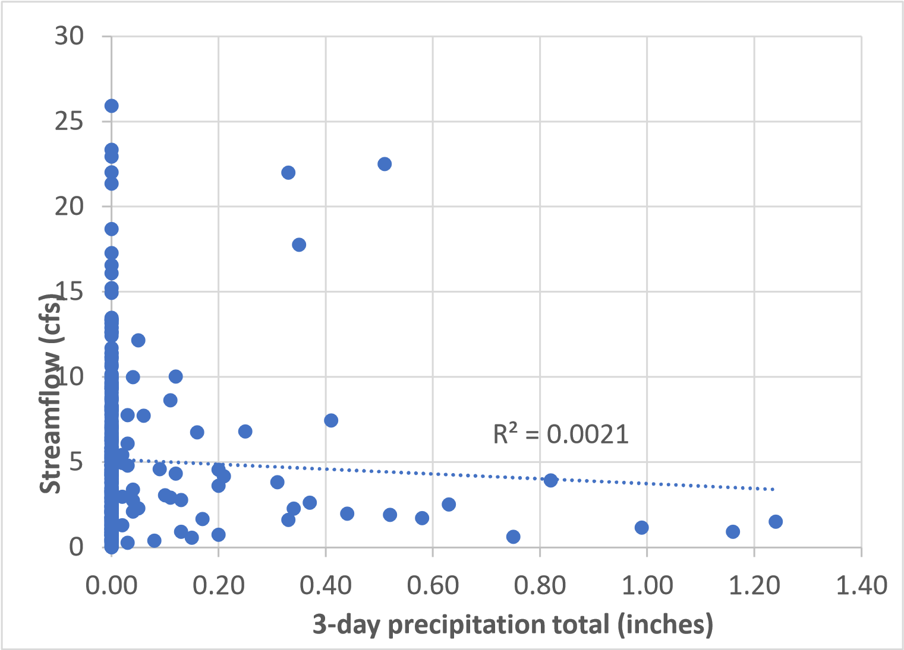
Figure A-1. The total precipitation that occurred on the day that the streamflow measurement was collected, and on the two preceding days (3 day total), shows no correlation with streamflow measurements.

October 2020 Stillwater Sciences
A-1

