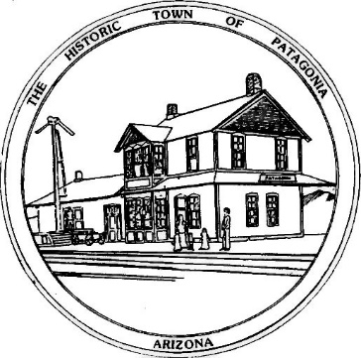
TOWN OF PATAGONIA
PLANNING AND DEVELOPMENT COMMITTEE SPECIAL MEETING
AGENDA, FEBRUARY 2, 2021 7:00 P.M.
Zoom Meeting I.D. 957-511-4862 Password 338501

1. CALL TO ORDER

2. ROLL CALL

3. CORRECTION AND/OR APPROVAL OF MINUTES FROM: JANUARY 5, 2021

4. CALL TO THE PUBLIC

5. CHAIR PERSONS REPORT ON CURRENT EVENTS

OLD BUSINESS

6. DISCUSSION OF USE PERMITS, AND ENABLING LANGUAGE IN CHAPTER 14 OF TOWN CODE, AND FUTURE OF USE PERMITS IN PATAGONIA.

7. DISCUSSION OF POSSIBLE ESTABLISHMENT OF A TEMPORARY USE PERMIT.

8. DISCUSSION OF ECONOMIC DEVELOPMENT PRIORITIES FOR PATAGONIA AND AREA, WITH DIRECT COMMITTEE INPUT.

NEW BUSINESS

9. INITIAL DISCUSSION OF PATAGONIA FALL FESTIVAL AS A MATTER OF TOWN PLANNING, AND DISCUSSION OF OTHER POTENTIAL TOWN SPONSORED EVENTS.

9. FUTURE AGENDA ITEMS

10. ADJOURN

