LICENSE AGREEMENT
This LICENSE AGREEMENT ("Agreement") is made as of July 8, 2020 (the "Effective Date"), by and between ARIZONA MINERALS, INC., a Nevada corporation authorized to do business in Arizona ("Licensee") and the TOWN OF PATAGONIA, ARIZONA, acting by and through its Town Manager/Clerk ("Licensor").

RECITALS
- Licensor owns certain real property located in Santa Cruz County, Arizona that is part of the Town of Patagonia depicted on Exhibit A attached hereto (the "Property").
- Licensee is willing to make certain public improvements to the Property described and depicted on Exhibit B (the "Work") at Licensee's sole cost and expense and for the benefit of Licensor.
- Licensor has the right and authority, and is willing, to authorize access to the Property for the Work to be conducted subject to the terms and conditions set forth in this Agreement.
NOW, THEREFORE, for good and valuable consideration, the parties hereto agree as follows:
- License to Enter and Occupy the Property. For a period of no more than one (1) year from the Effective Date hereof (the "Term"), Licensor hereby grants Licensee and its duly authorized employees, agents, contractors and subcontractors (collectively, "Representatives") a nonexclusive license to enter upon the Property for the purpose of conducting the Work at Licensee's sole cost and expense, provided that Licensee's or its Representatives' entry onto the Property to perform the Work shall be made in such a manner so as to minimize interfere with the use of the Property by Licensor if possible.
- Applicable Laws. In connection with any activities undertaken pursuant to this Agreement, Licensee and its Representatives shall comply with all applicable federal, state and local laws, rules, regulations, ordinances and private covenants, conditions and restrictions that pertain to the Property and the Work ("Applicable Laws"). In addition, both parties agree to: (i) comply with anti-bribery and anti-corruption Laws that are applicable to either party in connection with this Agreement and the Work; and (ii) not receive, accept or give any Bribe to any Governmental Official. For purposes of this Section 2(ii), the following terms have the following meanings:
  - "Bribe" means any offer of, payment of, or request for, any monetary or
other thing of value to influence a Government Official or any other person to act improperly in performing his/her duties, including the giving of a facilitation payment, which is a payment or gift, even if small, given to a Government Official to speed up his/her performance of a routine and non-discretionary service; and
  - "Government Official" includes any:
    - officer, employee or agent of a government or public international
organization or any department or agency thereof or any government-owned or controlled entity (including state owned or controlled enterprises);
    - political party or party official, or political office candidate; and
    - person acting on behalf of such government or public international
organization, or any agency, department, or instrumentality thereof.
- Liens. Licensee shall not suffer or permit to be enforced against the Property any mechanics', materialmen's, contractors' or subcontractors' liens or any claim for damage arising from the actions or omissions of Licensee or its Representatives on or about the Property, and Licensee shall pay or cause to be paid all of said liens, claims or demands before any action is brought to enforce the same against the Property.
- Indemnity. Licensee shall indemnify, defend, save and hold harmless Licensor and its officers, officials, agents, and employees (hereinafter referred to as "Indemnitee") from and against any and all third party claims, actions, liabilities, damages, losses, or expenses (including court costs, attorneys' fees, and costs of claim processing, investigation and litigation) (hereinafter referred to as "Claims") for bodily injury (including death), or loss or damage to tangible or intangible property caused, or alleged to be caused, in whole or in part, by the negligent or willful acts or omissions of Licensee or any of its Representatives arising out of or attributable to Licensee's entry onto the Property.
- Termination. Licensee's rights granted by this Agreement shall terminate automatically without notice, upon the expiration of the Term or completion of the Work. Upon expiration of this Agreement, Licensee shall promptly vacate the Property.
- Nature of Rights. Licensee acknowledges that: (i) this Agreement grants Licensee a nonexclusive license and (ii) Licensee has no rights as an owner, purchaser or tenant by virtue hereof.
- Assignability. This Agreement may not be assigned, whether voluntarily or by operation of law and Licensee shall not permit the use of the Property, or any part thereof, except in strict compliance with the provisions hereof, and any attempt to do so shall be null and void.
- Attorneys' Fees. If any action is brought by either party with respect to its rights under this Agreement, the prevailing party shall be entitled to reasonable attorneys' fees and court costs as determined by the court.
- Applicable Law. This Agreement shall be governed by and construed in accordance with Arizona law.
- Notices. All notices, requests, demands or documents which are required or permitted to be given or served hereunder shall be in writing and may also be sent by electronic mail. The addresses of the parties for notice by any of the foregoing means shall be as follows:
If to Licensee: |  | ARIZONA MINERALS, INC.
 |  | Attn: Pat Risner, President 2210 East Fort Lowell Road
 |  | Tucson, Arizona 85719
 |  | Pat.Risner@south32.net
If to Licensor: |  | TOWN OF PATAGONIA, ARIZONA  Attn: Ronald Robinson, Town Manager/Clerk  310 McKeown Avenue  Patagonia, Arizona 85624
patagoniagov@qwestoffice.net

Any party may change its notice address by giving prior written notice to the other party as described above.

- Entire Agreement. This Agreement constitutes the entire agreement between the parties pertaining to the subject matter contained herein. No supplement, modification or amendment of this Agreement shall be binding unless in writing and executed by Licensor and Licensee. This Agreement may be executed in any number of counterparts, each of which shall be an original, but all of which shall constitute the same instrument.
- No Recordation. Neither Licensor nor Licensee shall record this Agreement or any memorandum of this Agreement.
IN WITNESS WHEREOF, the parties hereto have executed this Agreement as of the date first above written.
LICENSEE:
ARIZONA MINERALS, INC.
an Arizona corporation

By:
Name: Pat Risner
Title: President

LICENSOR:

TOWN OF PATAGONIA, ARIZONA

By:
Name: Ronald Robinson
Title: Town Manager/Clerk
Exhibit A
Property
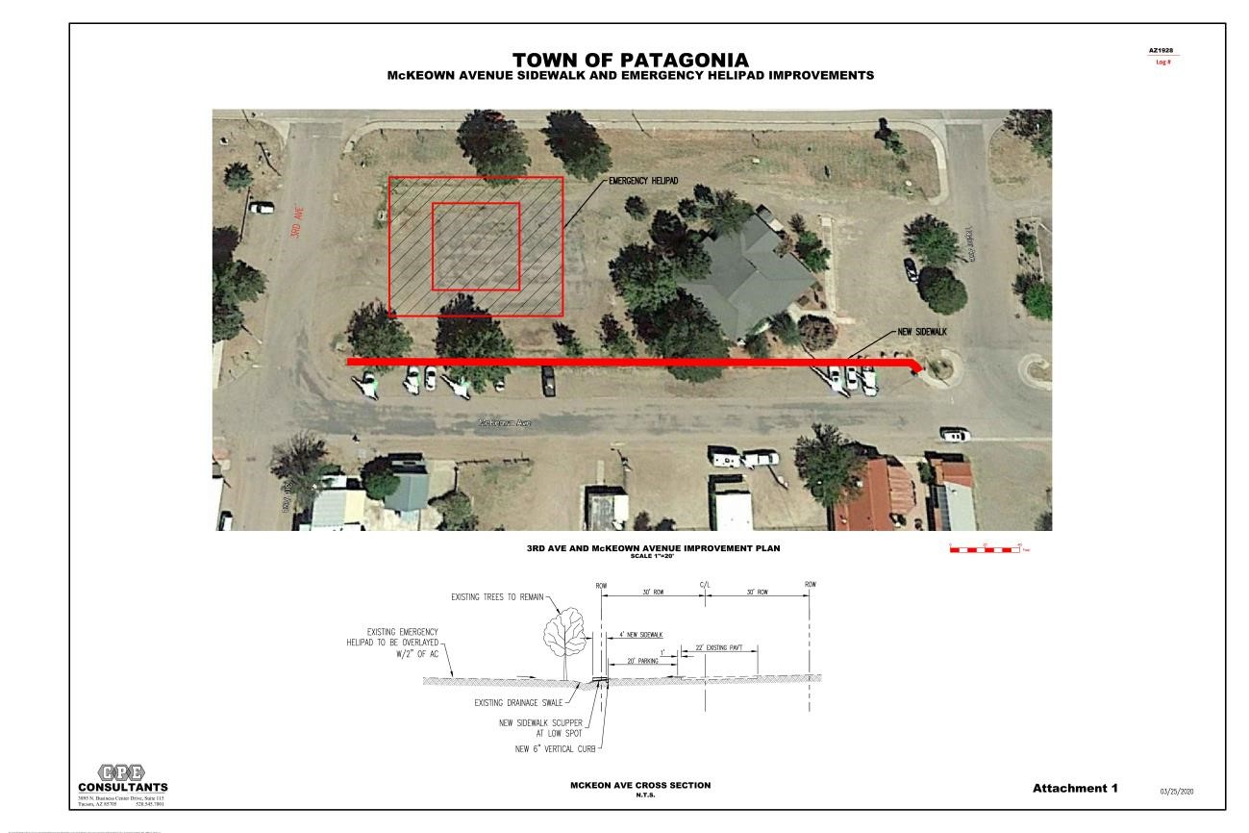
Exhibit B Definition of Work

TEMPORARY ROUTE IMPROVEMENTS DESIGN
Harshaw Road Overlay
McKeown Ave and 3rd Avenue
- Phase 1 – Sidewalk & Helipad Construction
- Phase 2 – New Pavement & Sidewalk Construction
Project General Services – Services include Design and Bid Period Services. Design services includes civil engineering, field surveys, utility coordination, and geotechnical investigations. Bid period services include preparation of the bid documents to include plan bid sets, special provisions & bid schedule, pre‐bid meeting attendance, addenda, & bid evaluation. Construction Administration services, if required, will be performed under separate scope of services and contract.
HARSHAW ROAD, TAYLOR STREET TO TOWN LIMITS Scope – Improvements will include the overlay of the existing Harshaw Road pavement between Taylor Street and the Town Limits (specifically ending at the bridge approach slab of the Harshaw Road bridge over Harshaw Creek. Features to include paved turnouts to existing paved streets/drives, an overlay plan view, removals sheet, re‐striping plan, concrete pavement edge headers at un‐paved drives, maintenance of existing pavement drainage features, documentation of existing improvements and conditions, notes and details as necessary for lateral roadside drainage ditches, finish grade adjustments of valve box and manhole cover lying within pavement areas, and R/W plan with construction centerline controls.

McKEOWN AVENUE AND 3RD AVENUE
Phase 1 ‐ Sidewalk & Helipad Construction Scope – The existing helipad area, lying within the northeasterly quadrant of the McKeown Ave./3rd Ave. intersection, will be resurfaced with 2” of asphaltic concrete. Along the northwesterly edge of McKeown Avenue, between 3rd Avenue and Taylor Street, the street will be widened to include new paving, curb and sidewalk. Area will be graded to drain and include appropriate sidewalk scuppers to drain McKeown Avenue to the existing drainage swale/system. Work will include field investigations and designs and studies necessary to ensure adequate street drainage (may include necessity of a retention basin in the ‘park’ area.
Phase 2 ‐ New Pavement & Sidewalk Construction Scope – Improvements will include the repaving of 3rd
Avenue, between McKeown and SR82, and the repaving of McKeown, between 3rd Avenue and Taylor Street. A sidewalk will be installed along the northeasterly edge of 3rd Avenue. McKeown Avenue will be widened to include a paved pedestrian area with bollards, separating traffic from pedestrians. Road drainage will consist of grading to drain to sidewalk scuppers to ‘park’ area.
Scope of services does not include a formal drainage report, roadway widening, nor utility line relocations except as noted above.
AZ1960 S32 Patagonia Streets Design Scope 200518.doc Page 1 of 3

General Services – Services include Design, Bid/Advertise/Award Contracting, & Construction Administration. Design services includes civil engineering, field surveys, utility coordination, and geotechnical investigations. Bid/Advertise/Award Contracting services includes preparation of the bid documents to include plan bid sets, contract, standard & special provisions bid schedule, general conditions, pre-bid meetings, addenda, bid evaluation, and advertisement of project, complete thru award and contract execution. Services during construction includes construction administration, inspection, and contract closeout.
Project Scope – The existing emergency helipad area, lying within the northeasterly quadrant of the McKeown Ave./3rd Ave. intersection, will be resurfaced with 2” of asphaltic concrete or similar type cover to be determined by geotechnical services. Along the northwesterly edge of McKeown Avenue, between 3rd Avenue and Taylor Street, a sidewalk will be constructed. Area will be graded to drain and include appropriate sidewalk scuppers to drain McKeown Avenue to the existing drainage swale/system. See Attachment 1 showing the improvements.
Attached is a depiction of each upgrade.
