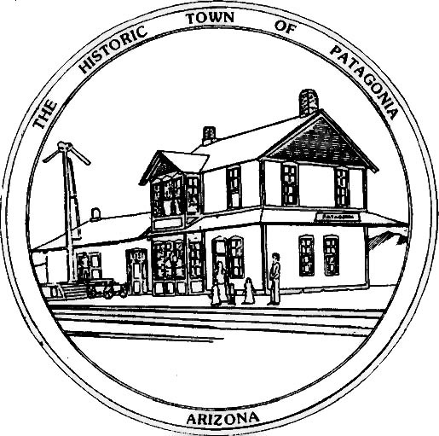
COMMUNITY ANNOUNCEMENT-COVID19

Beginning June 21, 2020, face masks are now required to be worn in public places and businesses in Patagonia, Arizona.

Authority is given by Governor Doug Ducey, encouraging local governments to implement current face mask policies.

While shopping in our stores, dining in our restaurants and bars and visiting our establishments, PLEASE WEAR A MASK.

Intentional disregard may result in fines imposed. PLEASE WEAR A MASK. This announcement complies with amended Proclamation #5
Dated: May 14, 2020

Your mask protects me. My mask protects you. Let us work together to protect us all. PLEASE WEAR A MASK.
SIGNED BY MY HAND THIS DAY OF JUNE 19, 2020 ATTEST:

_______________________________________ _____________________________________
Andrea Wood, Mayor Ron Robinson, Town Clerk

