Do You Live in Patagonia?
You May be in the Floodplain
Know Your Floodplain Hazard
Over 60% of the Town is within Flood Hazard Area
Over 80% of the buildings are within the Flood Hazard Area
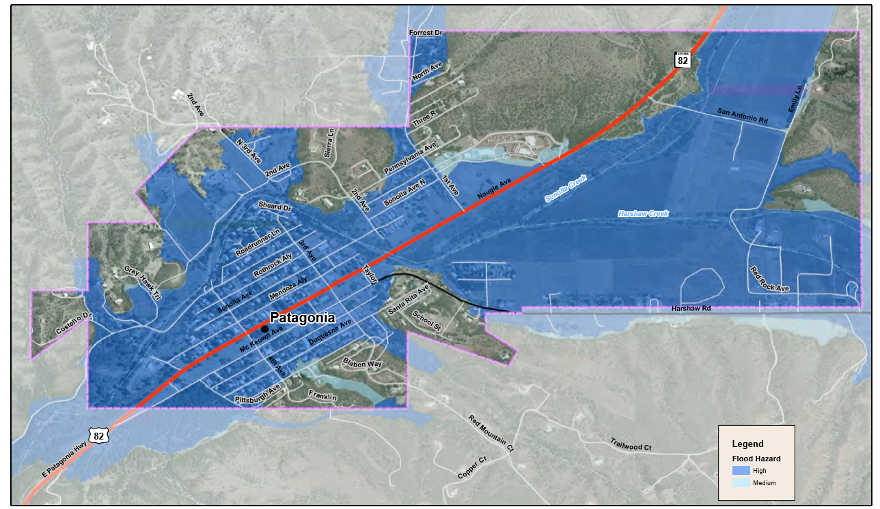Town of Patagonia Flood Hazard Map as of June 2017
Are you seeing BLUE?
Click here for more YOU CAN DO!
Community Rating System (CRS) Flood Information Page
http://patagonia-az.gov/community-rating-system-flood-information-page/

